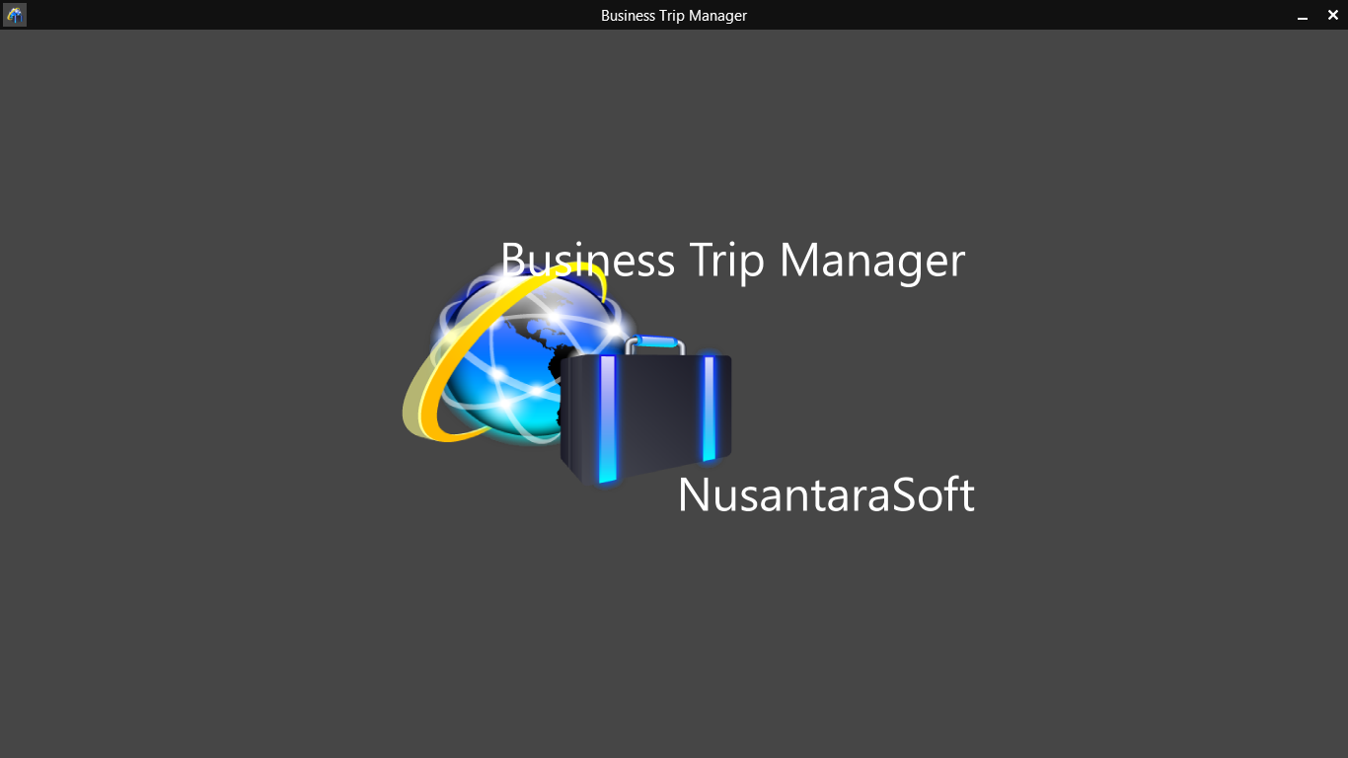
Business Trip Manager
User Guide

Thank your for using NusantaraSoft Business Trip Manager!
The following User Guide shows you all the features of Business Trip Manager and helps you to get started with managing your business trips.
Business Trip Manager will be frequently updated. Watch out for updates and download the newest version of this User Guide from: http://www.btm.nusantarasoft.net/download.aspx.
If you have questions or need support please visit http://www.btm.nusantarasoft.net/help.aspx or e-mail our support.
If you haven’t gotten Business Trip Manager yet, download it now from the Windows Store!

Contents
- Get Started, Enter and modify your personal data and settings and create your first trip
- Add and Edit Trip Participants
- Add and Edit Travel Data and Create a Driver’s Log
- Add and Edit Accommodation Data
- Add and Edit Expenses
- Using the File Cabinet
- Create and Print an Invoice
- Create and Print an Expense Claim
- Export Data to Excel as .csv - File
- Duplicate a trip
- Backup and Restore your Trip Data
- Fix File References
- Clean up your Trip Folder
- Import and Export your Trip Data
- Good Luck!

1. Get Started
Learn in this chapter how to set up Business Trip Manager for the first use and create your first business trip.
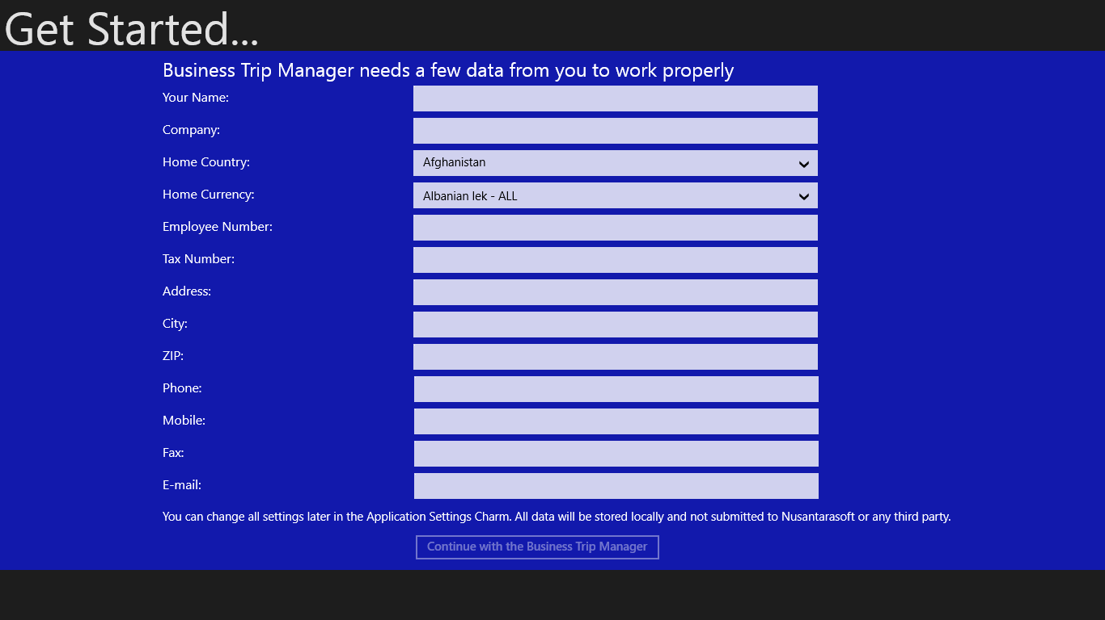
Figure 1: Start screen for the first use
When you start Business Trip Manager for the first time, you will be asked to enter a few personal data. These data are required for Business Manager to work properly. The following input is required:
- Your Name – to personalize your Business Trip Manager
- Company – to address claims and invoices
- Home Country and Home Currency – to calculate exchange rates and allowances
- Employee Number – to address claims and invoices
- Tax Number – to address claims and invoices
- Address – to address claims and invoices
The entries for phone, fax and e – mail are optional. Please note that none of the data you enter here will be submitted to NusantaraSoft or any third party.

☺Hint:
Selecting the country from the dropdown list will in most cases automatically select the corresponding currency.

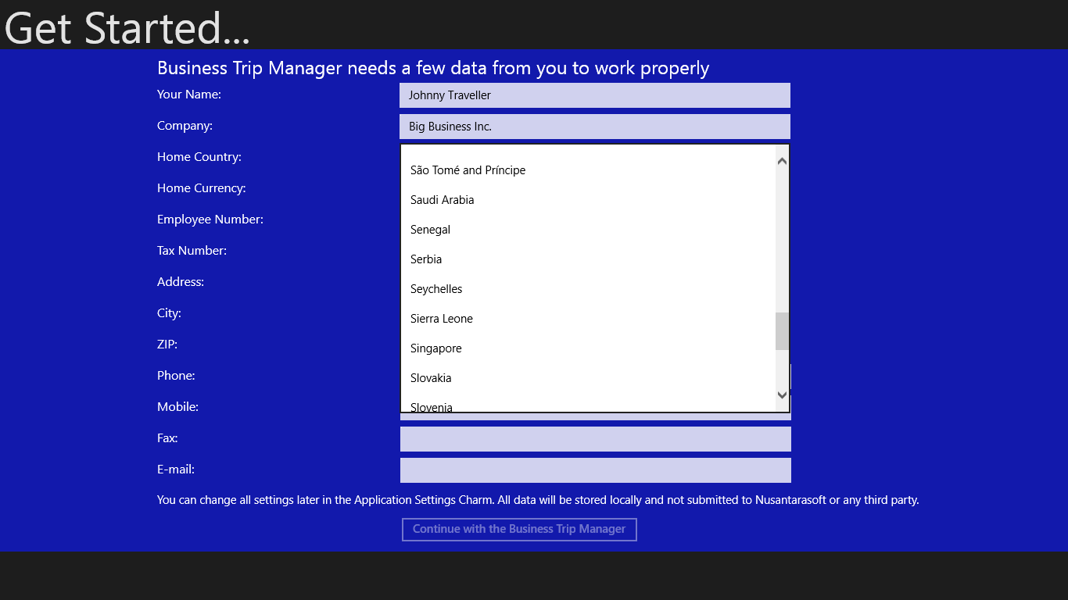
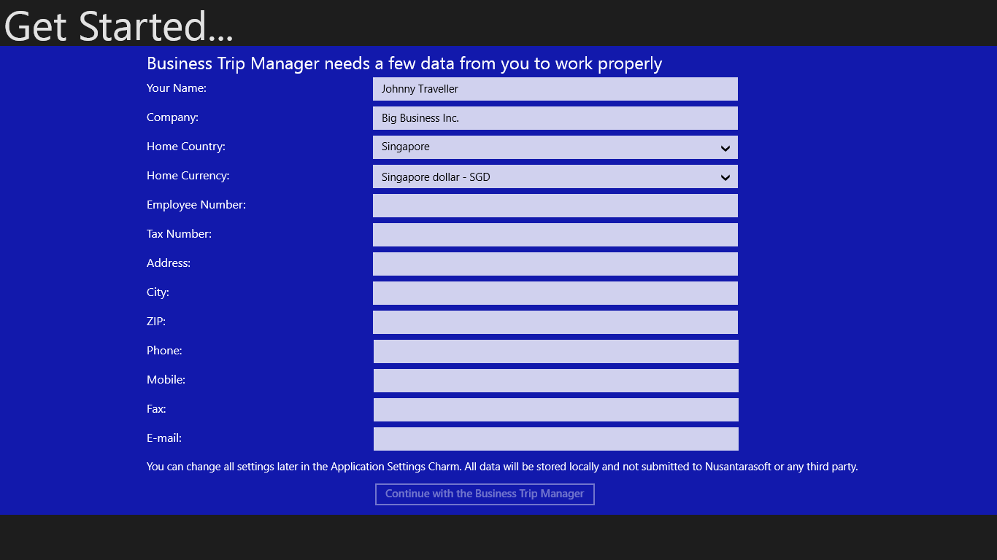
Figure 2: Country and currency selection.
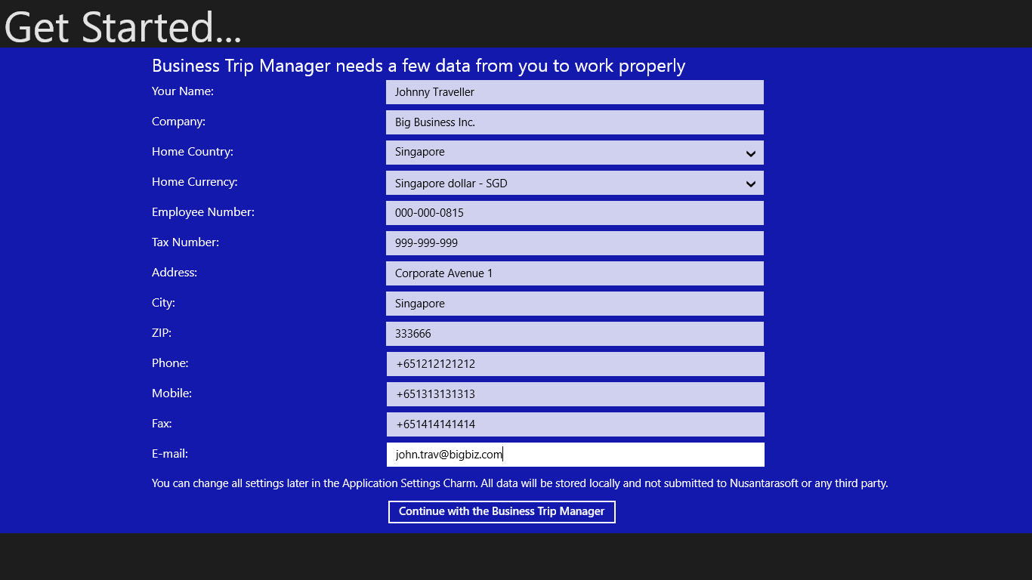
Figure 3: Personal Data complete.
Please note, that you can always change your settings in the Settings – Menu.
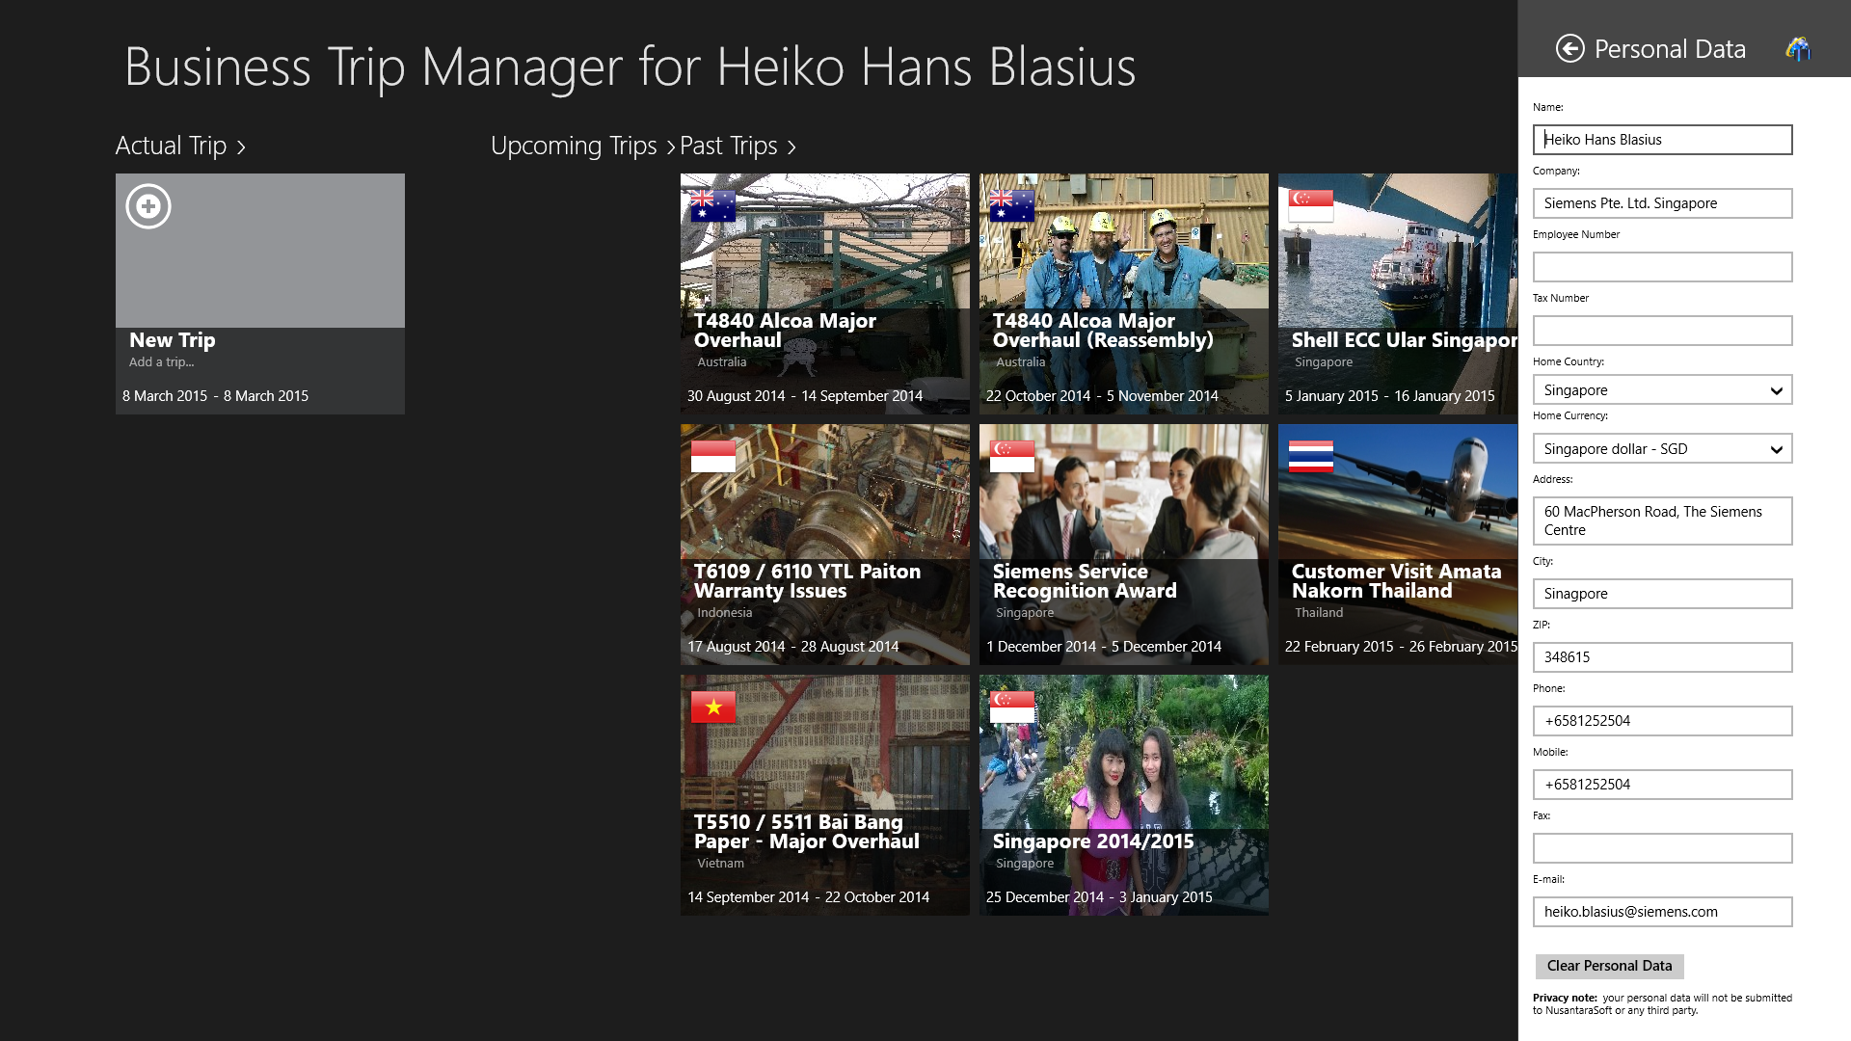
Figure 4: Settings Menu
If you have entered all required data click or tap on the “Continue with the Business Trip Manager” – button and we you are ready to create your first trip.
The Business Trip Manager Start Screen will be shown. Click or tap the box “New Trip”. Alternatively you can swipe from the bottom and select the “Add Trip” – Menu.
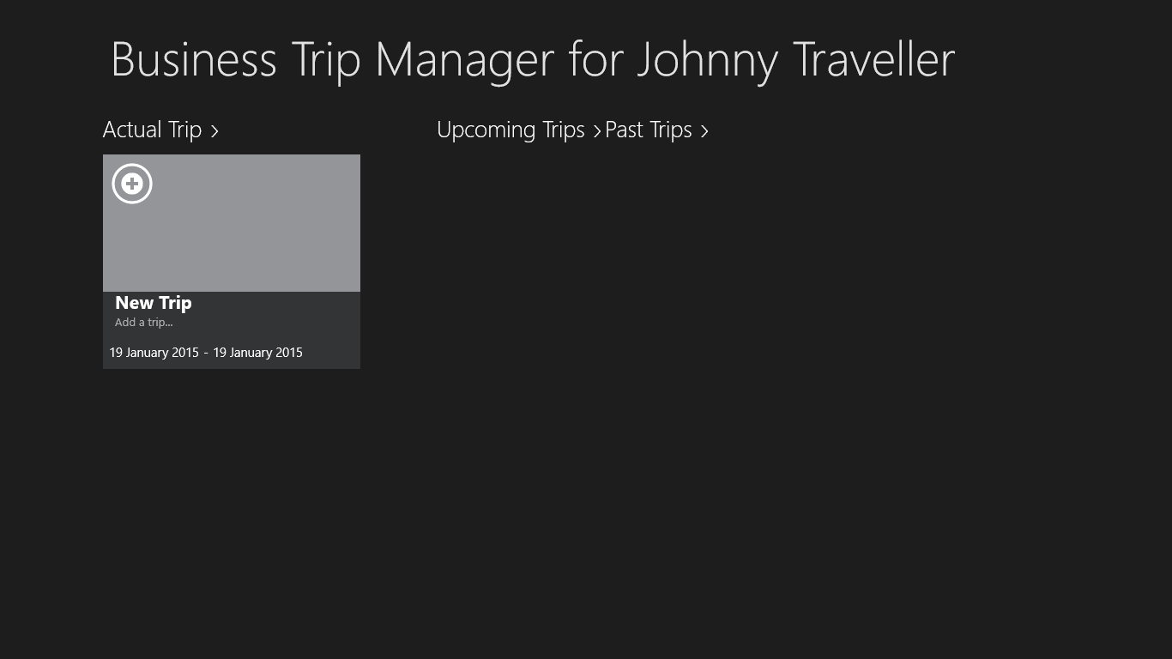
Figure 5: Business Trip Manager Start Screen. Tap the “New Trip”- Box to create a new trip or swipe from the bottom and select the “Add Trip” – Menu.
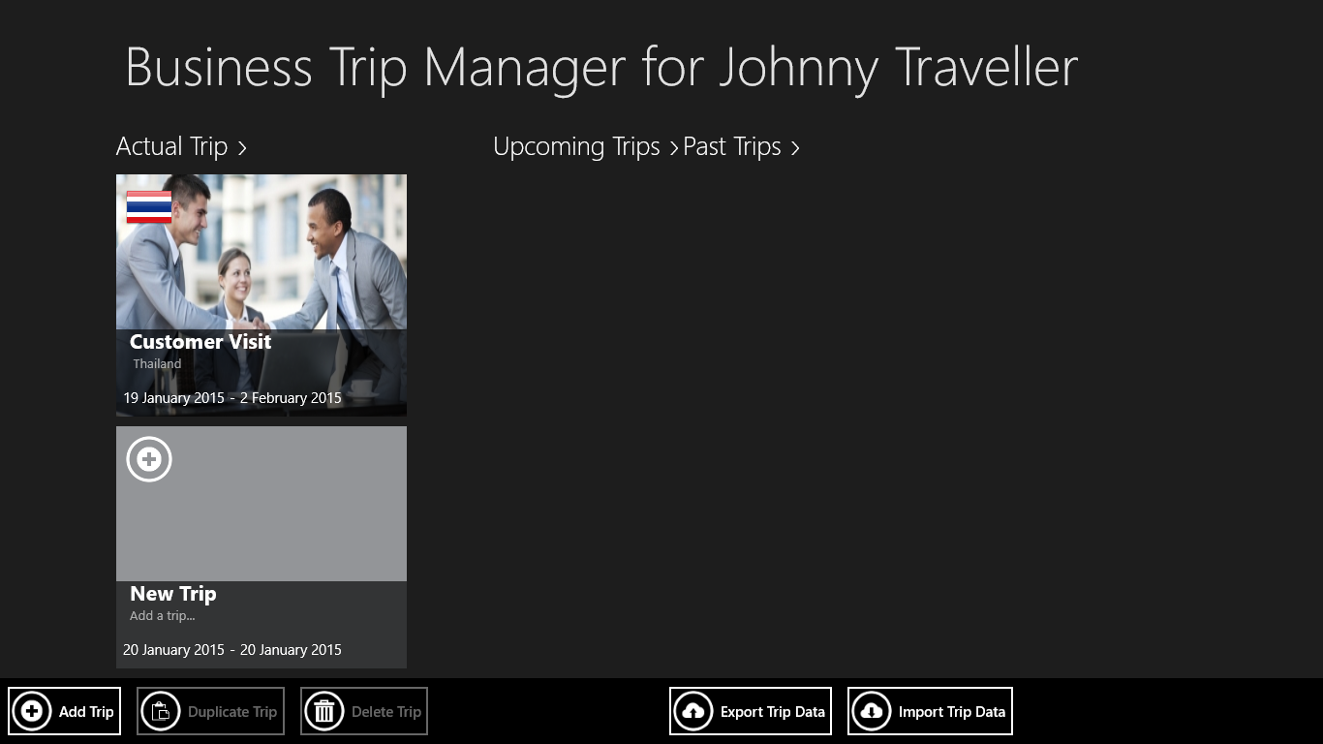
The “New Trip”- page will be shown.
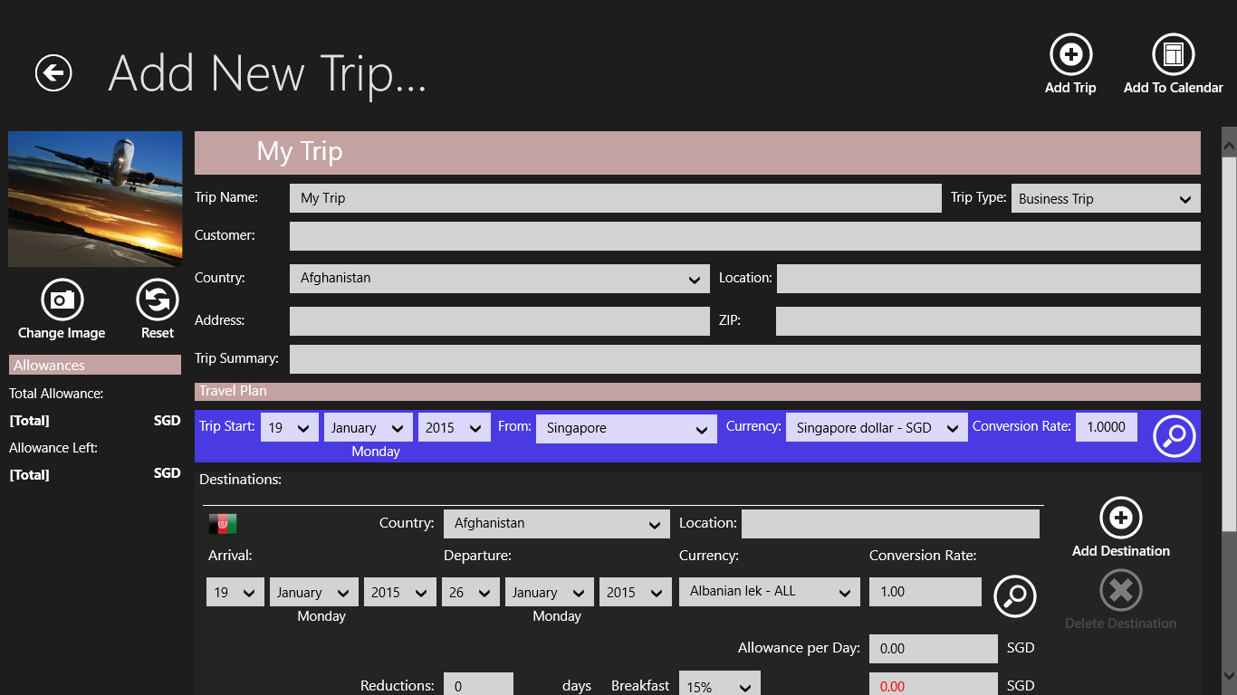
Figure 6: The New Trip Page.
Enter first the trip data as follows:
- Trip Name – a unique name for the trip needs to be specified. The trip cannot be created if there was no Trip Name given!
- Trip Type – select the type of the trip from the dropdown list. Different trip types are used in most companies to determine the amount of allowances and reimbursement of expenses.
- Customer address – can be left blank. This is used to create invoices and claims.

Fill in the Travel Plan Trip Start Section (Figure 7):
- Select the trip start date and start country. By default your home country is selected as the start country and actual date as start date. Selecting the country from the dropdown list will in most cases automatically select the corresponding currency.
- Enter the conversion rate either manually or click on the magnifier symbol. The most actual conversion rate will be displayed. Copy and paste the shown rate. Please ensure you always enter the rate as follows: 1 Foreign Currency = Home Currency as shown in figure 7. The foreign currency is Indonesian Rupiah, the Home currency is Singapore Dollar.

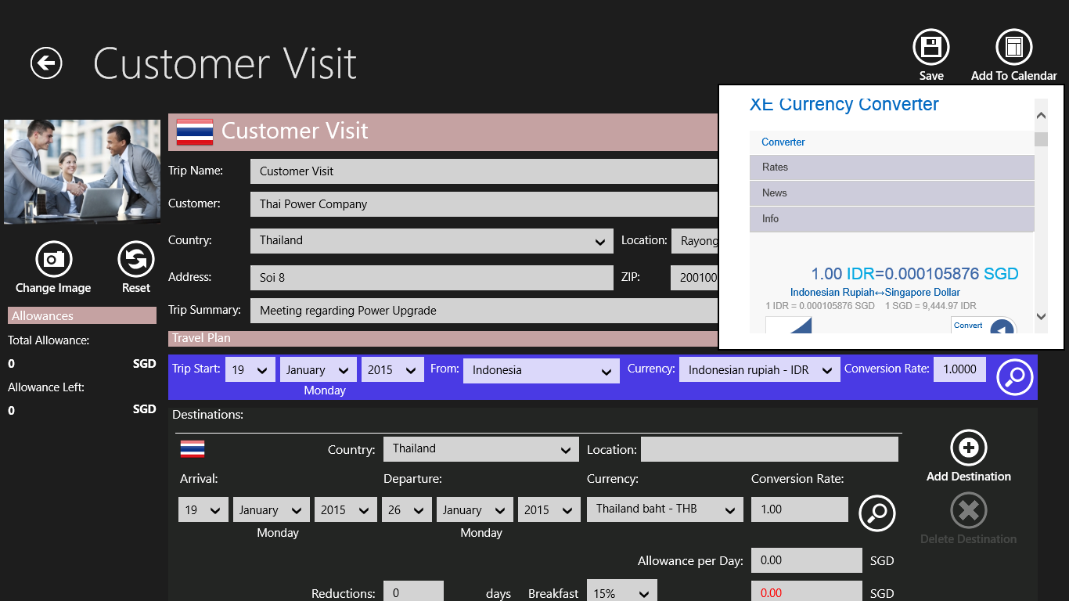
Figure 7: The New Trip Page.
Enter Trip Destinations (Figures 8 – 10):
Enter all the destinations of your trip. You can enter multiple destinations even in different countries. You need at least to enter one destination. Here, you will also set the amount of daily allowances and any deductions from it. Steps for entering a destination are as convenient as the steps for specifying the trip start and end dates.
- Select the arrival date, departure date and country. Selecting the country from the dropdown list will in most cases automatically select the corresponding currency.
- Enter the conversion rate either manually or click on the magnifier symbol. The most actual conversion rate will be displayed. Copy and paste the shown rate. Please ensure you always enter the rate as follows: 1 Foreign Currency = Home Currency as shown in figure 8. The foreign currency is Thai Bhat, the Home currency is Singapore Dollar.
- Specify the amount of daily allowance. The total amount will be automatically computed.
- Specify the deduction from the daily allowance. Usually, a percentage of the daily allowance is deducted if meals are paid by the company or customer.
- Click on the “Plus” – Button to add another destination. You can enter as many destinations as you want. You repeat steps 1 – 4 for each destination.
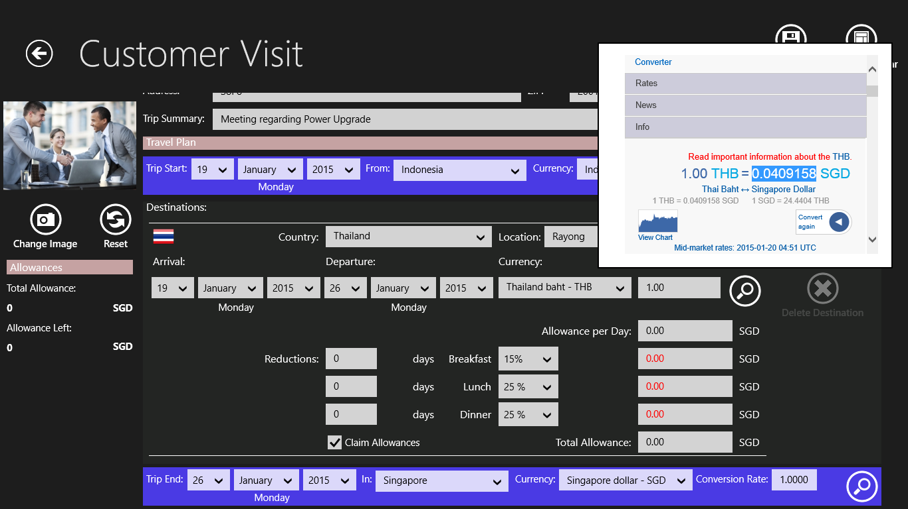
Figure 8: Setting up the first destination: Arrival and departure date, country, currency and exchange rate.
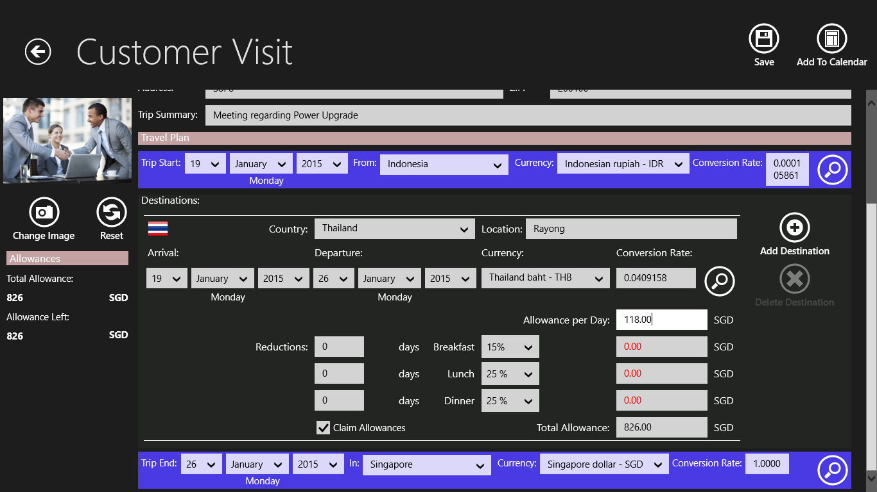
Figure 9: Enter the daily allowance. The total allowance will be automatically computed.
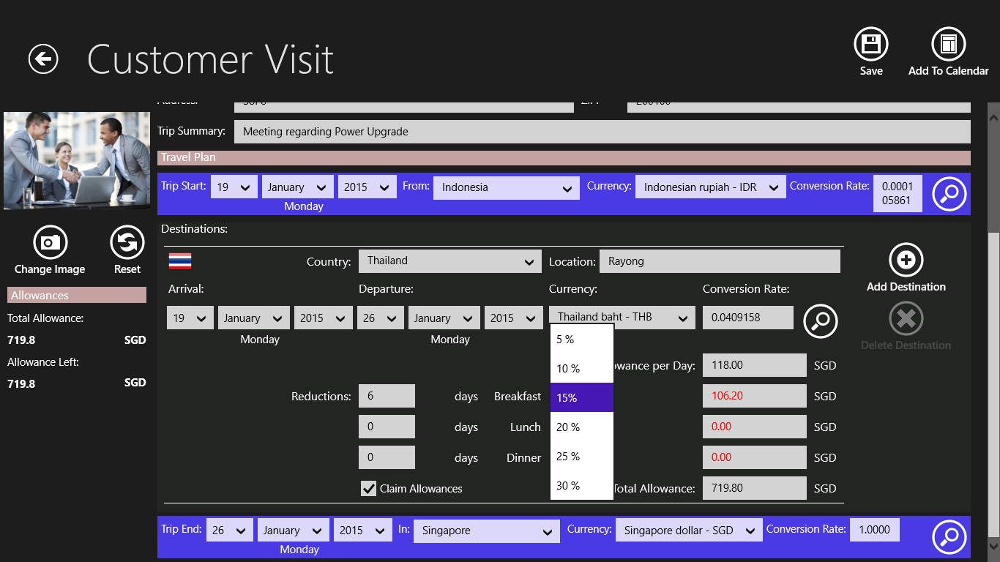
Figure 10: Specify any deductions from your daily allowance. All allowances will be automatically recalculated.
Enter the Trip End Section:
The trip end section will be automatically updated as you set up your trip destinations. Just check the entries Business Trip Manager has made for you. Steps to modify the entries in the trip end section are the same as for the start section.
Add Trip to your Calendar:
You can add your trip to your windows calendar. All your trip data will be automatically synchronized with all your devices and Outlook accounts.
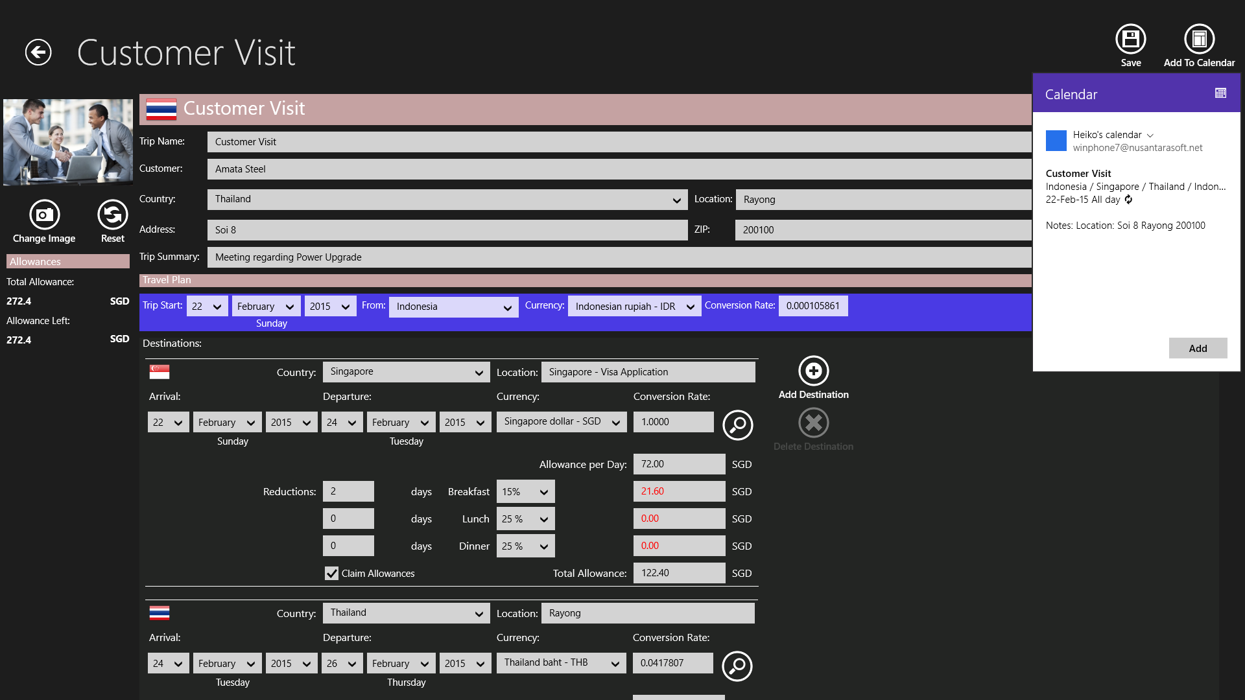
Figure 11: Click the “Add to Calendar” – Button and confirm the data in the popup.
Removing the trip from the calendar is just as easy:
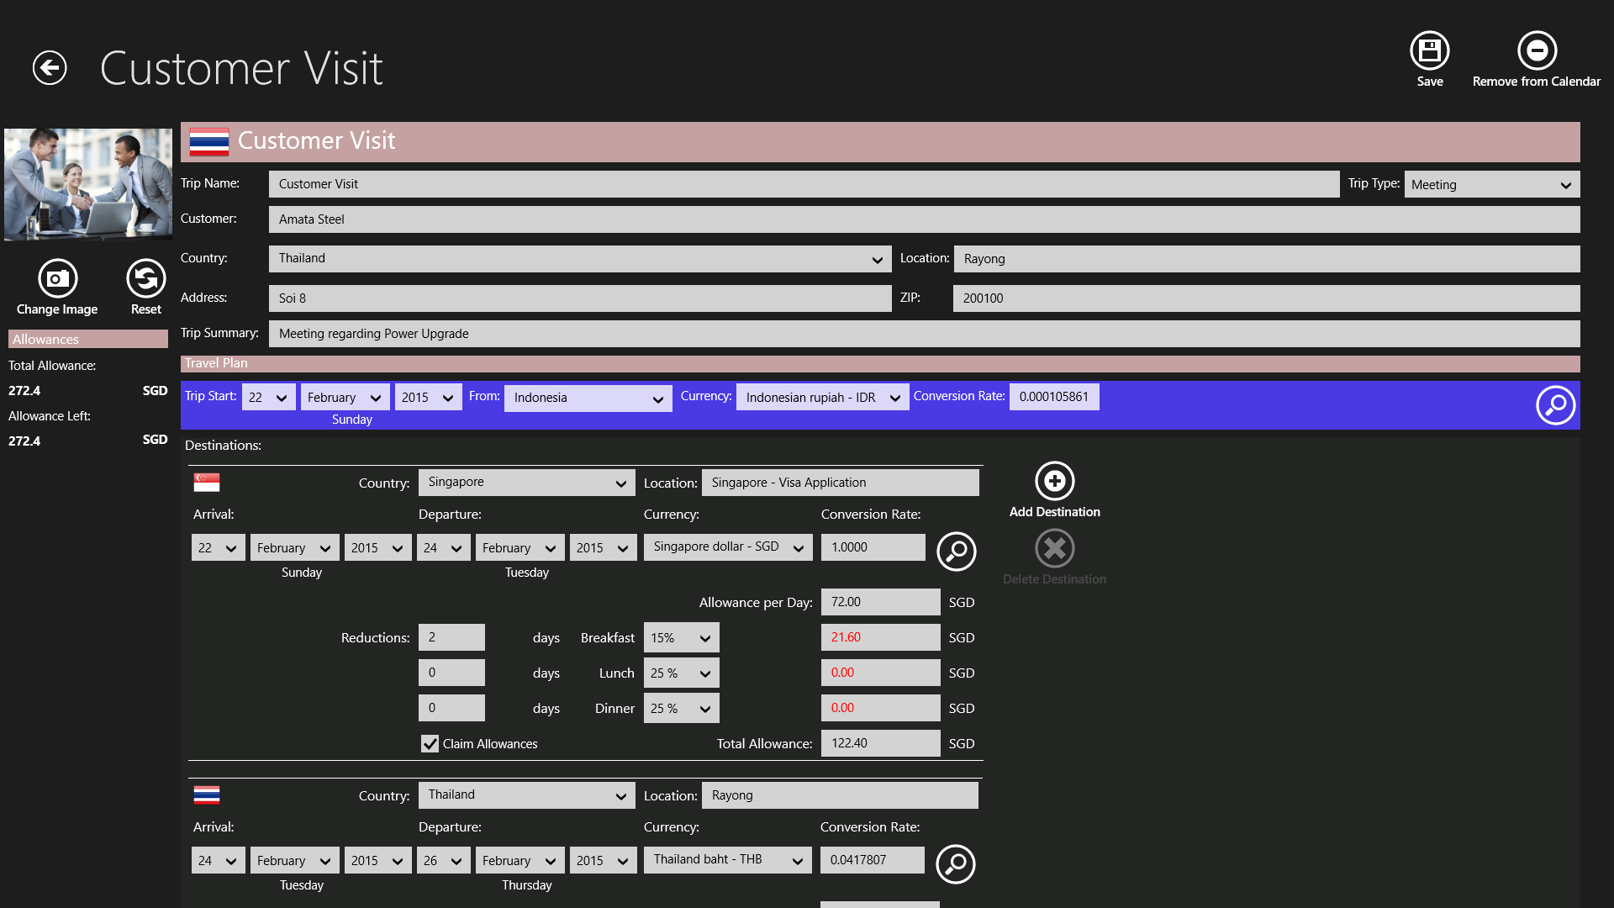
Figure 12: Click the “Remove from Calendar” – Button and …

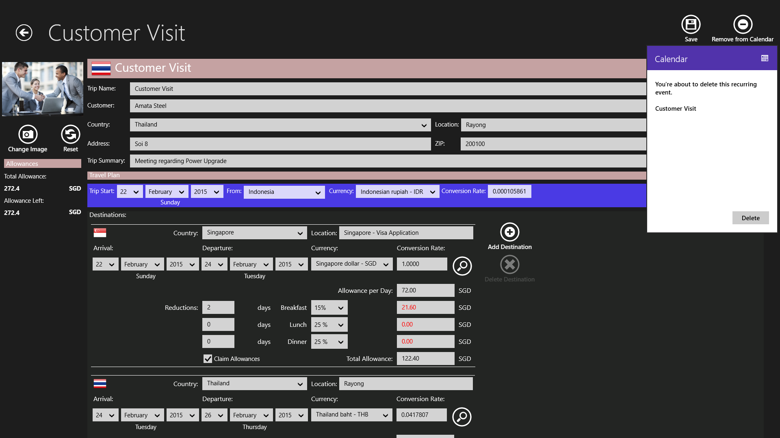
Figure 13: … Confirm deleting the trip from the calendar in the popup.
Note: If you have added a trip to your calendar, the calendar data will be updated automatically when you edit your trip data.
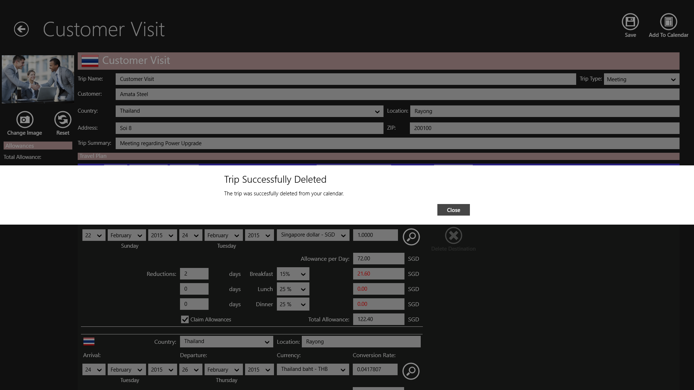
Figure 14: Please wait for the confirmation that the trip has been deleted from the calendar.
Finally, click the “Add Trip” – Button on top of the page to add your trip to the trip list.
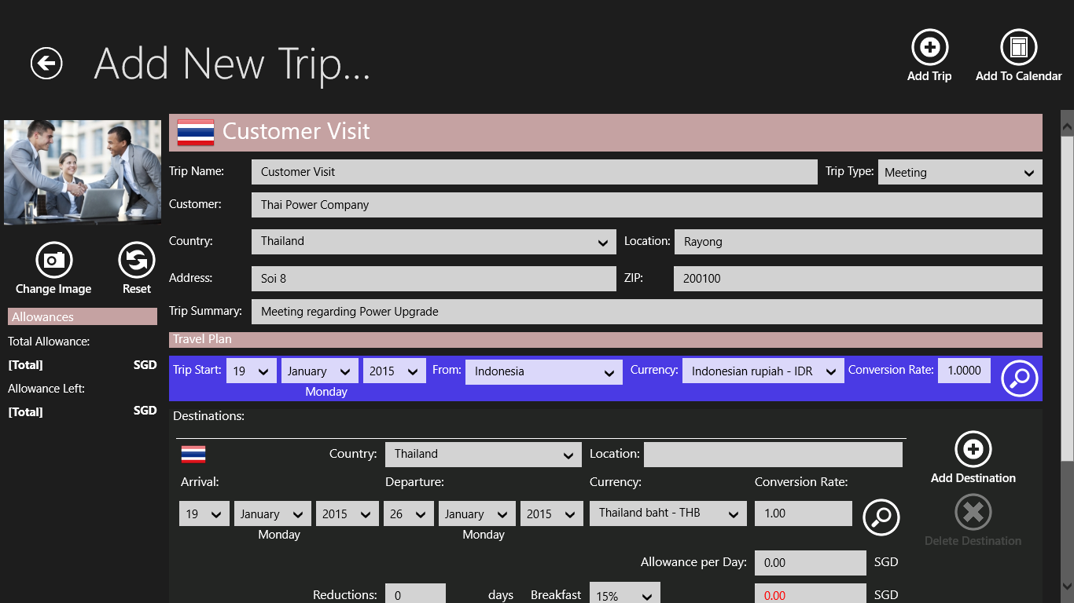
Figure 15: Click the “Add Trip” – Button to add the trip to your trip list.
Congratulations! You have just added your first trip! You now can start to enter data and add documents to your trip.
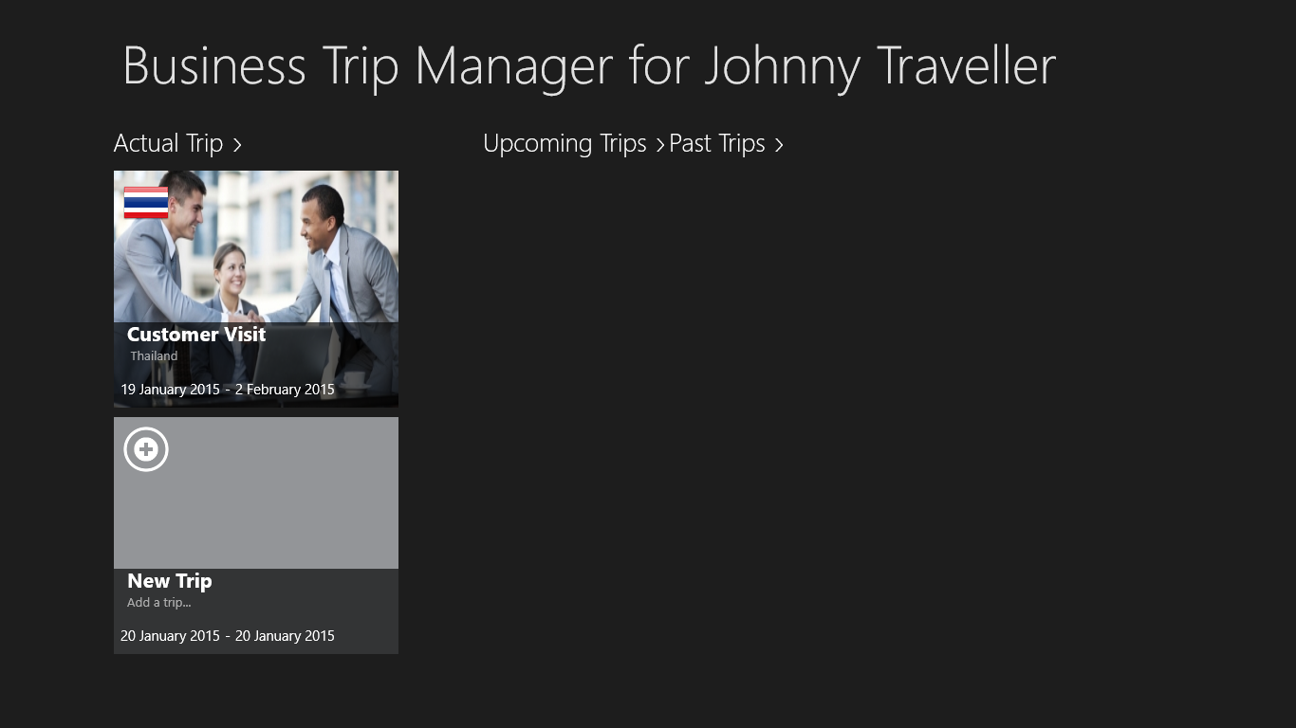
Figure 16: Trip successfully created!
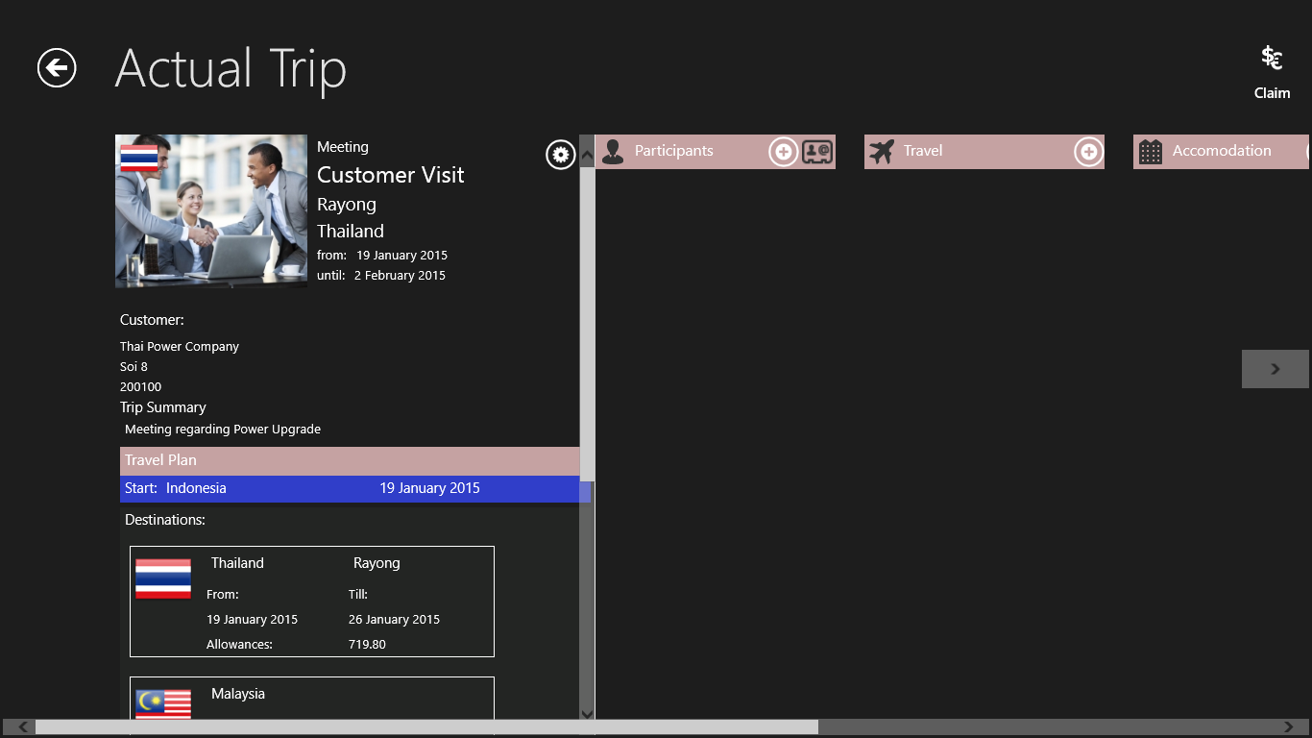
Figure 17: You can always edit your trip data by clicking on the little gear symbol on the top right panel of the trip overview pane.
Note: When you edit the currency and conversion rates, the prices and conversion for accommodation, travel and expenses will be updated automatically.
The trip dates for flight tickets, participants and accommodation need to be updated manually.

1. Add and Edit Trip Participants
Add the people who will join you on your trip.
There are two ways of adding trip participants to your list. You can enter the participants’ data manually or you can select the participants from the Windows People’s Hub.
Entering the data manually:
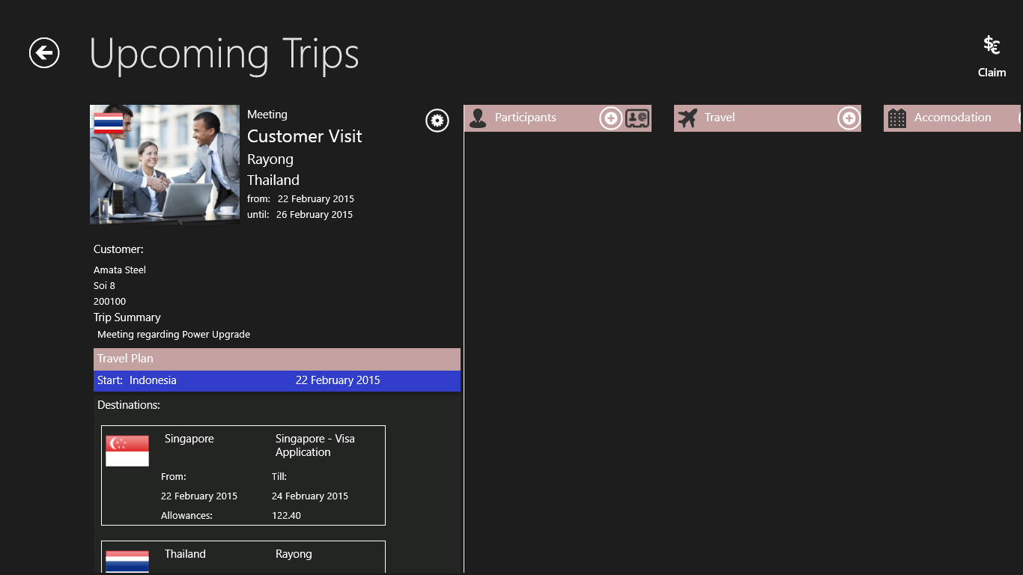
Figure 18: Click or tap the “+” – Button on top of the participants list.
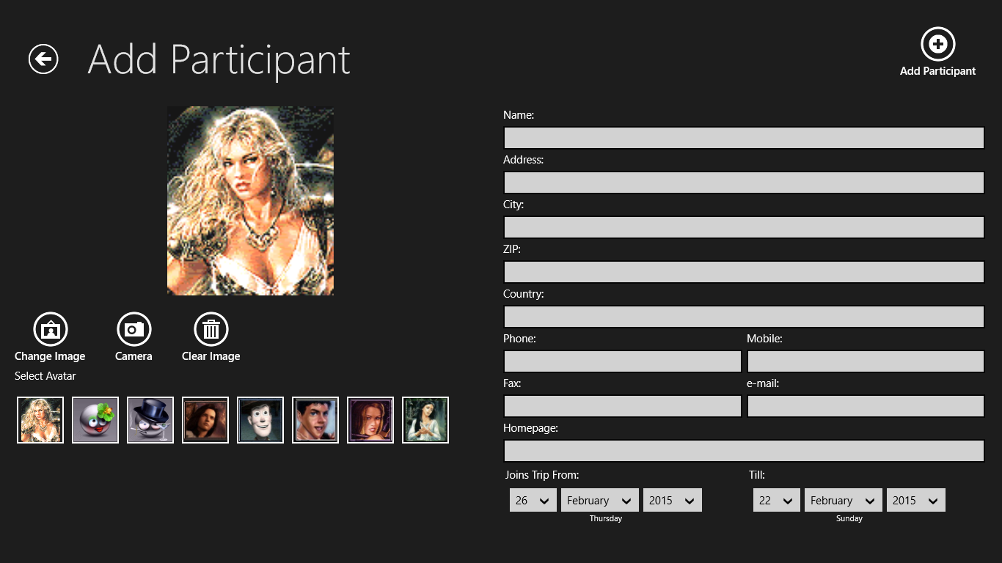
Figure 19: The participants’ page will be shown. Enter all the relevant data, like name, phone numbers, address and e – mail.
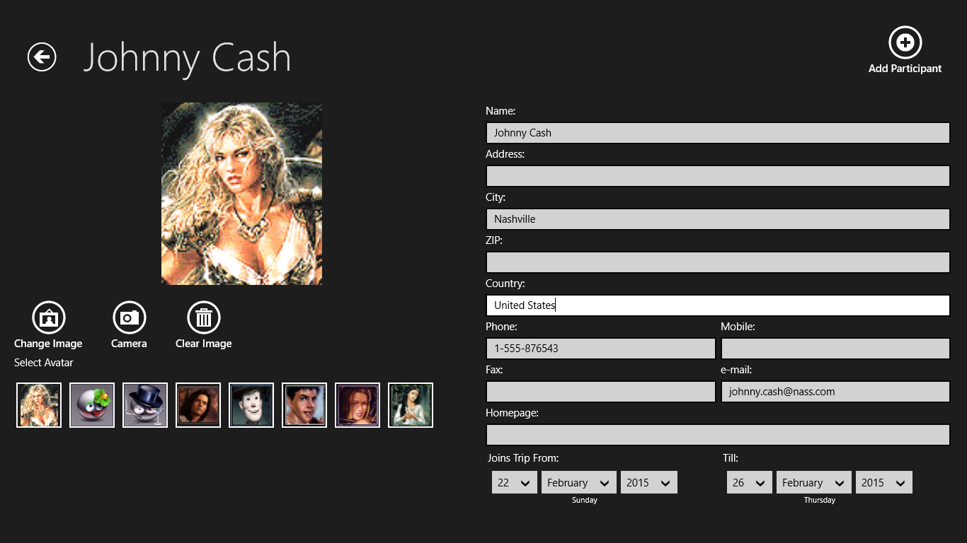
Figure 20: You can assign an avatar for the participant …
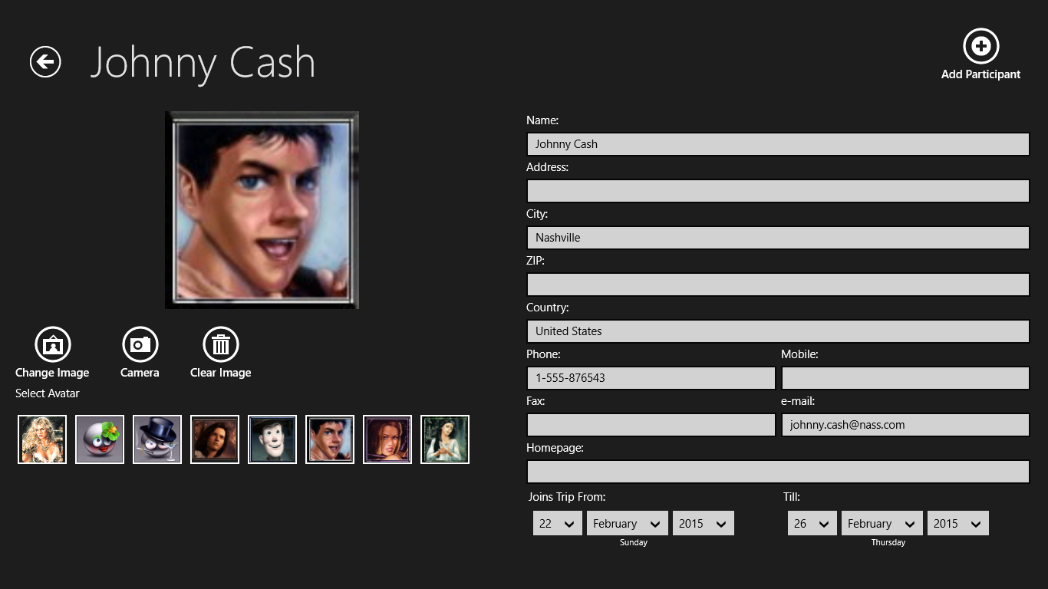
Figure 21: Avatar assigned.
You can also assign an image for the participant. Choose and image saved on your computer or take an image with your built – in Webcam.
Figure 22: To select an images stored on your computer, click the “Change Image” – Button.
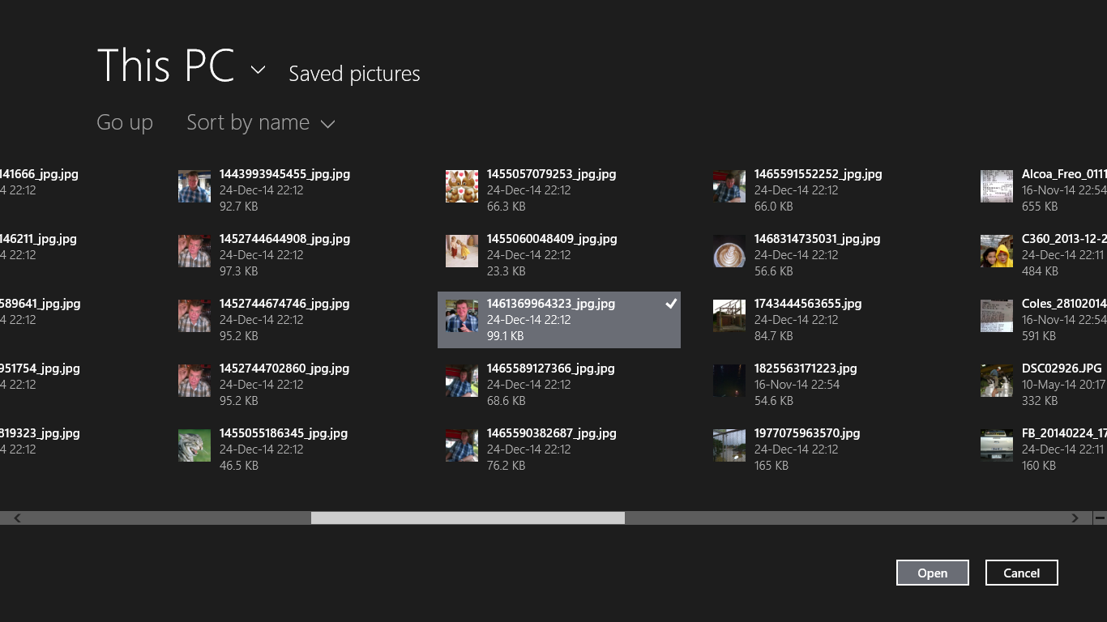
Figure 23: Select an image from the file dialog.

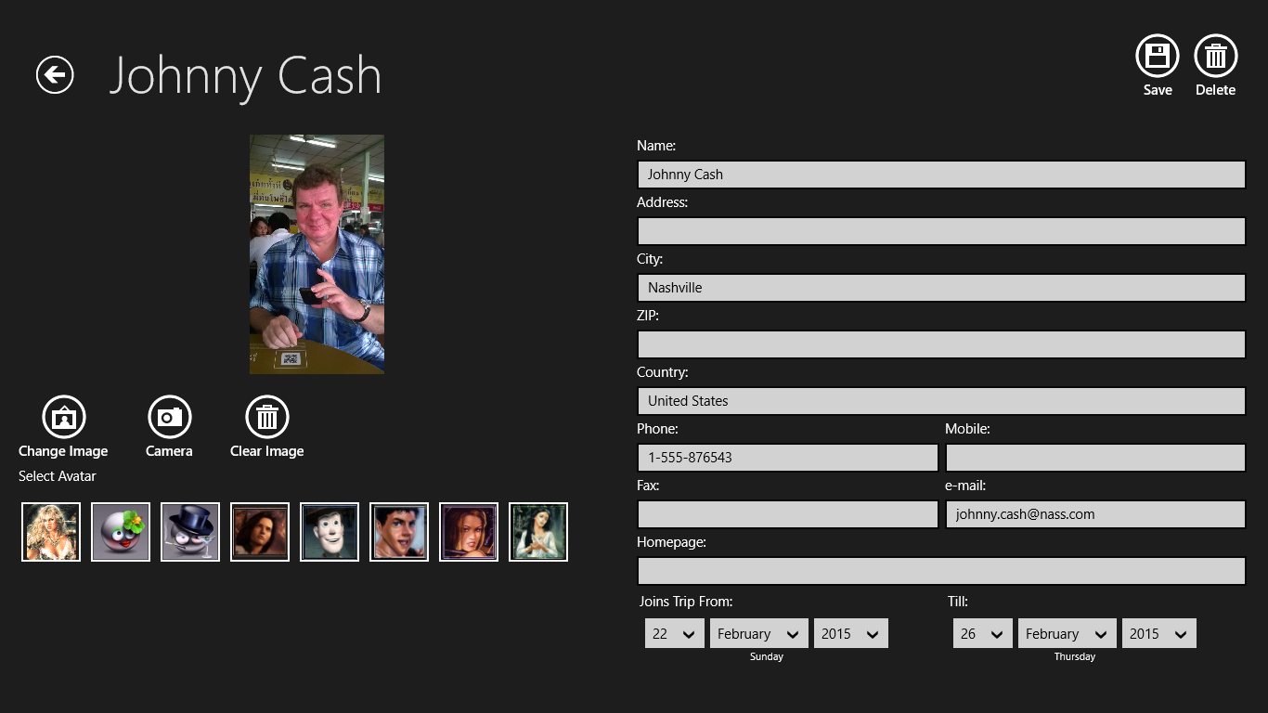
Figure 23: The selected image will appear on the page. To take an image with your Webcam, click on the camera button next to the image button.
Figure 24: Click the “Add Participant” – Button in the top right corner when you are done.

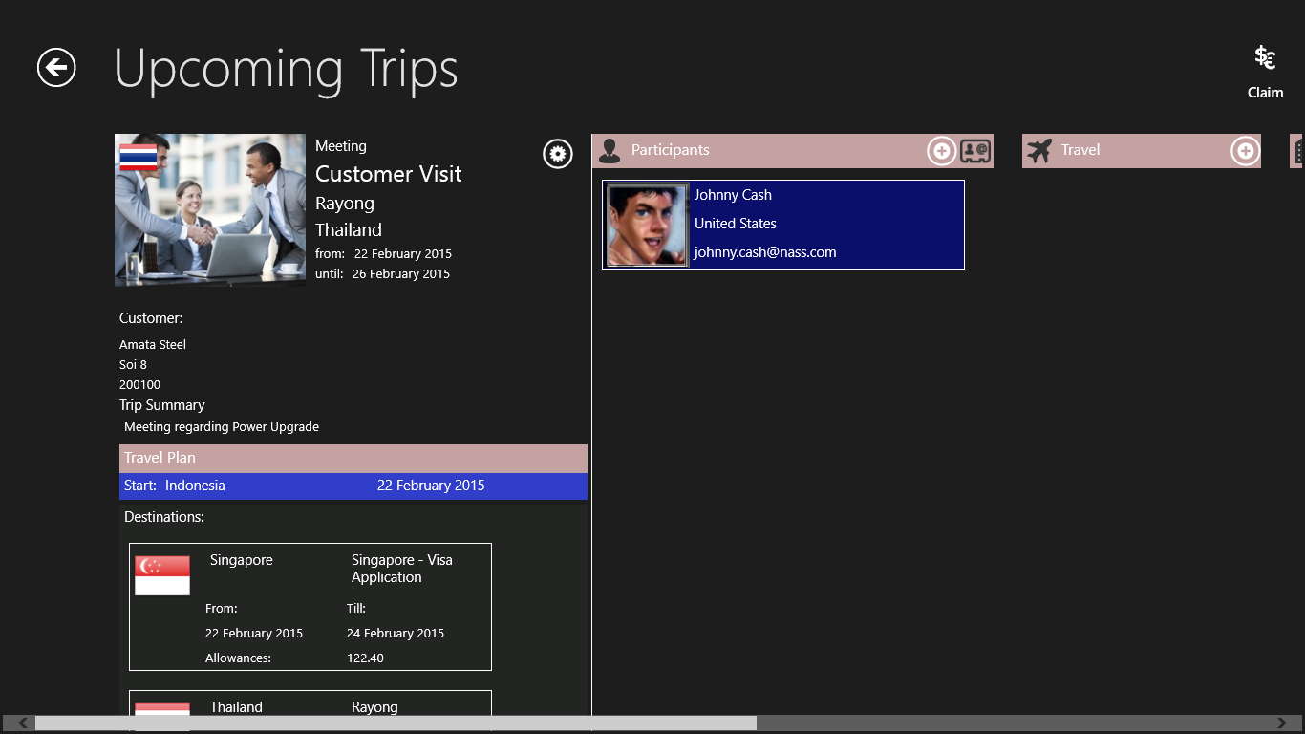

Figure 25: The Participant is added to the list.
Clicking on the participants’ entry in the list will bring you back to the participant’s page. Here you can make necessary changes. Click the “Save” – Button to save the changes otherwise they will be discarded.
Figure 26: Edit Participant.

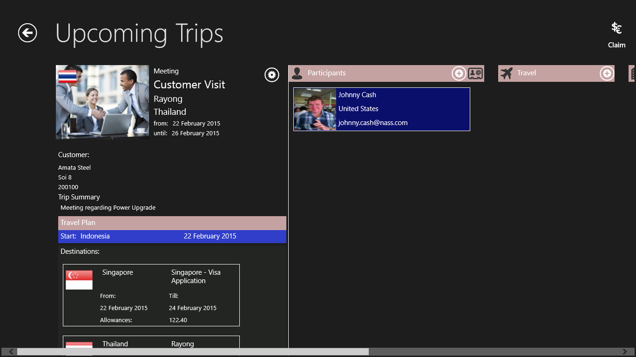
Figure 27: Updated list entry.
☺Hint:
If you ever have entered participant data on previous trips a list with previous participants will be shown when you want to add a new participant. This is a convenient way to add people who frequently join your trips without doing all the typing again. Please note that this list will not be shown if you choose participants from the people’s hub.

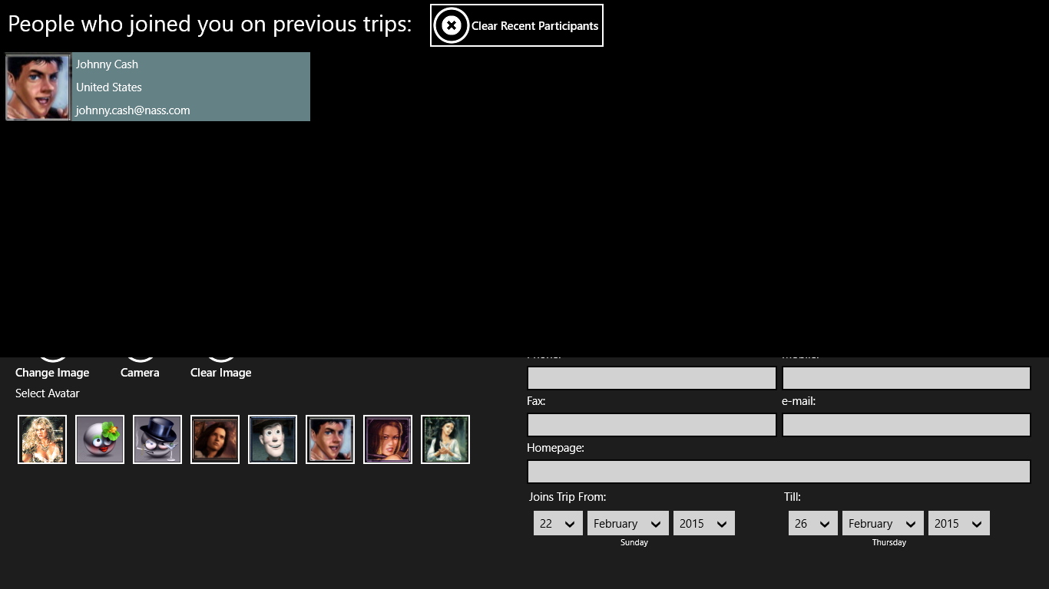
Figure 27: List of previous participants.

Choosing participants from the people’s hub:
Figure 28: Click on the “People’s Hub” – Button.

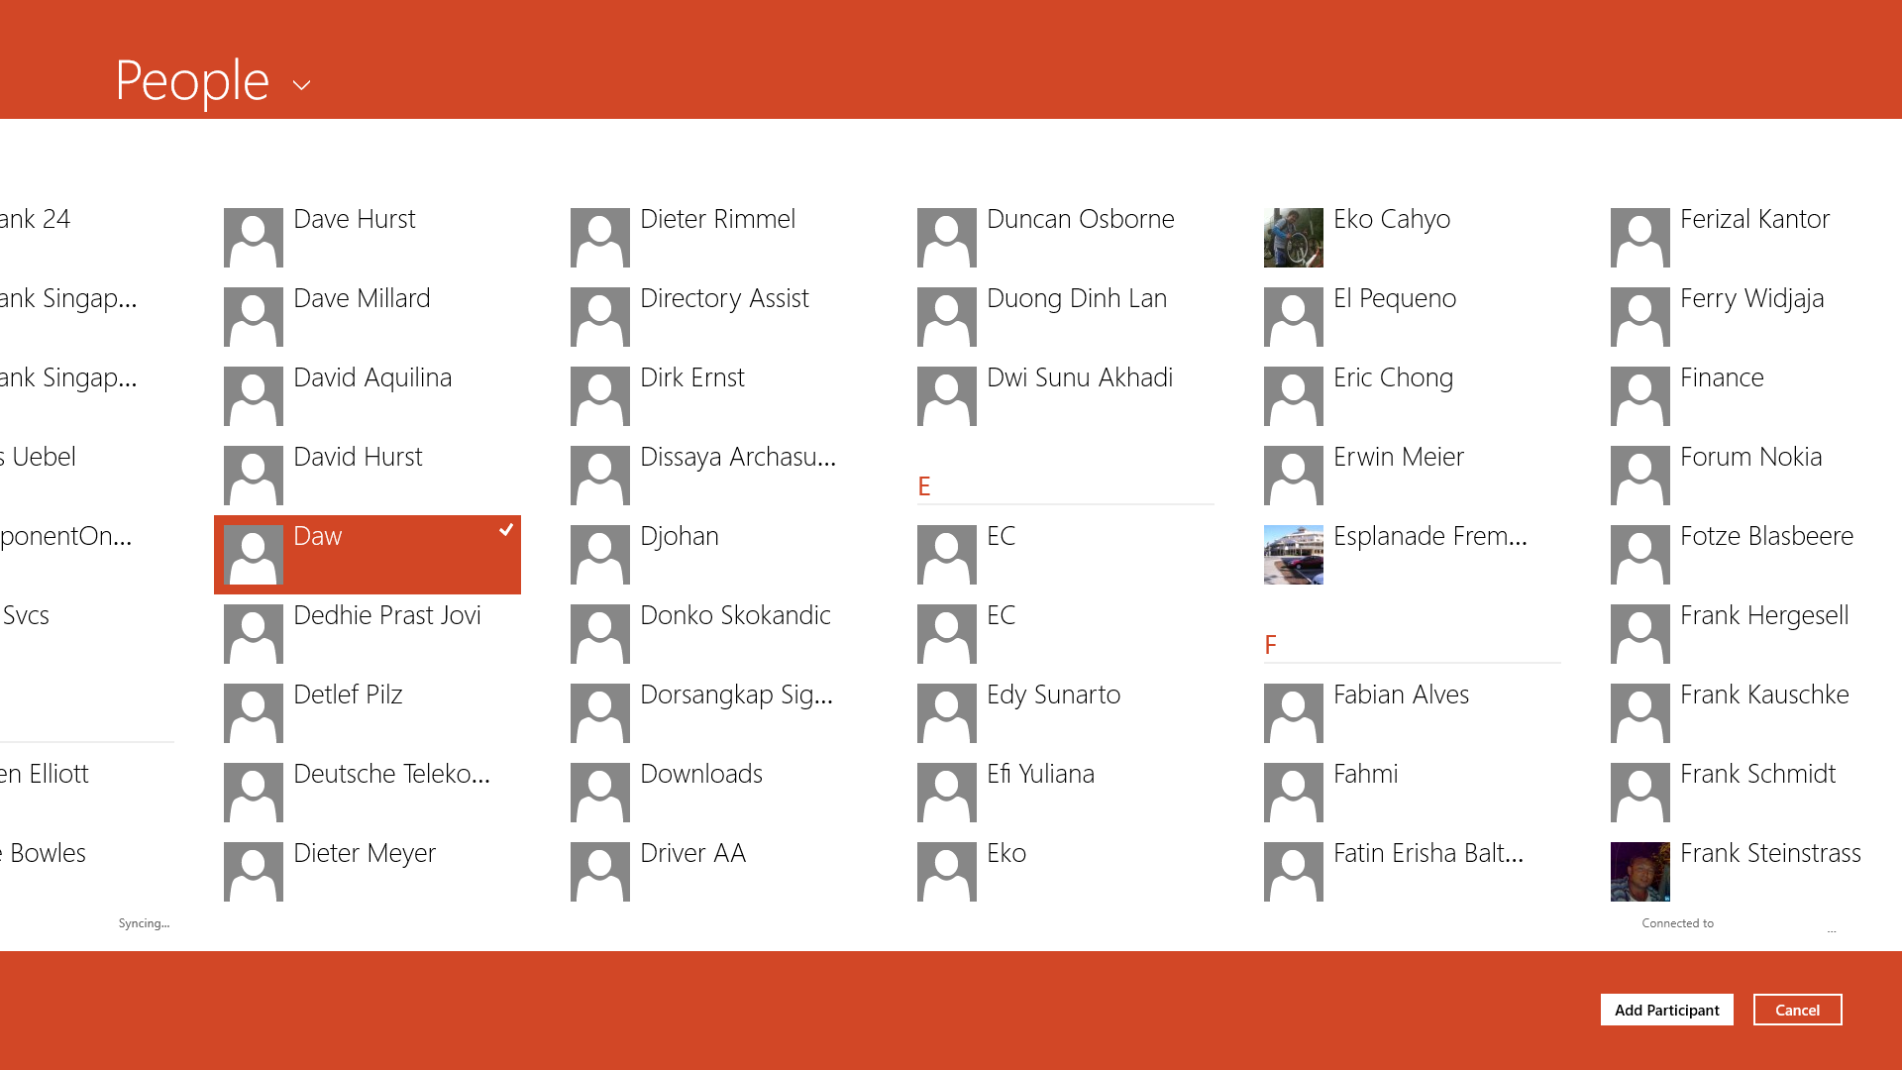
Figure 29: Select the participant from the People’s Hub dialog and click the “Add Participant” – Button.

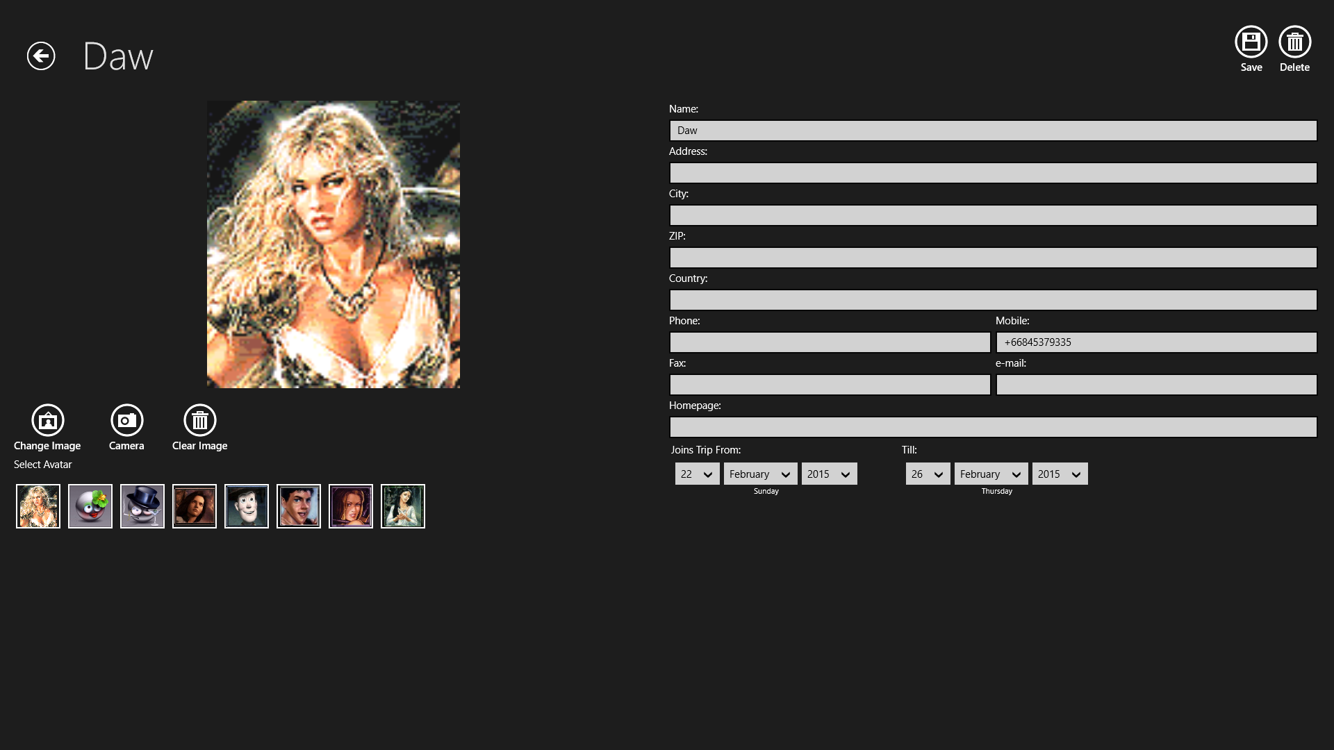
Figure 30: The participant’s page will be opened with all the data retrieved from the people’s hub already entered.

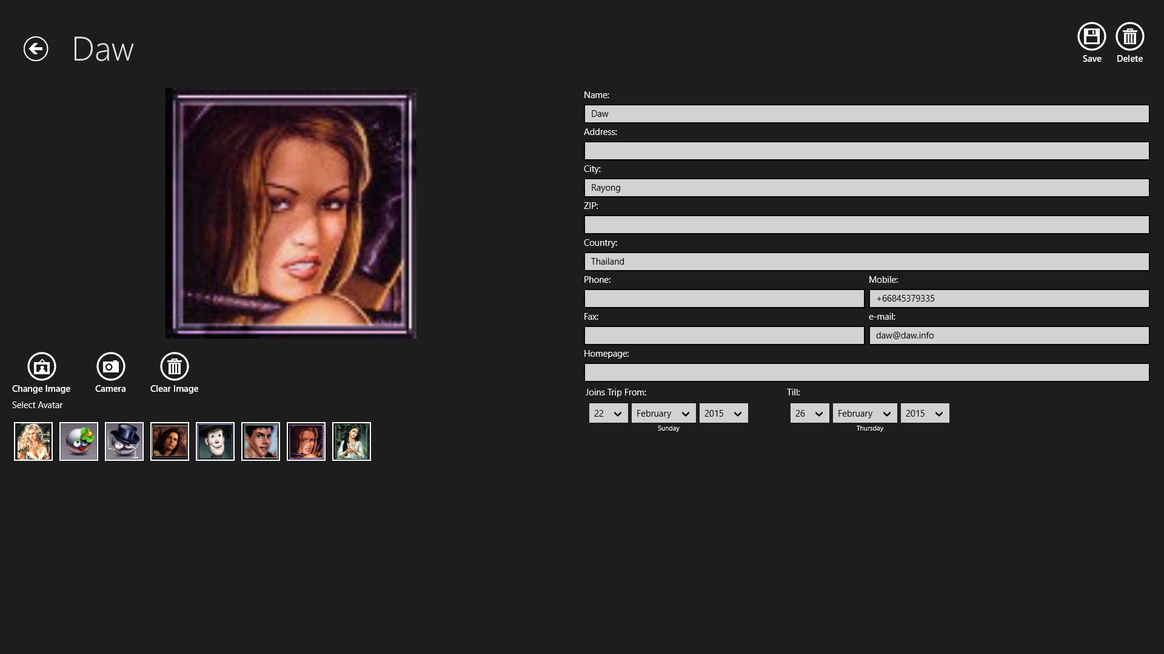
Figure 31: You can edit the participant’s entries, change avatars and picture as in manual entering mode. Click the “Save” – Button to save the participant to your list.

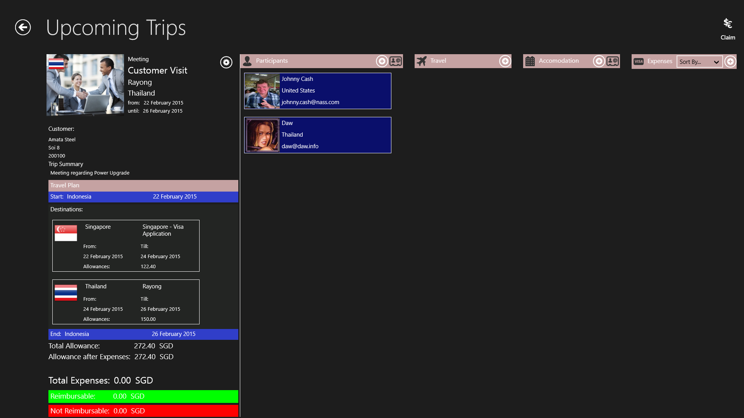
Figure 32: Save Entry from the people’s hub.
Note: Any editing of the participant taken from the people’s hub will only be saved in the Business Trip Manager App and will not affect the original entry in the people’s hub.
Deleting a Participant:
Select the participant to delete from the list. The participant’s page will open. Click the “Delete” – Button in the top right corner of the page.
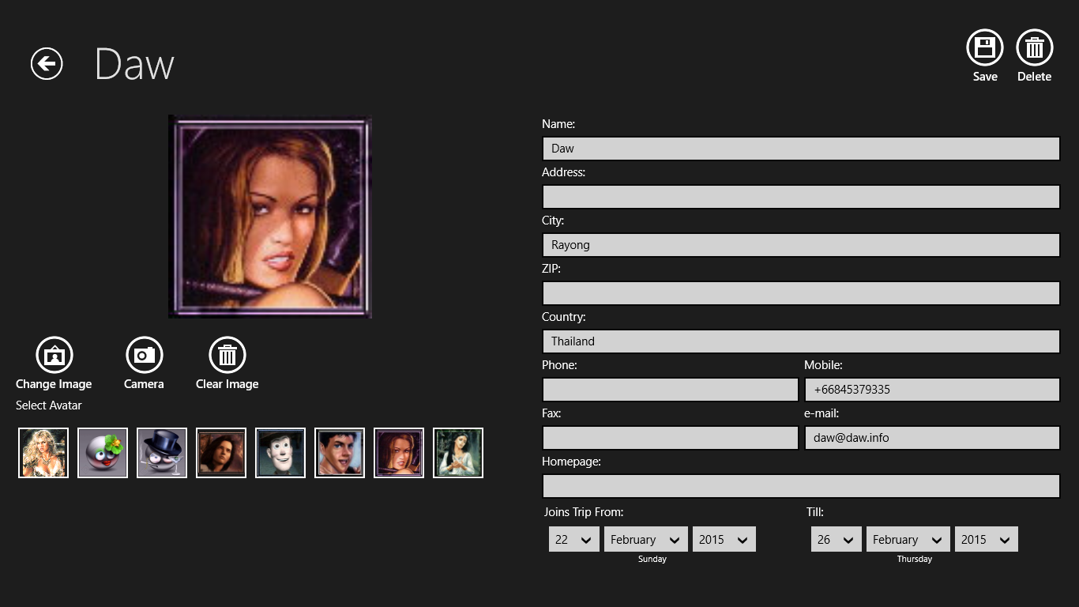
Figure 33: Click the “Delete” – Button in the top right corner of the page.

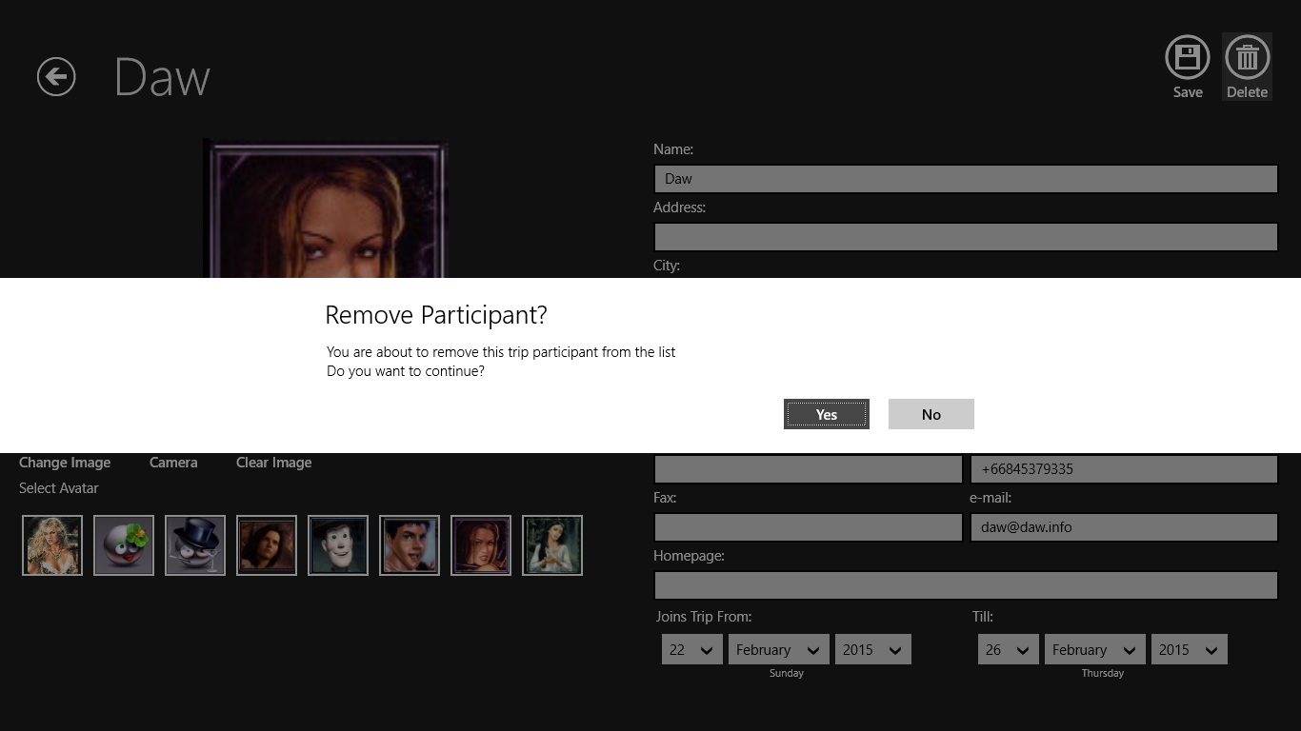
Figure 34: Confirm the delete dialog.
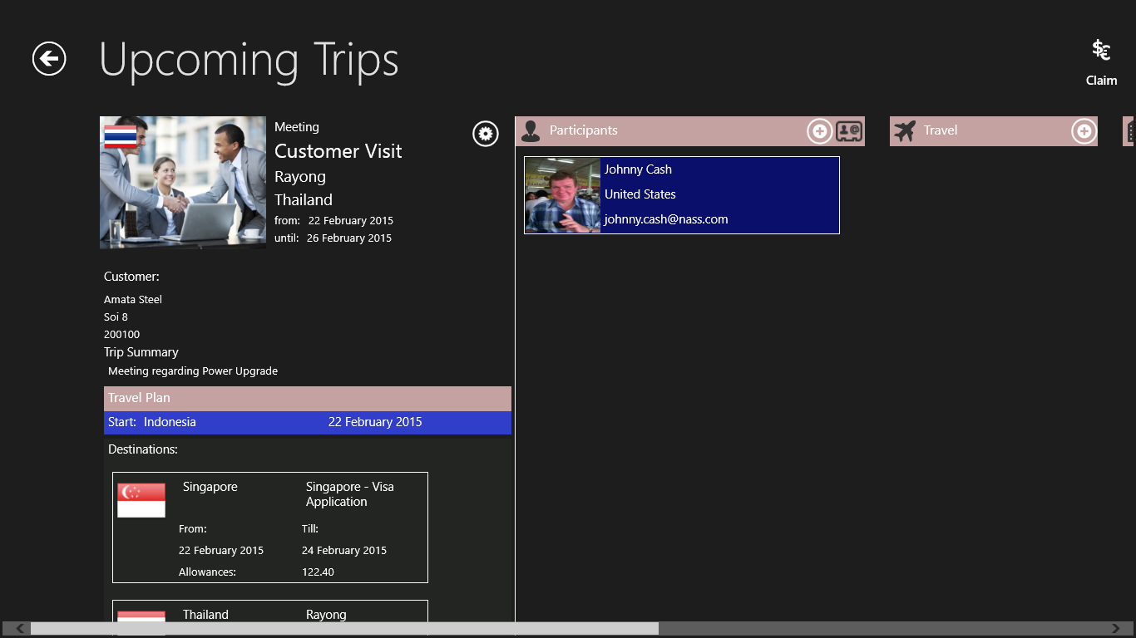
Figure 34: Participant deleted.
☺Hint:
Deleted Participants will only be removed from the actual trip. The will still appear in the list of previous participants. So, if you want to add this participant to your trip again or he joining you on another trip it’s just two clicks and he is “in” again!

Images you select from your computer or take with your Webcam will automatically downscaled in dimension and file size, so they will not occupy much space on your device. You don’t need to edit them manually. So, don’t be afraid to select large, beautiful images for your participants.
3. Add and Edit Travel Data and Create a Driver’s Log
There is no trip without travelling. So, let’s add the travel data to the trip. Travel data are air, train or ship tickets, rental car bookings or even the use of your private car.
Figure 35: Click or tap the “+” – Button on top of the travel list.
The Travel Page will open:
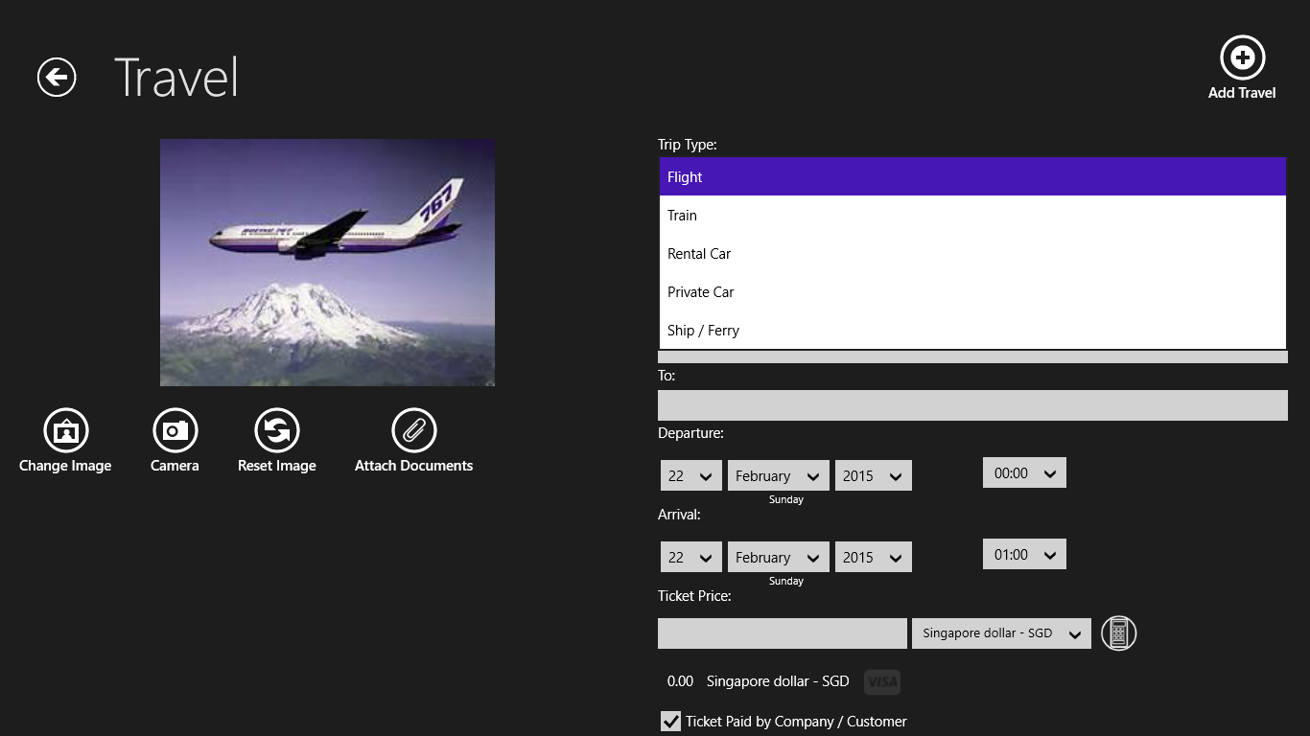
Figure 36: Select from the Dropdown – List the kind of travel you want to add.
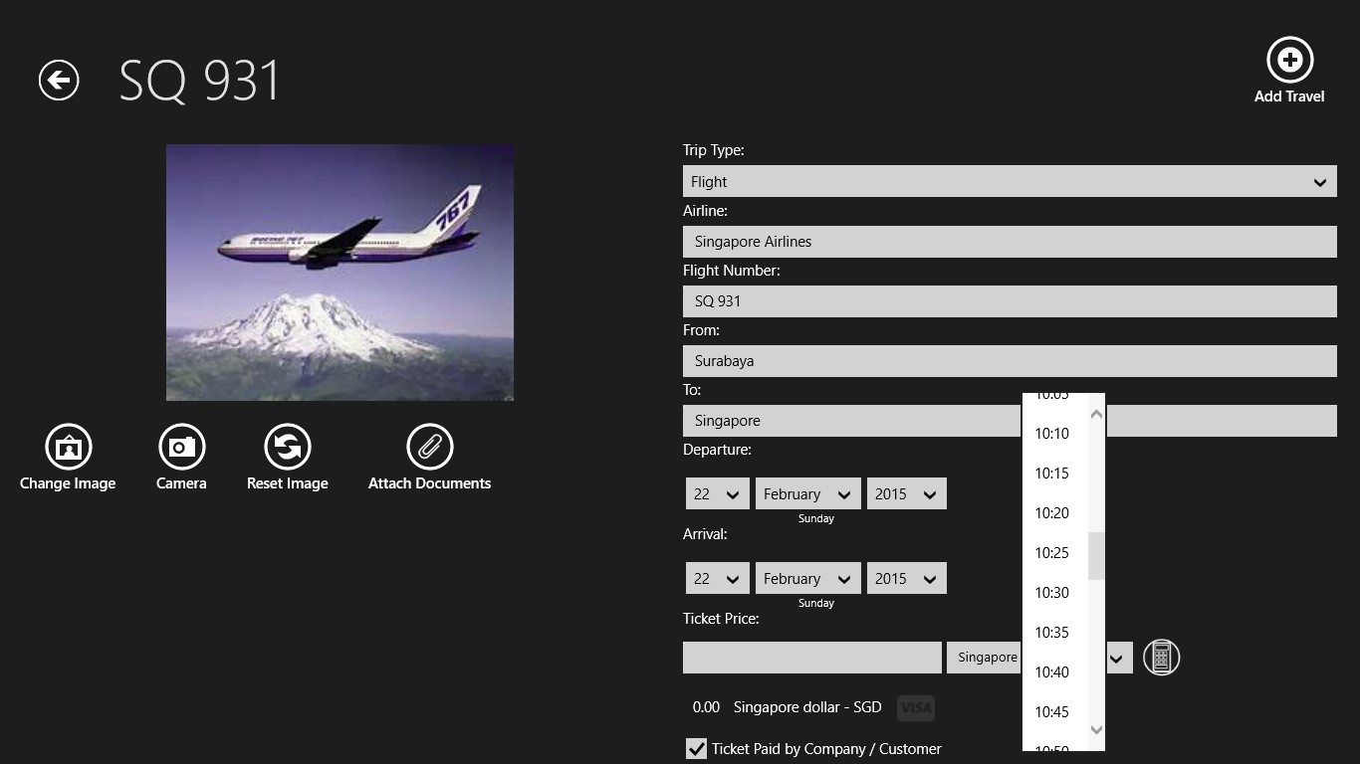
Figure 37: Enter all relevant data.
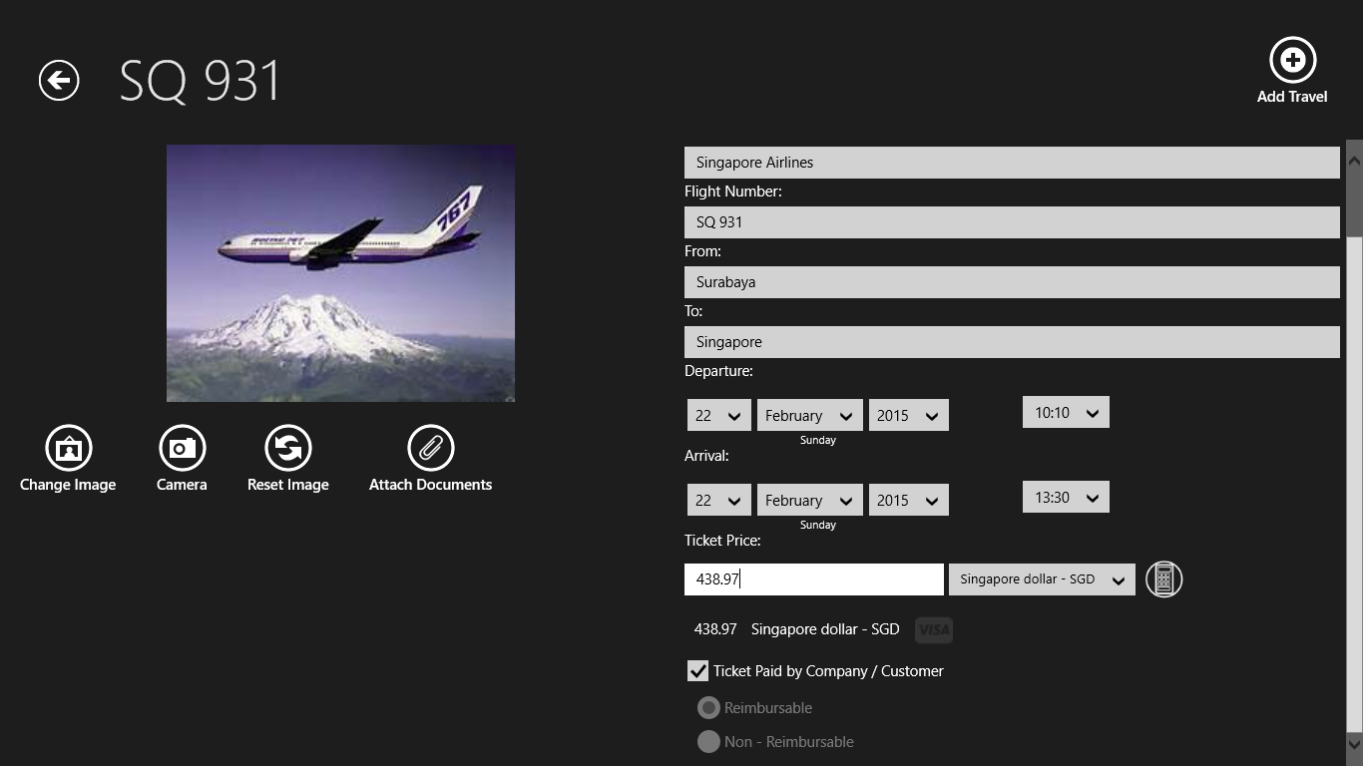
Figure 38: Enter the price for the ticket.
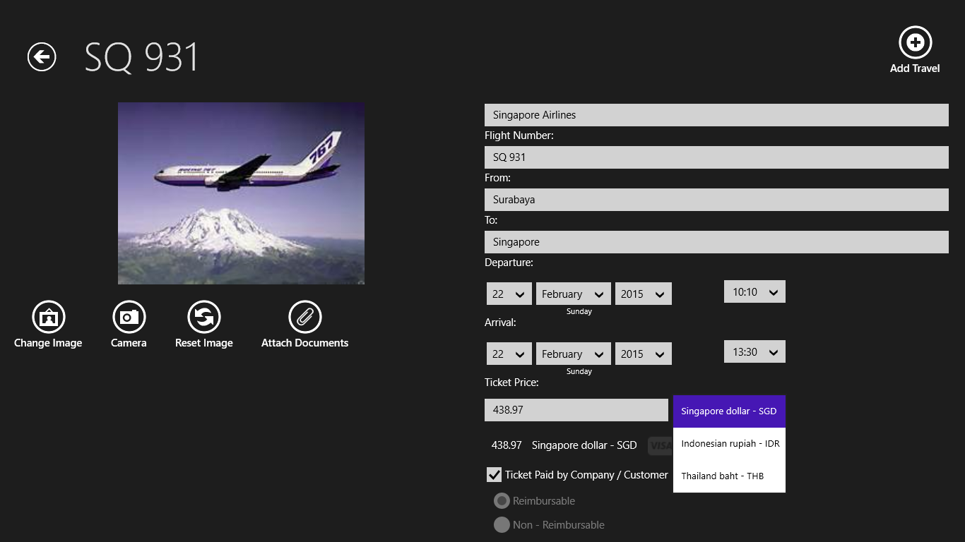
Figure 39: Select the currency of the ticket price click the “Add Travel” – Button and the Travel will be shown in the list.
Note:
All currencies of the destination countries are shown. The ticket price will be converted into your home currency according the exchange rate you have entered.
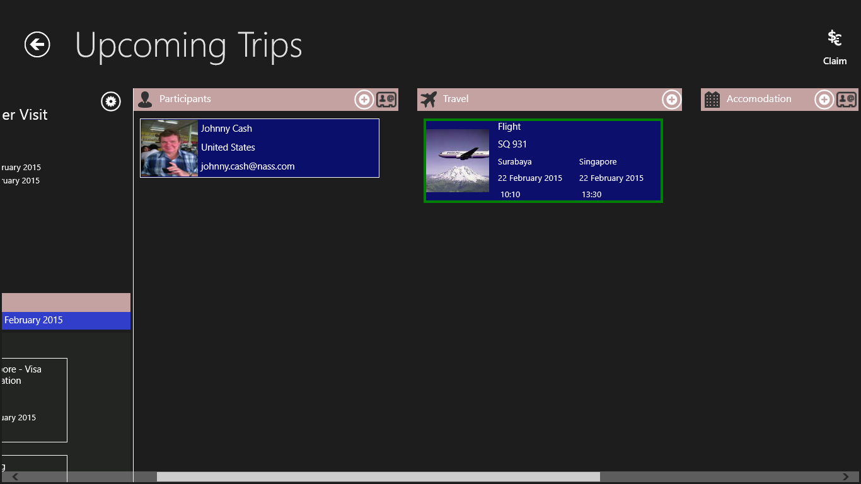
Figure 40: Travel added to the list.
Entering Expenses, Select Currencies and Specifying Reimbursable / Non – Reimbursable Expenses
This chapter is very important. It explains how to enter expenses and how Business Trip Manager calculates the expenses. We use the air ticket just added to the travel as example. For “Accommodation” and “Expenses” the method is the same.
There is a checkbox (except on the “Expenses” – Page) “Ticket Paid by Company/Customer”. If this checkbox is ticked the expense amount will not be shown in the trip overview page and also not calculated in your trip expenses (as shown in Figure 40). You can, however, enter the expense amount just for your record.
When you uncheck the “Ticket Paid by Company/Customer” – Box, you can choose between Reimbursable and Non – Reimbursable. Reimbursable means you will get the expenses paid back by your company or customer.
Let’s make the ticket reimbursable:
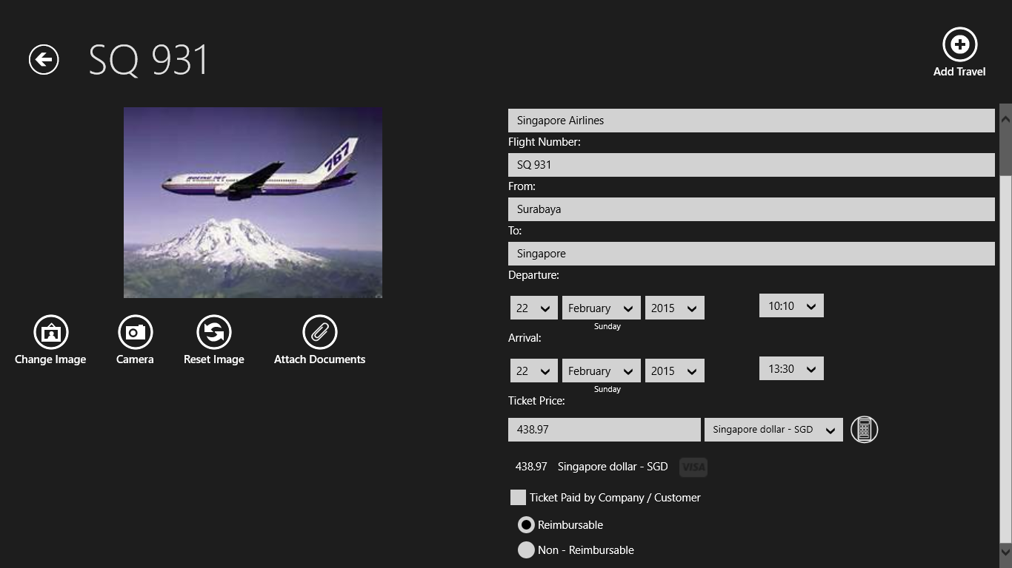
Figure 41: “Ticket Paid by Company/Customer” – Box is unchecked, the “Reimbursable” – Radio Button is selected.
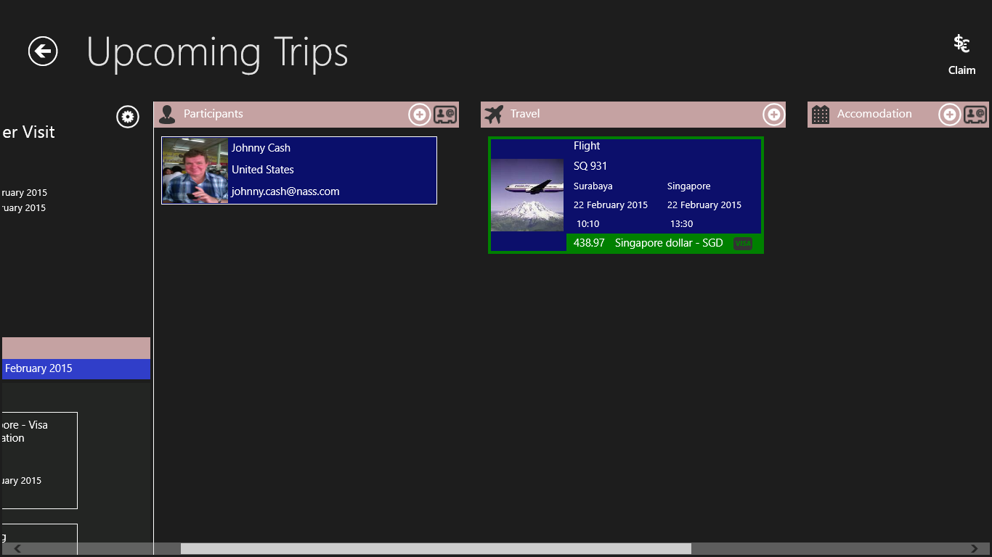
Figure 42: The Expense amount is now shown in a green box. The green box means the amount is reimbursable.
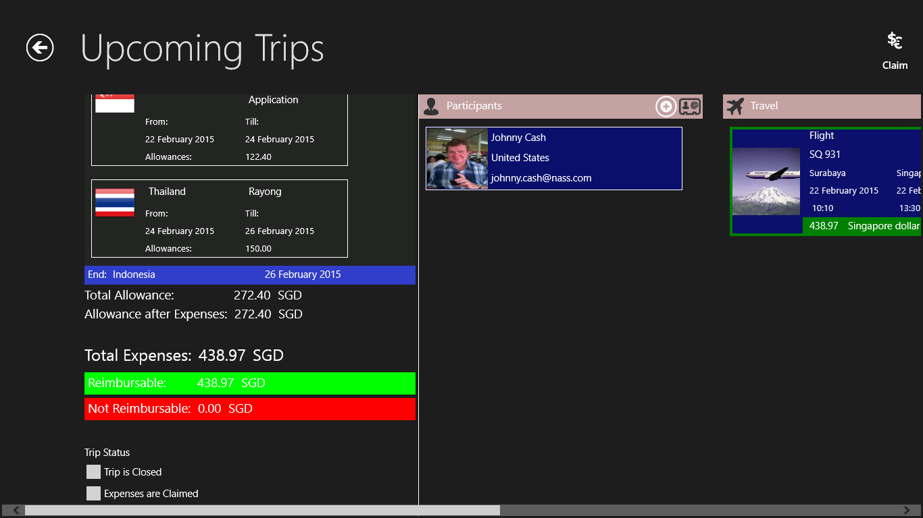
Figure 43: You can also see the total of your reimbursable expenses in the expense section of the trip overview page.
Let’s now make the ticket Non – Reimbursable:
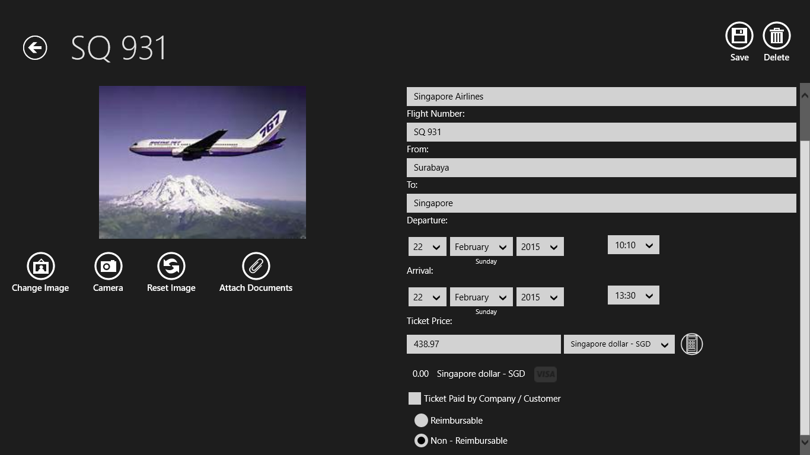
Figure 44: “Ticket Paid by Company/Customer” – Box is unchecked, the “Non - Reimbursable” – Radio Button is selected.
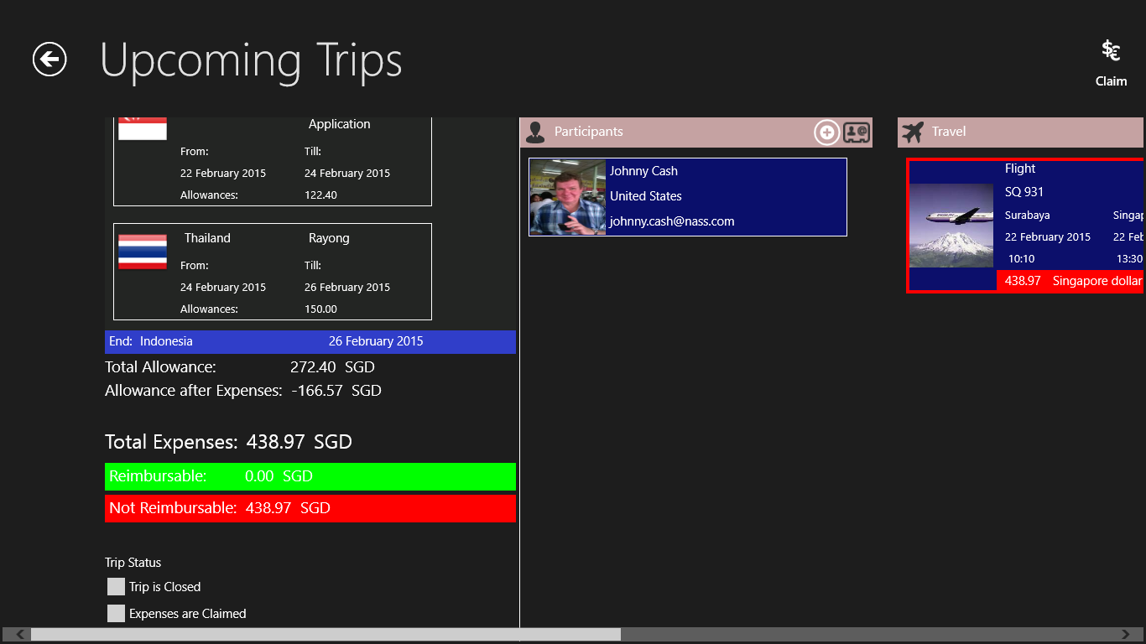
Figure 45: The Expense amount is now shown in a red box. The red box means the amount is non - reimbursable. You can also see the total of your non - reimbursable expenses in the expense section of the trip overview page. The non – reimbursable amount will be automatically deducted from your daily allowance.
Entering expense amounts from a credit card statement:
If you have paid expenses in a foreign currency with your credit card, the amount reflected in the credit card statement might be quite different from the amount Business Trip Manager has calculated from the exchange rate you entered for the country. You can easily overwrite this and enter the amount from your credit card statement:
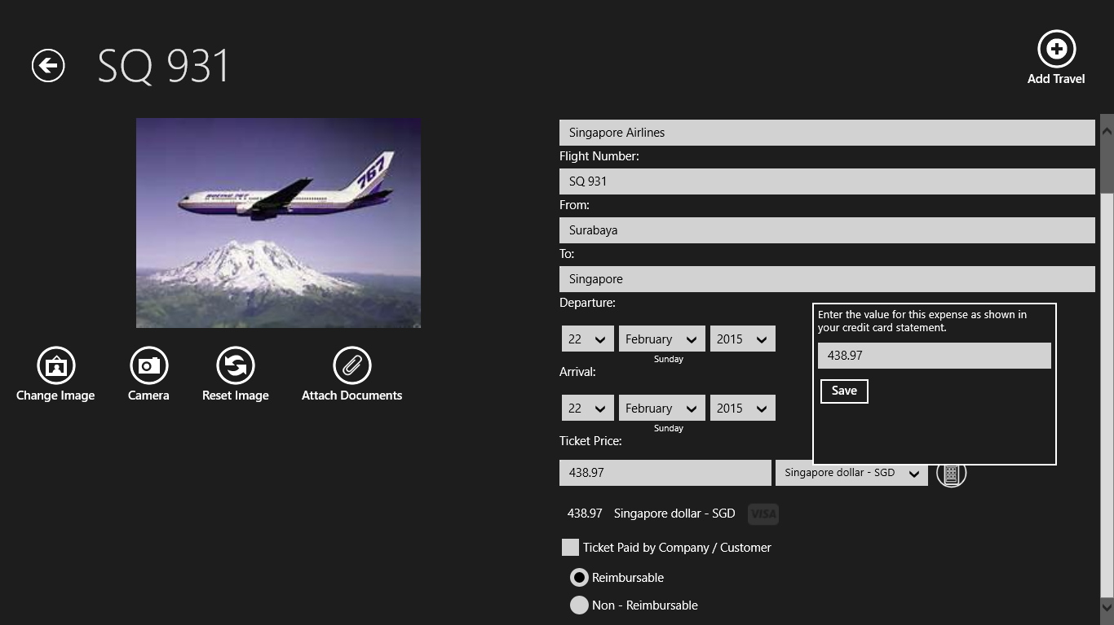
Figure 46: Click the “Visa” – Symbol next to the value calculated by Business Trip Manager. Enter the amount from your credit card statement into the popup and click “Save”.
Figure 47: The “Visa” – Symbol will be also shown in the trip overview list, indicating that this amount was paid by credit card.
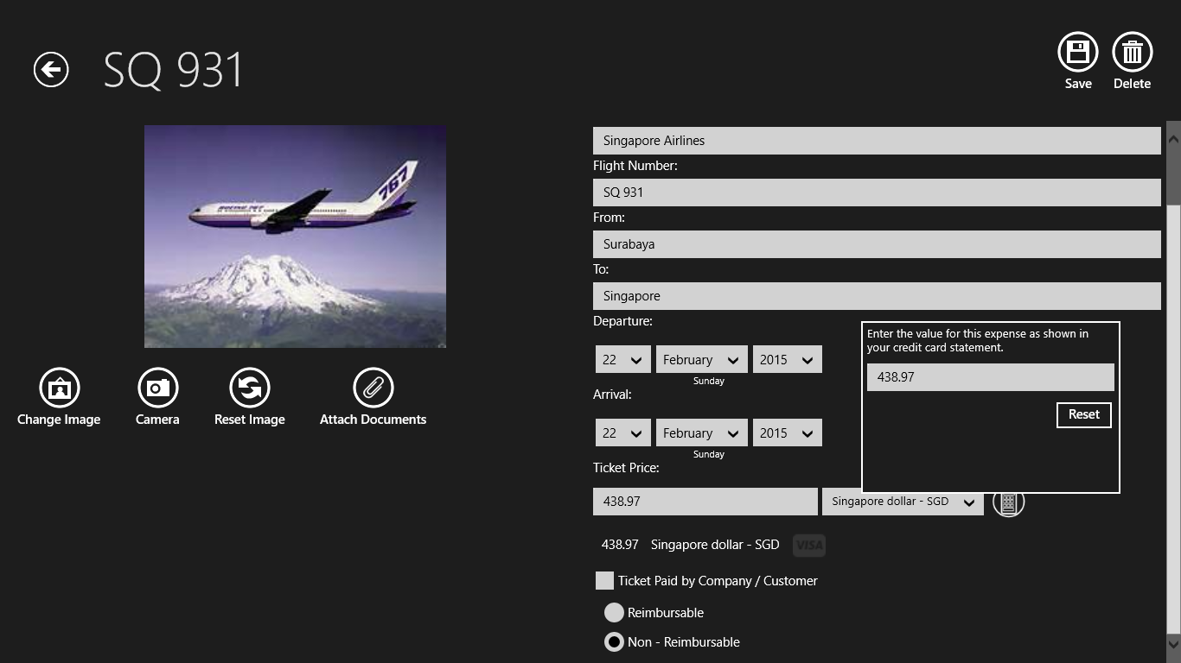
Figure 48: To reset the amount to value calculated by Business Trip Manager, click the “Visa” – Symbol again and click reset in the popup.
The Calculator – Tool:
Business Trip Manager provides a simple calculator for the “Travel”, “Accommodation” and “Expense” Pages. So, there is no need to use an external calculator.
The calculator result will be inserted into the “Price” – Field.
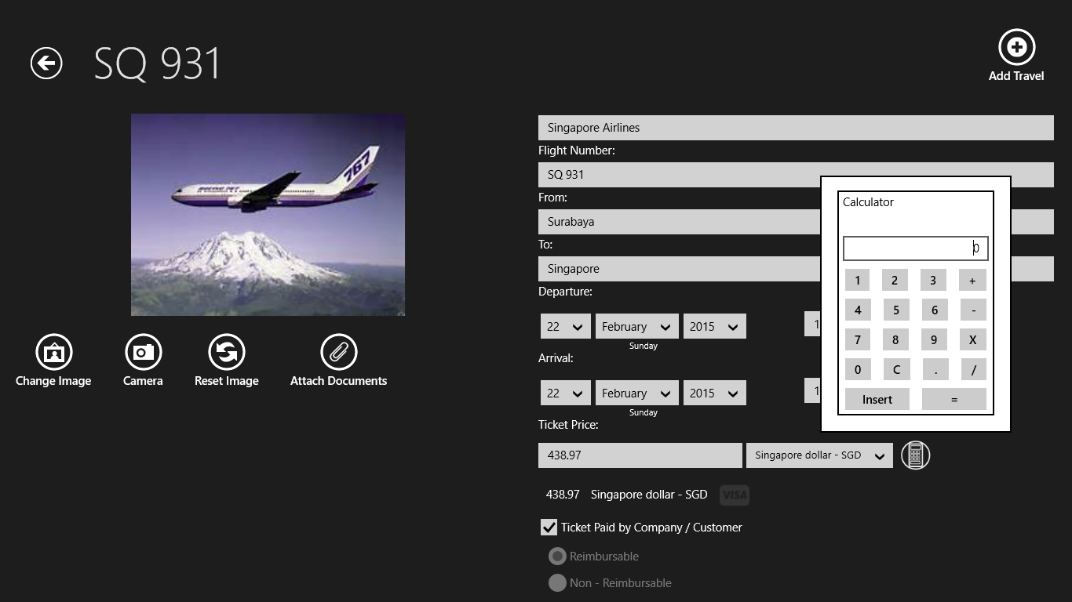
Figure 49: To open the calculator, click the “Calculator” – Button. Click “Insert” on the calculator to insert the result into the “Price” – Field.
Personalizing the Travel Data and Adding Receipts:
1 2 3 4
Figure 50: Buttons to personalize your travel data and attach receipts. See explanations below:
- “Change Image”: Select a file from your computer to be shown instead of the default image. For flights, i.e. this could be the boarding pass.
- “Camera”: Replace the default image with a picture taken with the Webcam of your device.
- “Reset Image”: Reset the image to its default.
- “Attach Documents”: Attach the documents related to this travel, like e – tickets, rental car bookings or bills, etc. You can attach documents of all common file formats (see Figures 51 – 53).
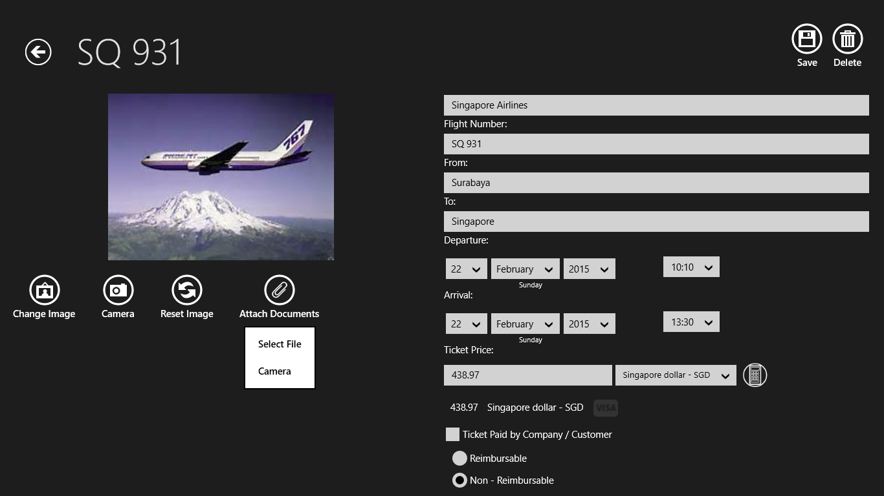
Figure 51: To attach a document you can also choose between selecting a file from your device or taking a shot with your Webcam.

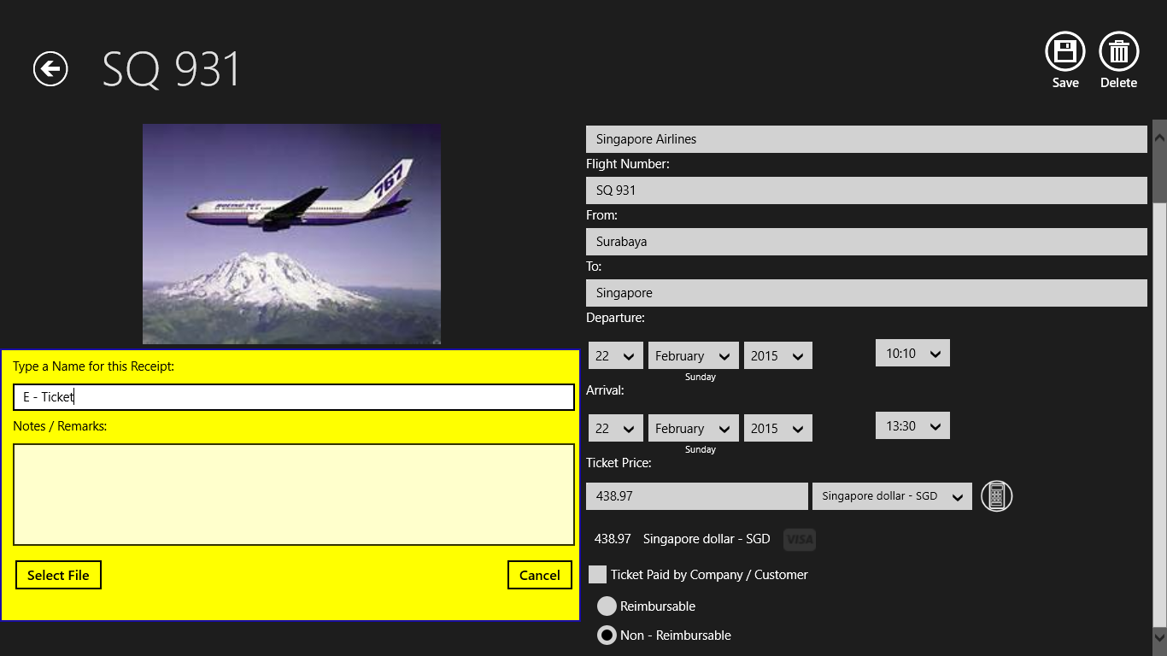
Figure 52: Type a name for the document to attach. Optionally, you can add notes to easier identify the attachment.

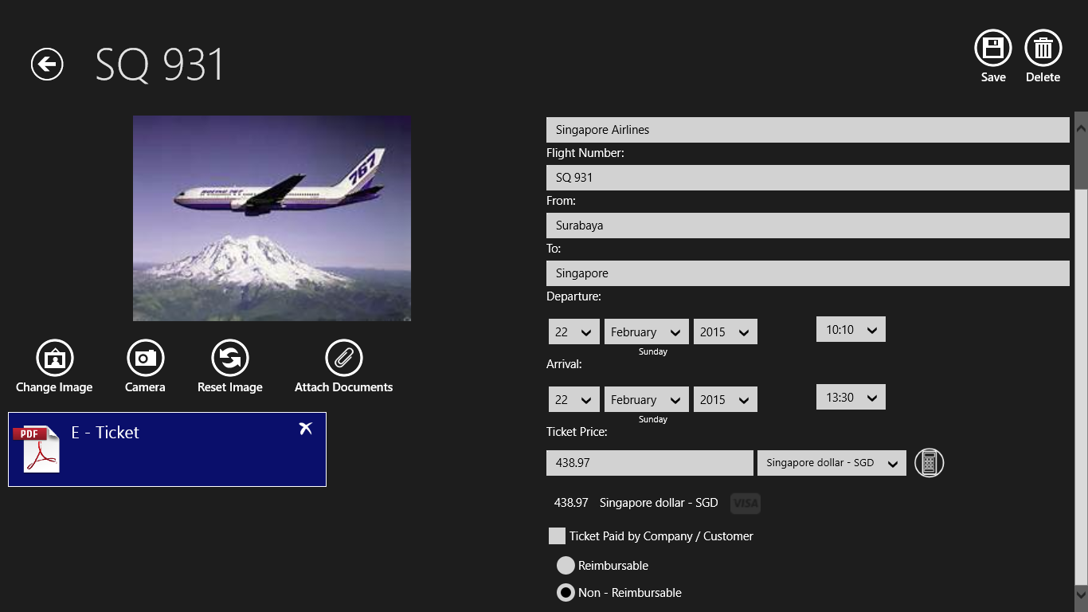
Figure 53: Attachment will be shown in the attachment list. To delete the attachment, click the delete – button in the upper right corner of the attachment.
Note:
Business Trip Manager will save a copy of the attachment in your Business Trip Folder. So, even if you delete the original file, on purpose or not Business Trip Manager will still have a copy!
Deleting the attachment will also delete the copy of the file.
☺Hint:
If you ever have entered travel data on previous trips a list with previous travel data will be shown when you want to add a new travel. This is a convenient way to add travel you do frequently without doing all the typing again.

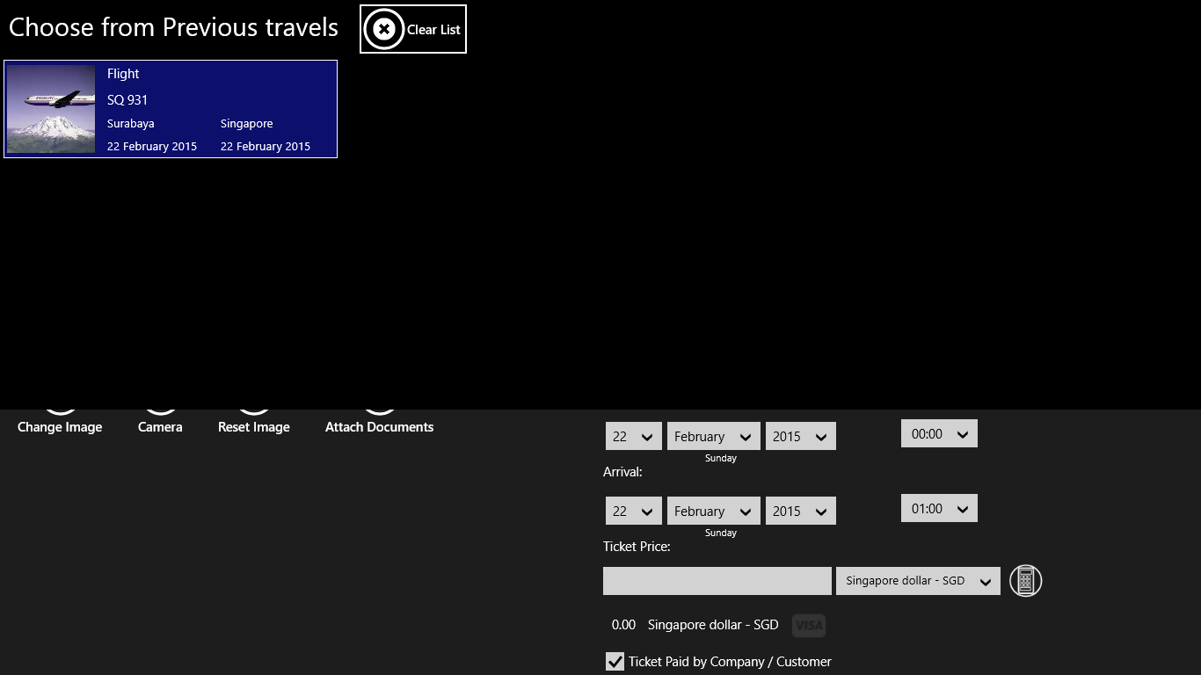

Figure 54: Previous Travels shown.
Create a Driver’s Log:
The law of some countries or the regulations of some companies require you to maintain a Driver’s Log when using a rental or private car on company expenses or when the expenses are reimbursed by the company.
Business Trip Manger provides an easy and convenient way to create and maintain such a Driver’s Log. The Log can be printed and attached to the claim.
Repeat the above described steps to create a new travel. You need to select “Rental Car” or “Private Car” in order to create a Driver’s Log.
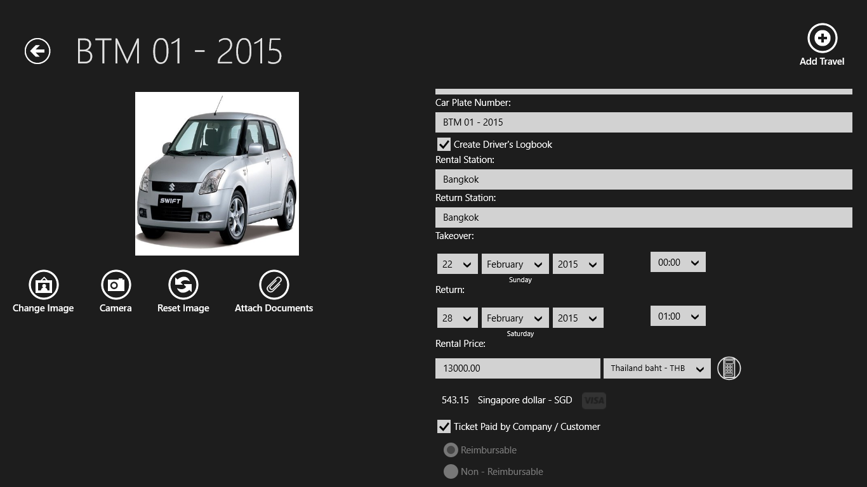
Figure 55: Enter the necessary data and thick the “Create Driver’s Log” – Checkbox.

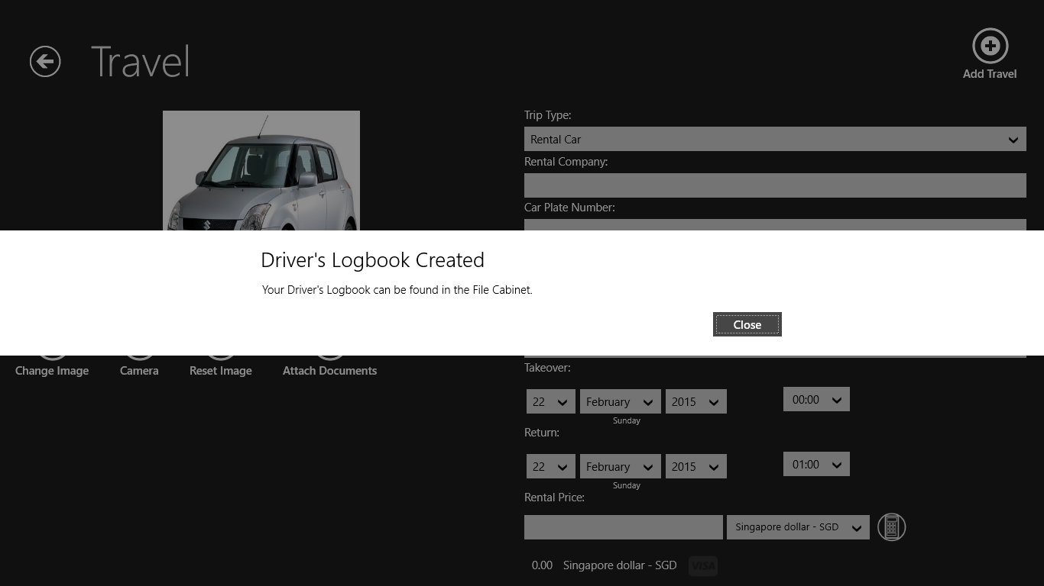
Figure 56: The Driver’s Log will be created and can be found in the “File Cabinet”.

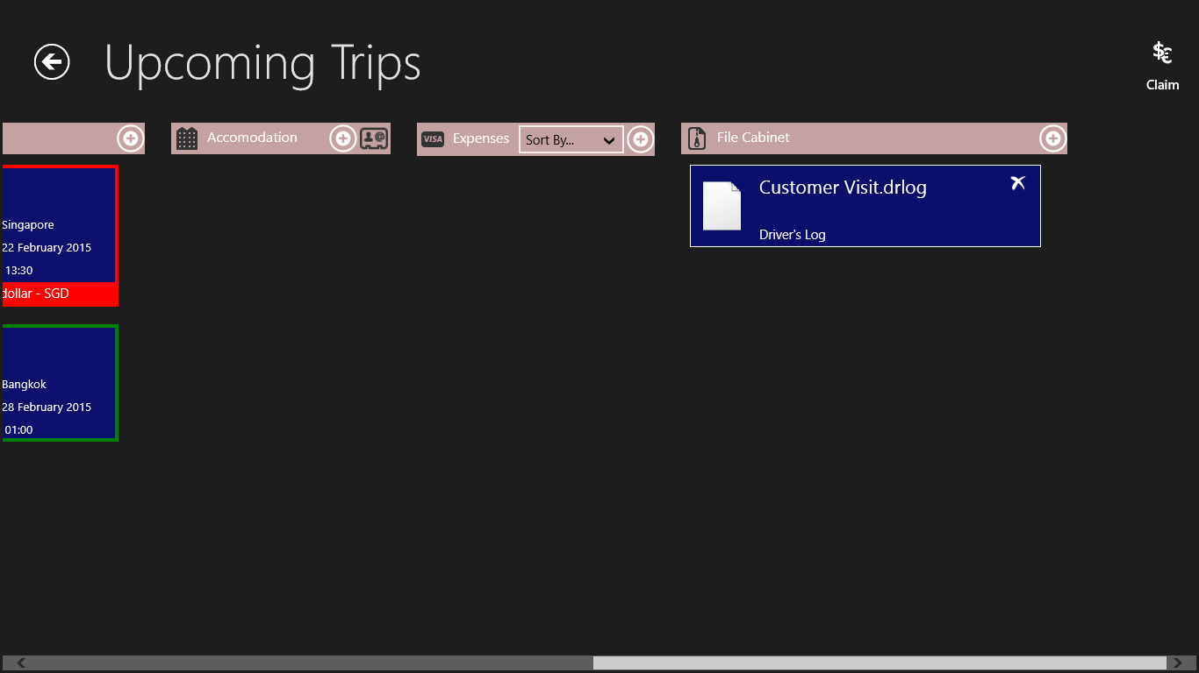
Figure 57: Driver’s Log in the “File Cabinet”. Click or tap the Log to open it.

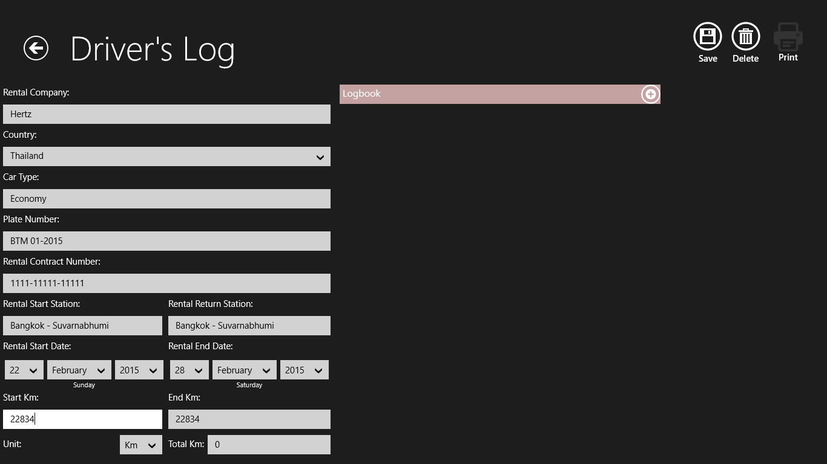
Figure 58: Enter the necessary data on the left side of the Driver’s log. Note: The End and Total km will be updated automatically as you add trips.
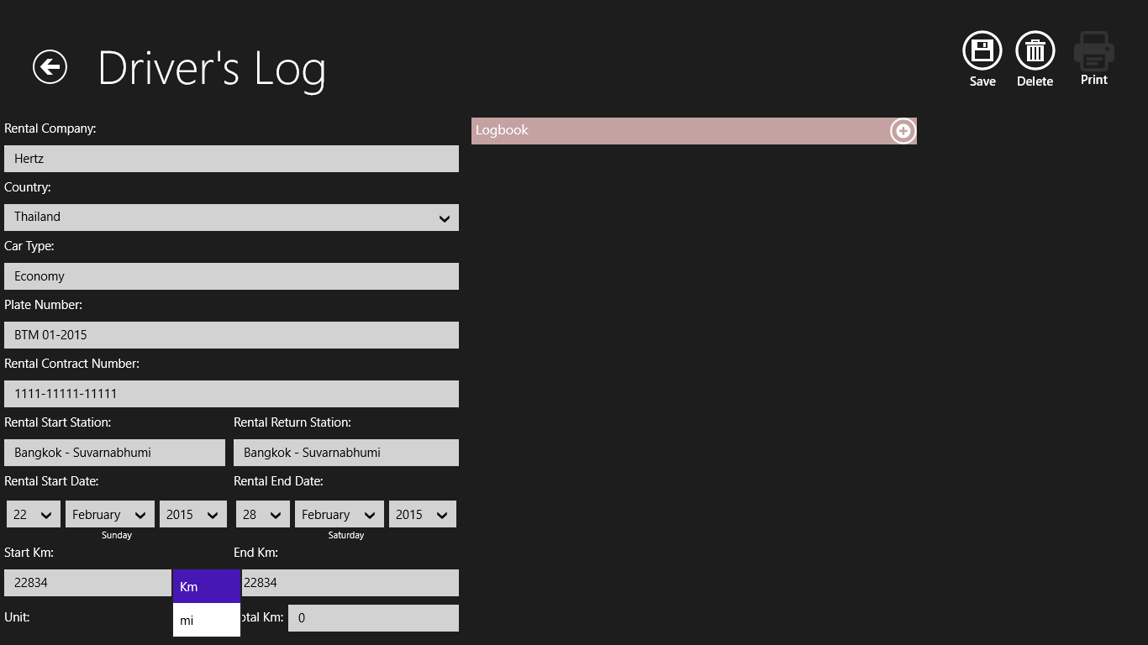
Figure 59: Select the preferred unit for your Driver’s Log, Miles or Kilometer. Click the “+” – Button on the “Logbook” –Column to add a trip.

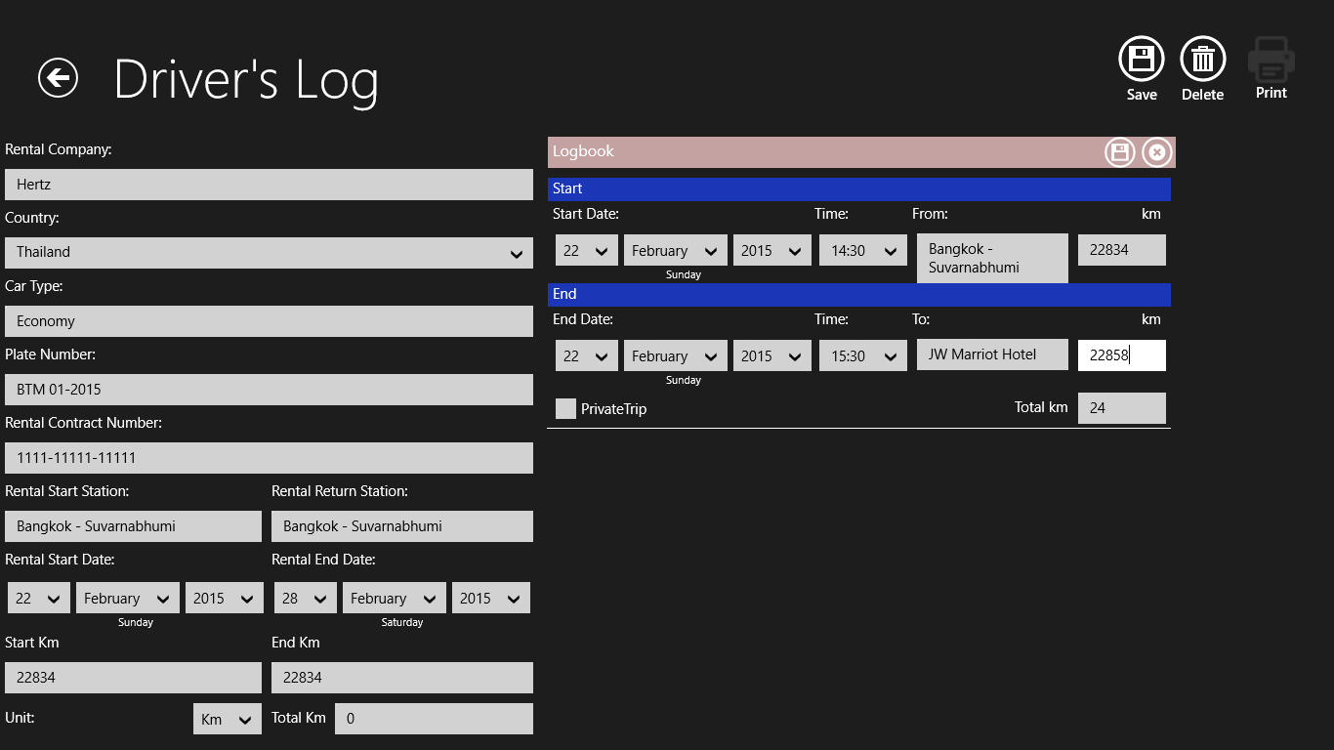
Figure 60: Enter the trip data and click the “Save” – Button on the “Logbook” – Column. Thick the “Private Trip” – Checkbox if necessary. Note: The Total Km will be calculated automatically.
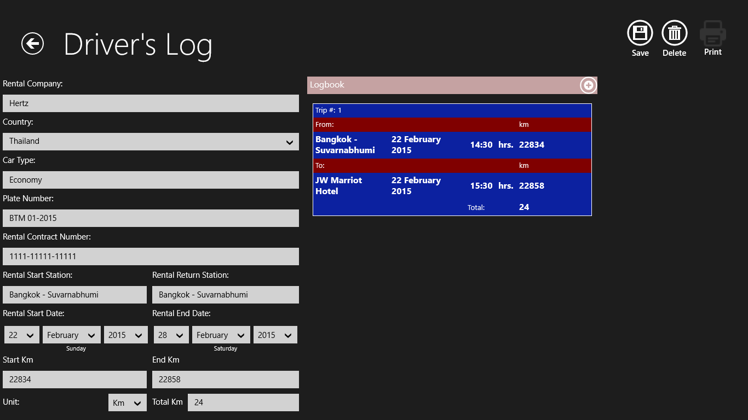
Figure 61: Trip is added to the trip list. The End km and Total Km are updated automatically. Click the “Save” – Button to save the changes of the Log.
☺Hint:
All destinations you enter into the Driver’s Log will be saved and you can select them later from a dropdown list. This is a convenient way to select frequent destinations without doing all the typing again. All saved destinations will be available also in all future Driver’s logs you create.

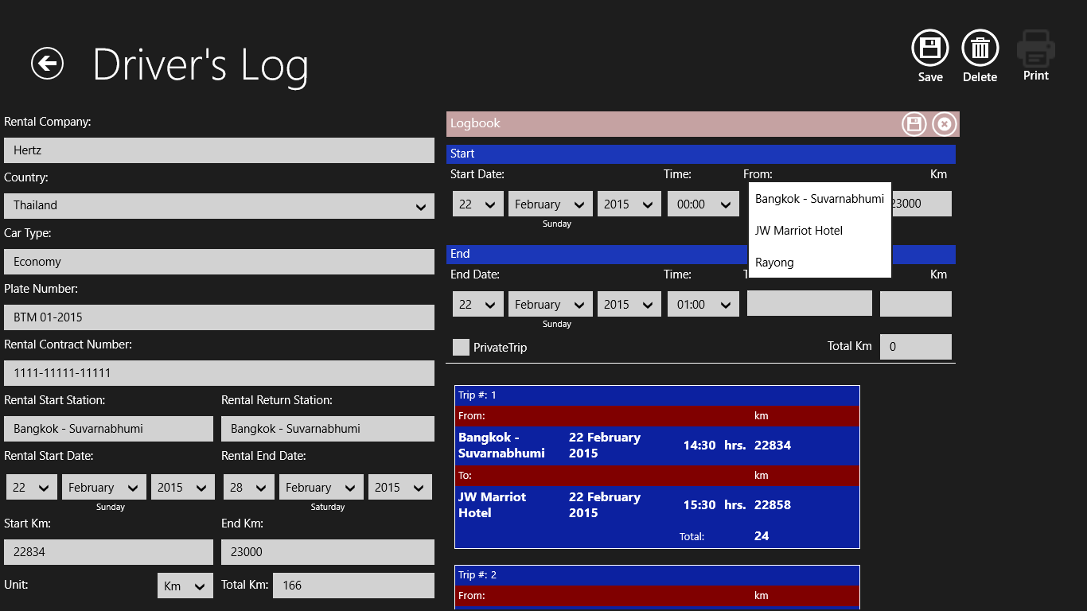
Figure 62: Dropdown list of frequent trip destinations.
Figure 63: To Print the Driver’s Log click on the “Print” – Button.

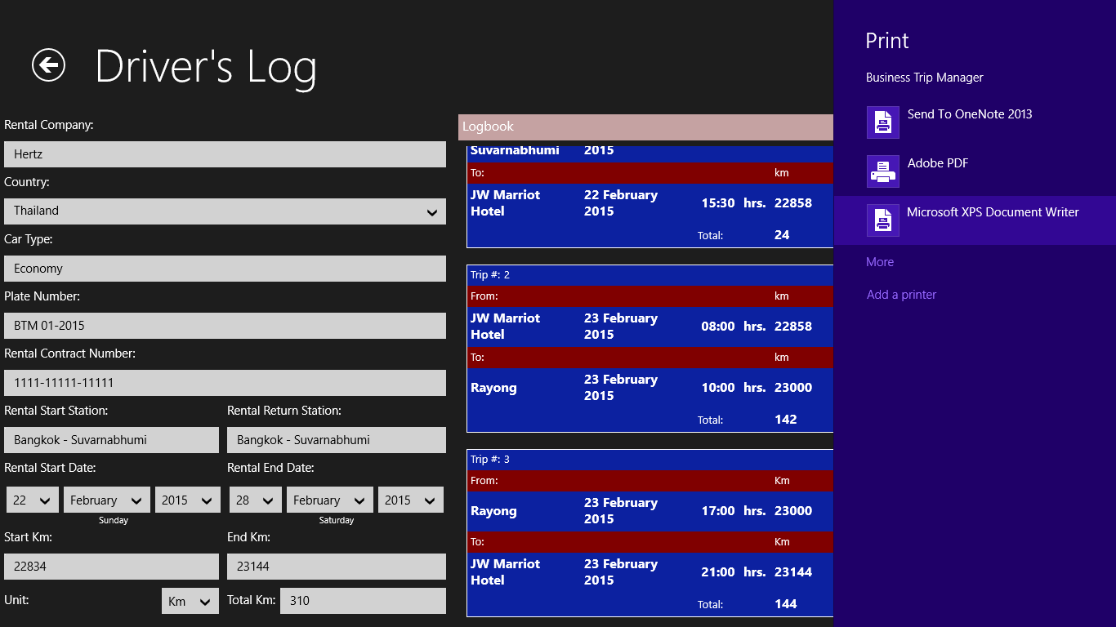
Figure 64: The Print Charm will open and show you all installed printers. Select the printer you want to use.
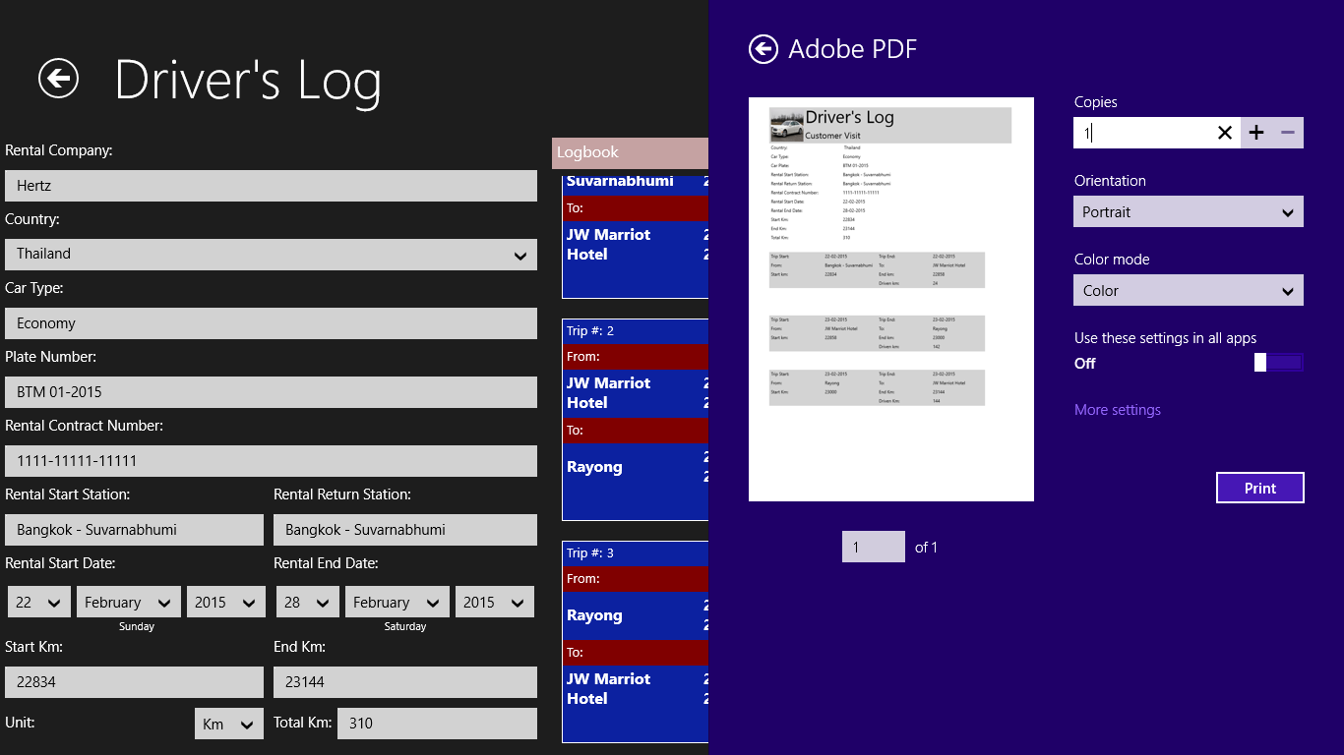
Figure 65: Check / adjust the printer settings and click the “Print” – Button in the Charm.

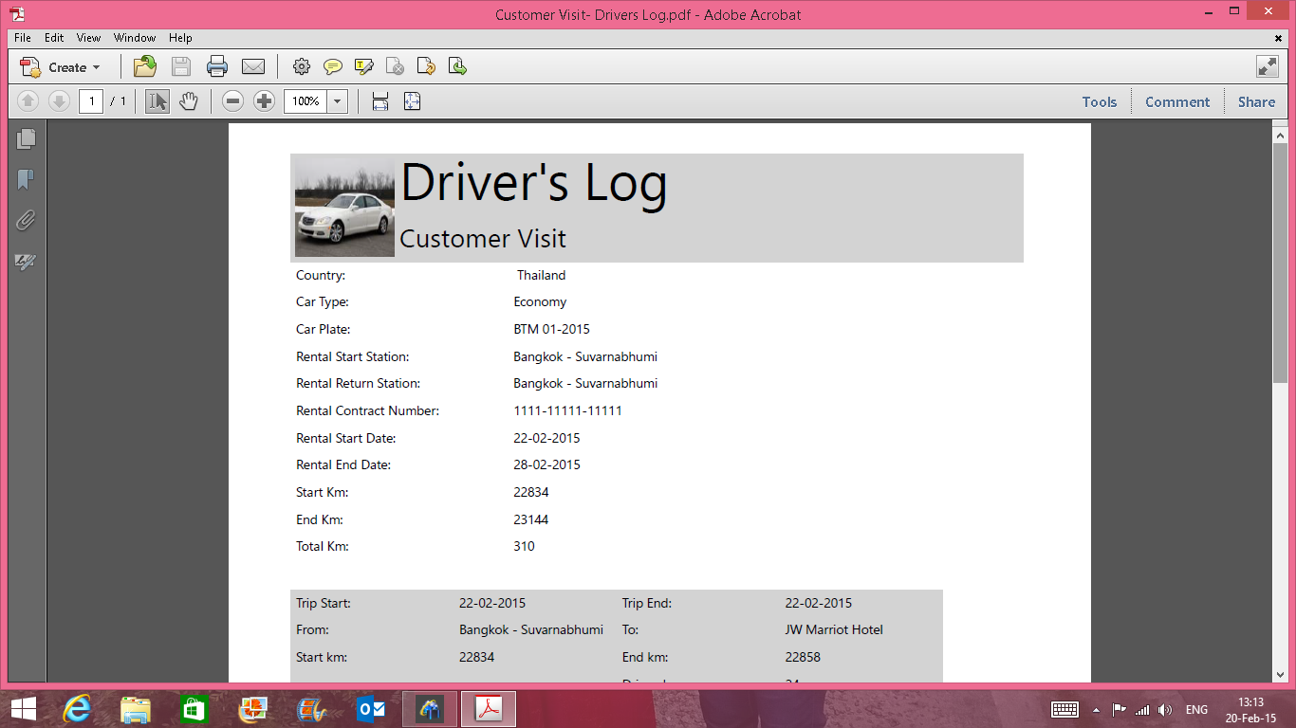
Figure 66: The printed Driver’s Log!
Note:
Please do not call the print function directly from the charm. This will not work and you will get an error message.
Deleting of a Driver’s Log:
There are three ways of deleting a Driver’s Log:
- From the Travel – Page: Just uncheck the “Create Driver’s Log” – Checkbox. This will delete the Driver’s Log and Remove it from the “File Cabinet”.
- From the “File Cabinet”: Click the “Delete” – Button in the upper right corner of the Log. This will delete the Driver’s Log and remove it from the “File Cabinet”. The “Create Driver’s Log” – Checkbox will be unchecked the next time you open the Travel Page.
- From the Log itself: Click the “Delete” – Button on the Driver’s Log Page. This will delete the Driver’s Log and remove it from the “File Cabinet”. The “Create Driver’s Log” – Checkbox will be unchecked the next time you open the Travel Page.

4. Add and Edit Accommodation Data
The principle for adding and editing accommodation data is the same as for adding participants or travel. Here you also can create a new accommodation manually or choose one from your people’s hub.
Entering accommodation prices and declaring them reimbursable or non – reimbursable is the same as described under travel. Please read this section for more information.
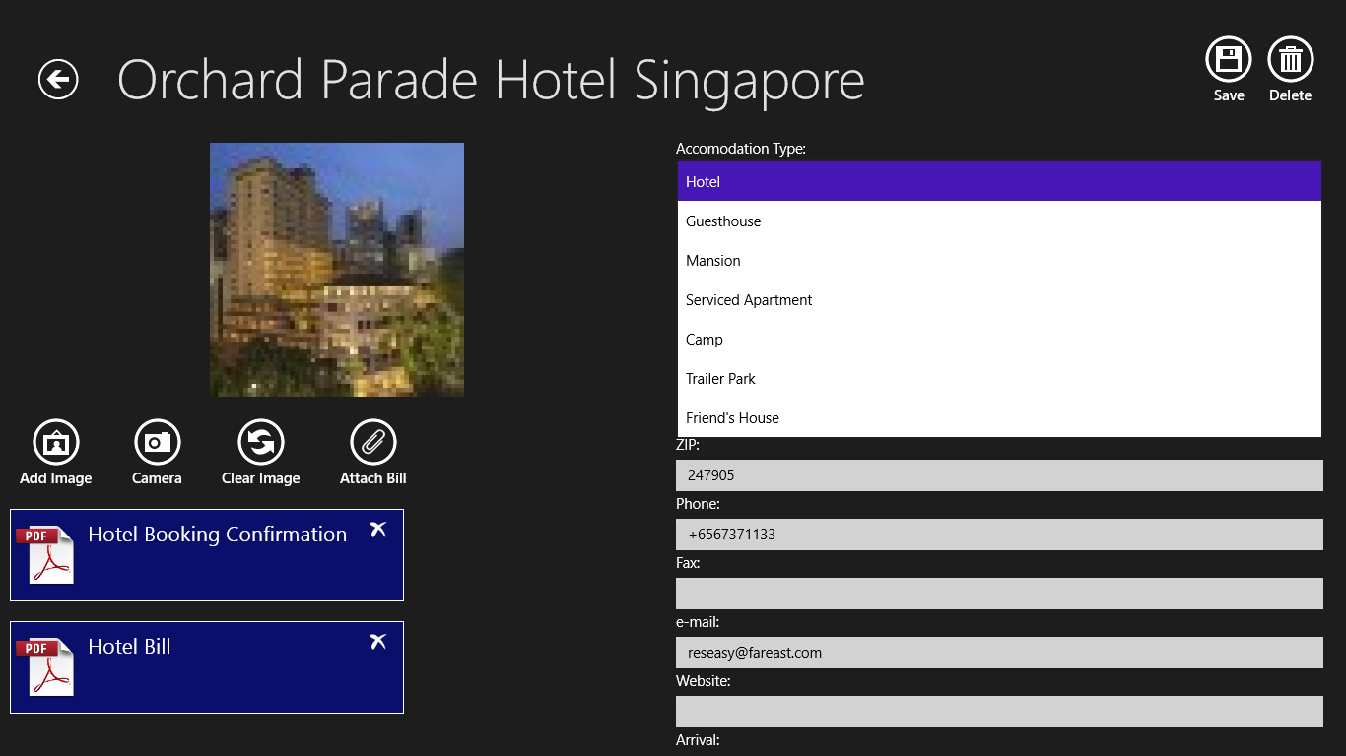
Figure 67: You can choose from different accommodation types.
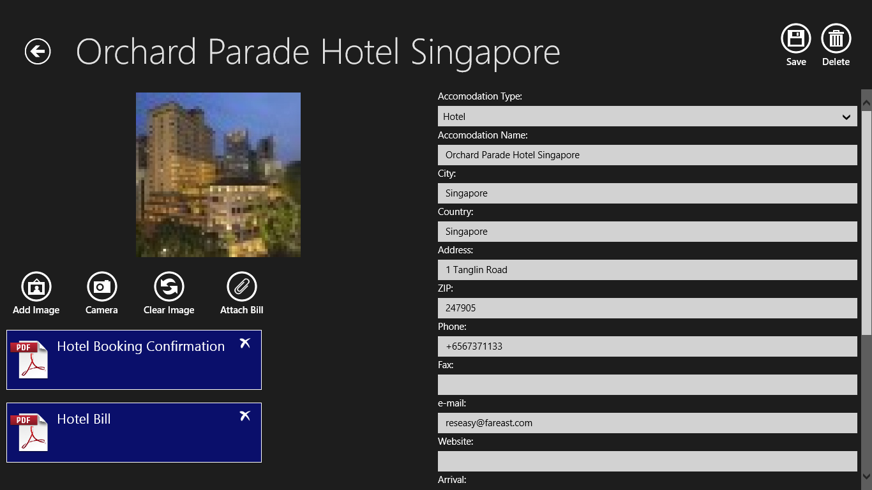
Figure 68: Completed Accommodation entry with Booking Confirmation and Hotel Bill attached.
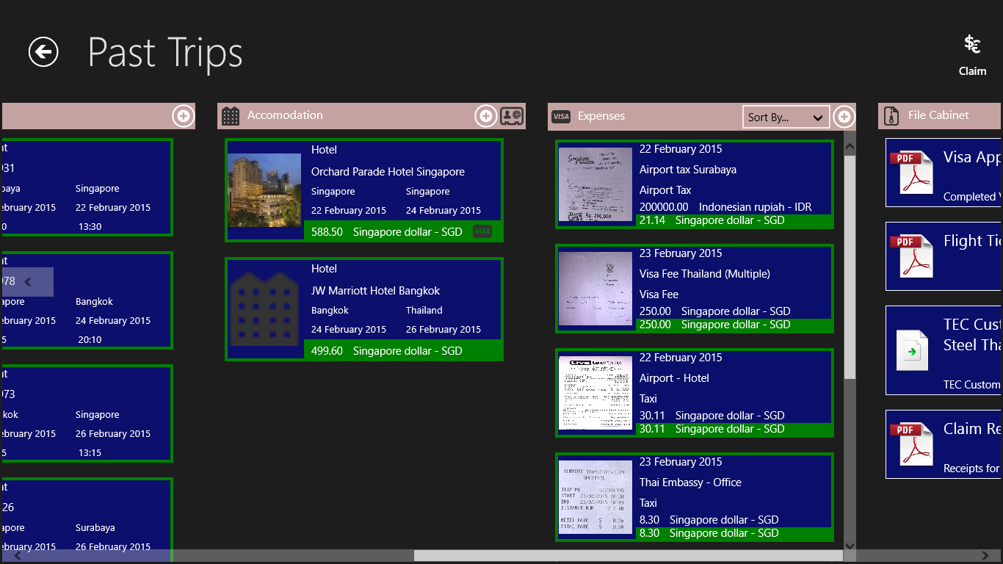
Figure 69: Accommodation added to the accommodation list.
☺Hint:
If you ever have entered accommodation data on previous trips a list with previous accommodation data will be shown when you want to add a new accommodation. This is a convenient way to add accommodation you frequently use without doing all the typing again.

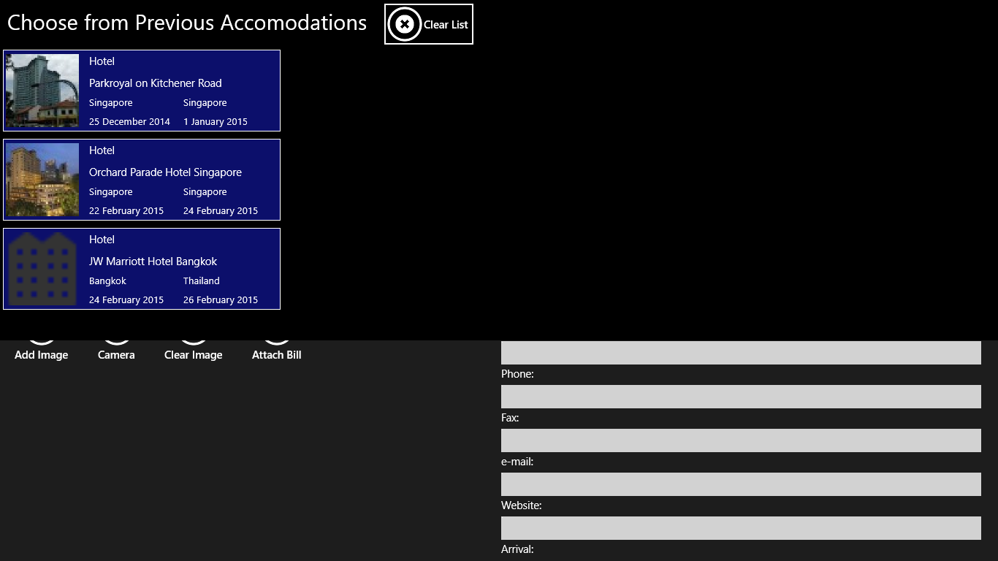
Figure 70: List of previous accommodation.

5. Add and Edit Expenses
The principle for adding and editing expenses is the same as for adding participants or travel. Entering expenses and declaring them reimbursable or non – reimbursable is the same as described under travel. Please read this section for more information.
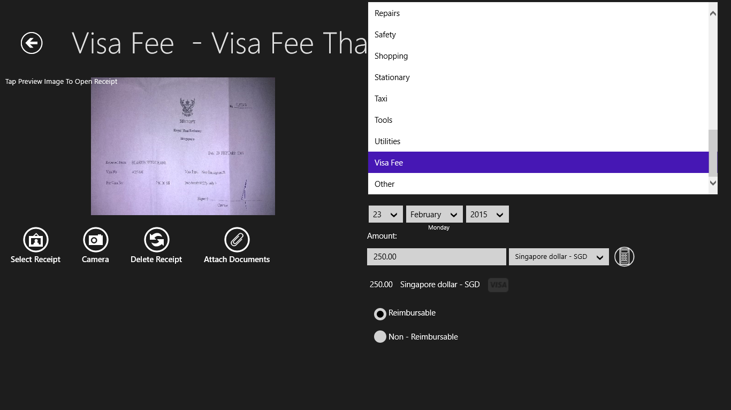
Figure 71: You can choose from different expense types.
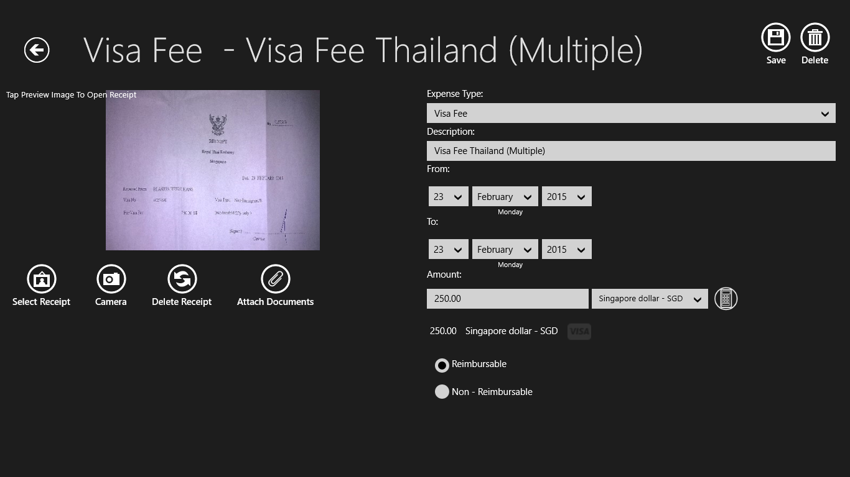
Figure 72: Completed expense entry.
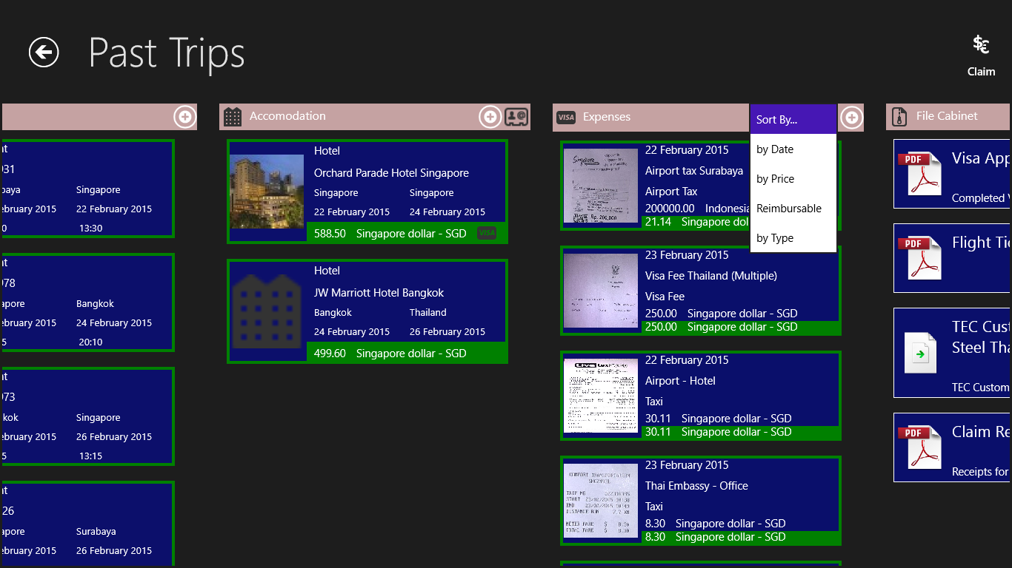
Figure 73: You can sort your expense list by Date, Price, Type and whether it is reimbursable or not.
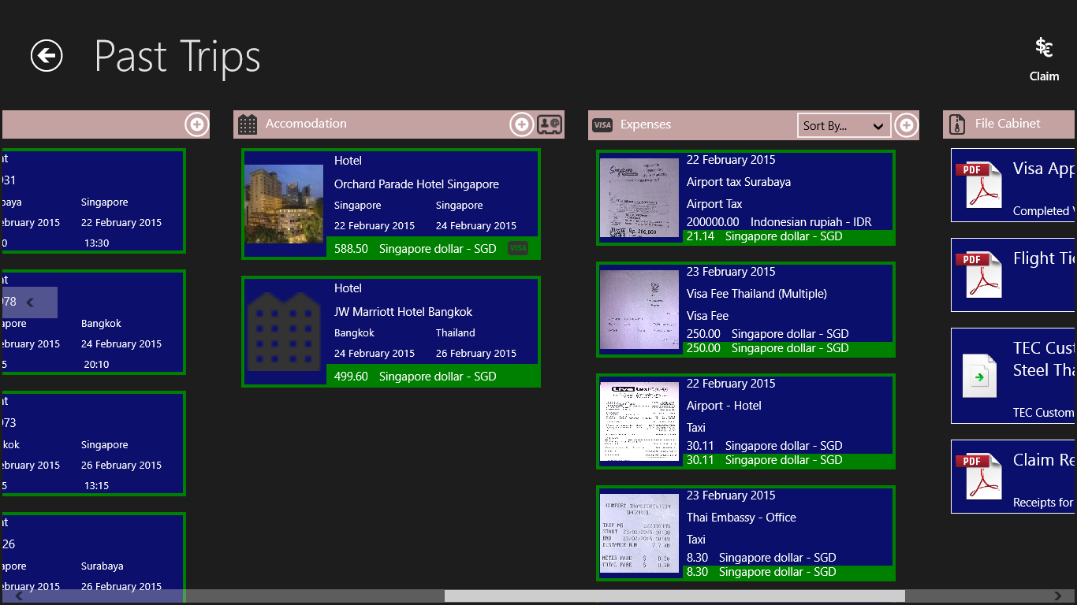
Figure 74: Expense list sorted by Date.

6. Using the File Cabinet
The File Cabinet is a very convenient way to store files related to the trip, which do not fit into the categories travel, accommodation and expenses. This could for instance e-Visa granted to you, passport copies or medical certificates and many, many more. It greatly helps to keep your trips organized.
Adding a file to the File Cabinet
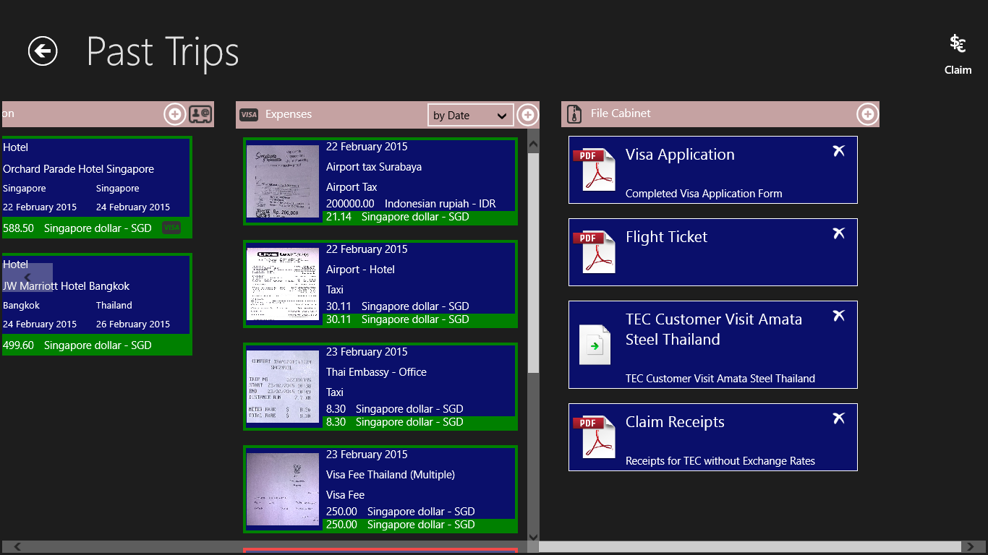
Figure 75: Click the “+” – Button to add a file to the File Cabinet.
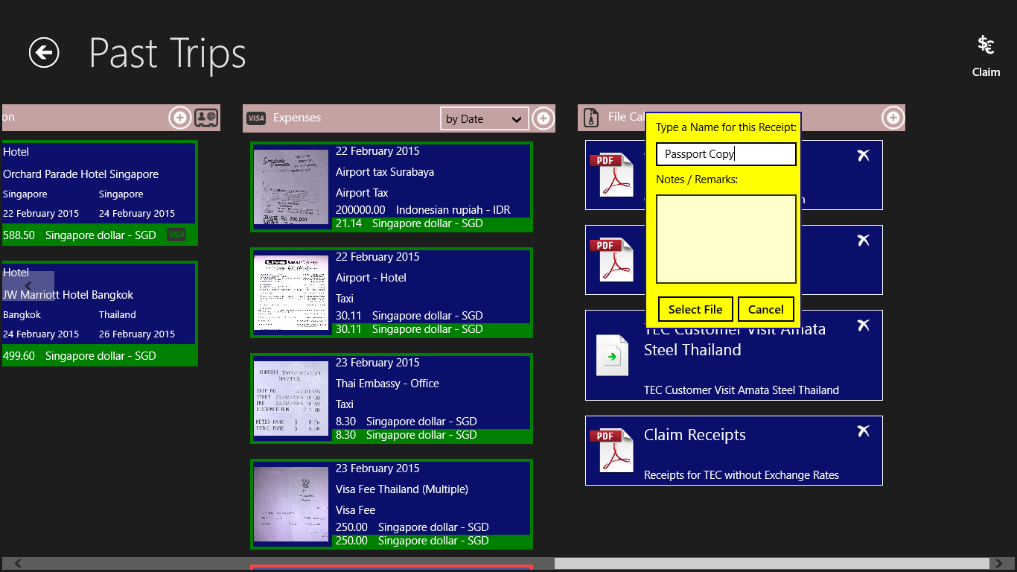
Figure 76: Enter a name or description for the file into the dialog box. To enter a name is mandatory.
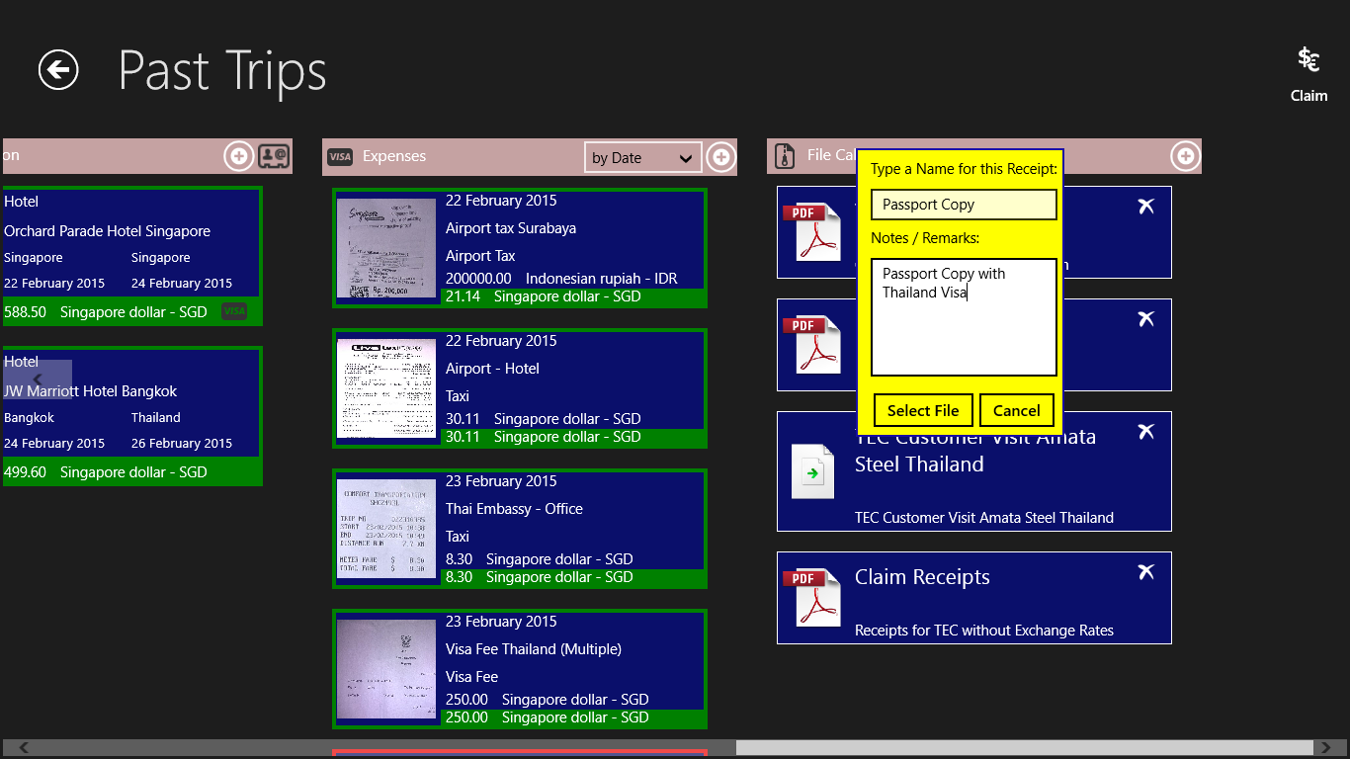
Figure 77: Optionally, you can enter Notes and Remarks to make the file easier identifiable later. Click the “Select File” – Button.
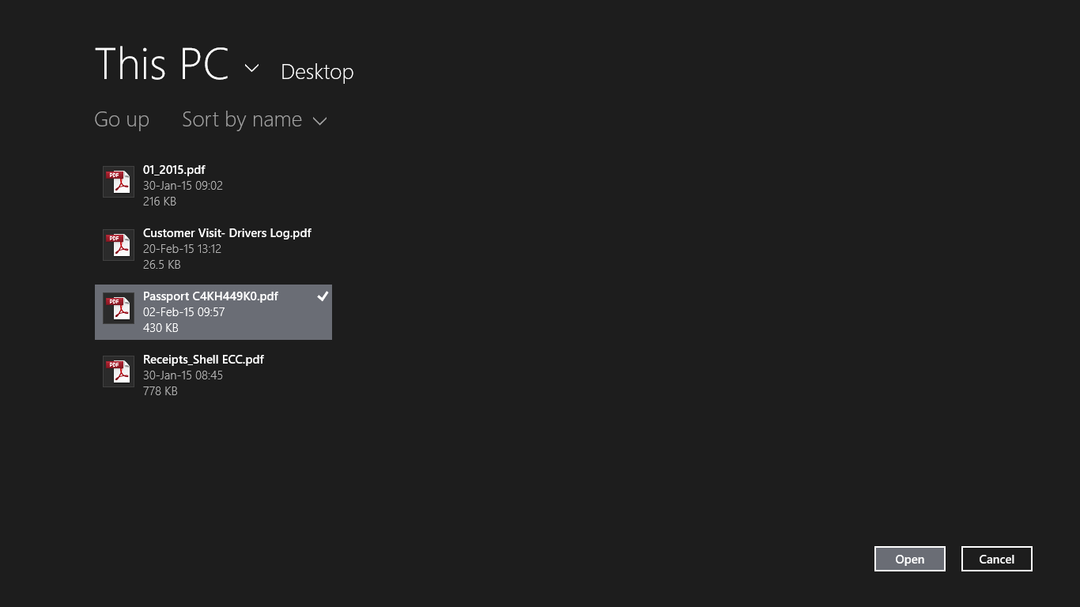
Figure 78: Pick the File you want to add from File Dialog. All common file types are supported.
Note:
The files in the File Cabinet will be opened with their associated application. You need to have this application installed on your device. You can, however, add a file to the File Cabinet without the necessary application installed on your system.
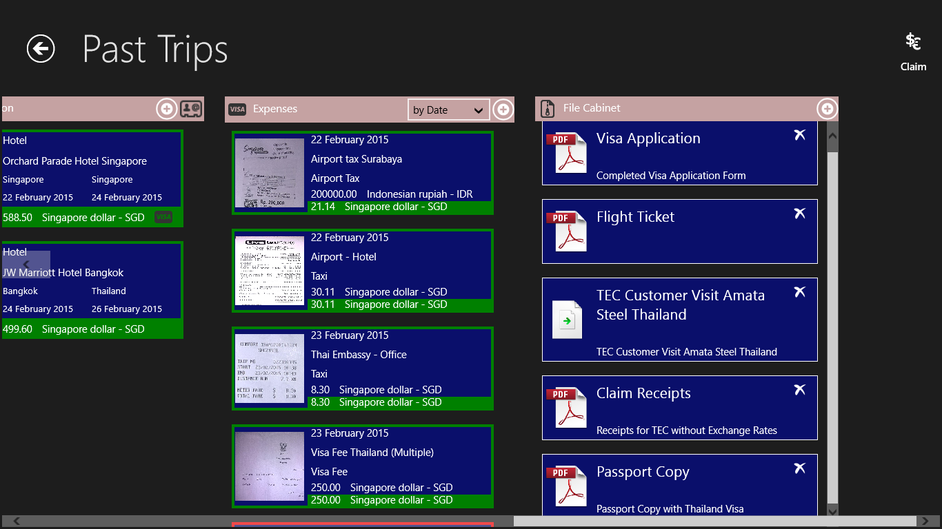

Figure 79: The file was added to the File Cabinet.
Deleting a file from the File Cabinet
Figure 80: Click the “Delete” – Button of the file you want to delete.
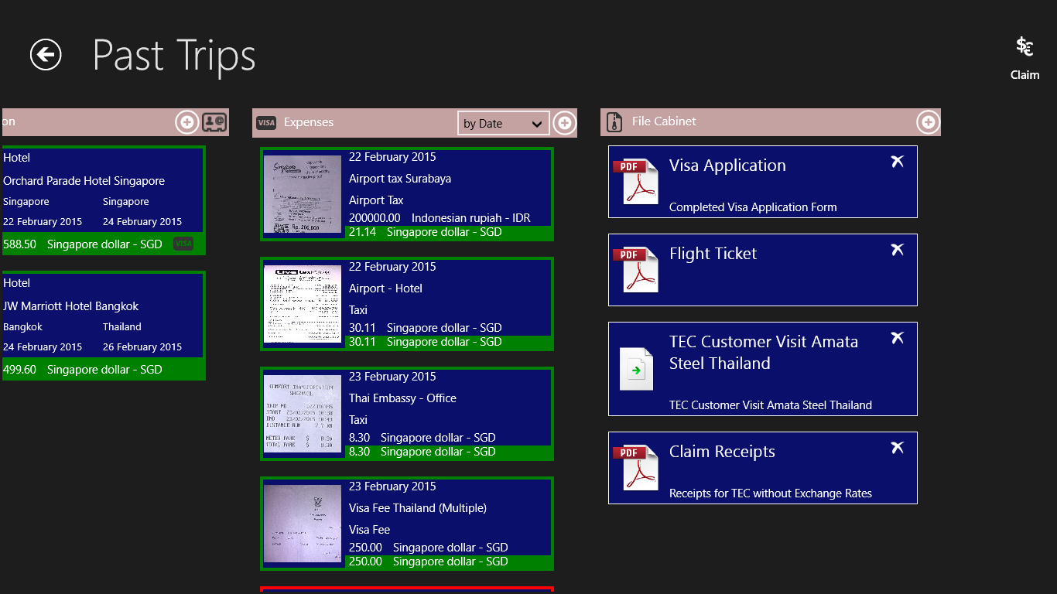
Figure 81: The file will be deleted and the entry removed from the File Cabinet.
Note:
Business Trip Manager will save a copy of the files in the File Cabinet in your Business Trip Folder. So, even if you delete the original file, on purpose or not, Business Trip Manager will still have a copy! If you delete the file from the File Cabinet, the copy of the file will be also deleted.

7. Create and Print an Invoice
Business Trip Manager provides you an easy feature to create and print a simple invoice for your trip. You can send the invoice together with the supporting document to your customer. The invoice can be also saved in your File Cabinet for easy reference later.
Creating an Invoice
Figure 82: Click on the “Claim” – Button in the top right corner.
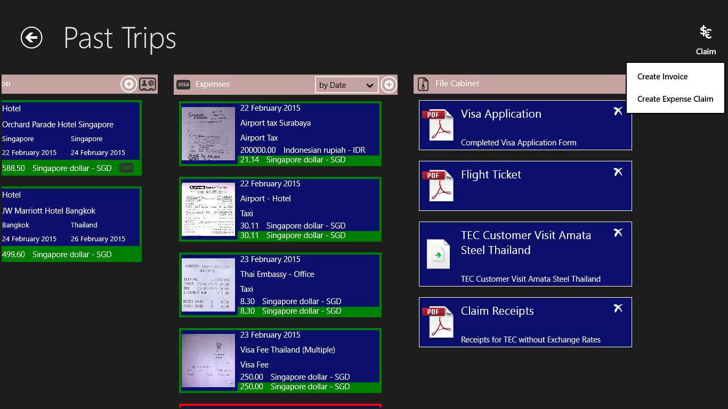
Figure 83: Select “Create Invoice” from the menu.
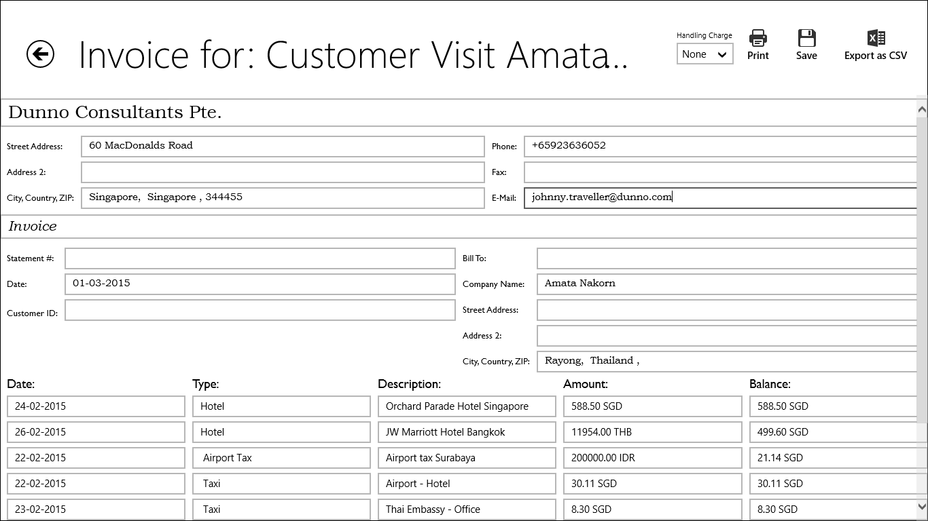
Figure 84: The invoice will be created. The personal data you have entered in the Business Trip Manager settings will be used. All Fields, however, are editable.
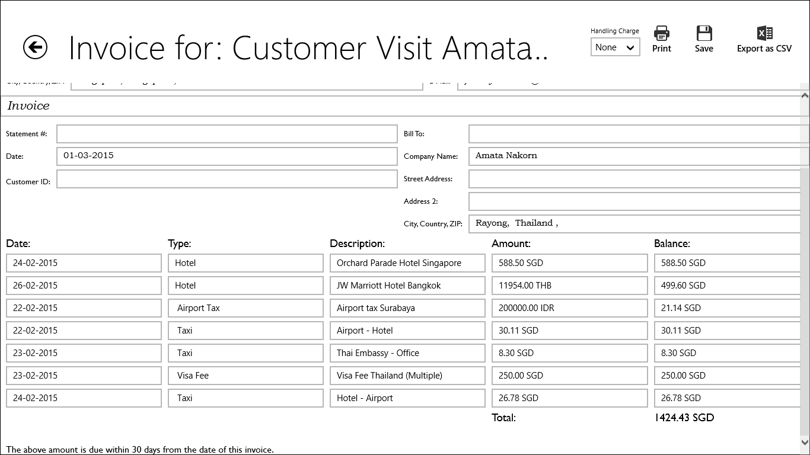
Figure 85: All expenses marked as reimbursable are reflected in the invoice.
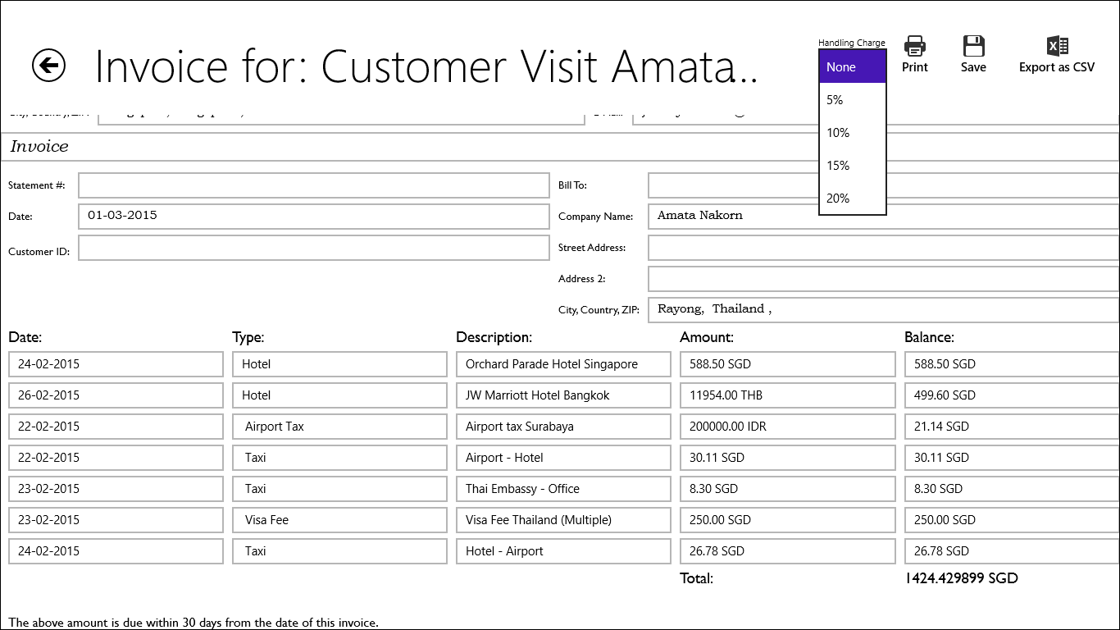
Figure 86: Select a Handling Charge you may want to add to your invoice.

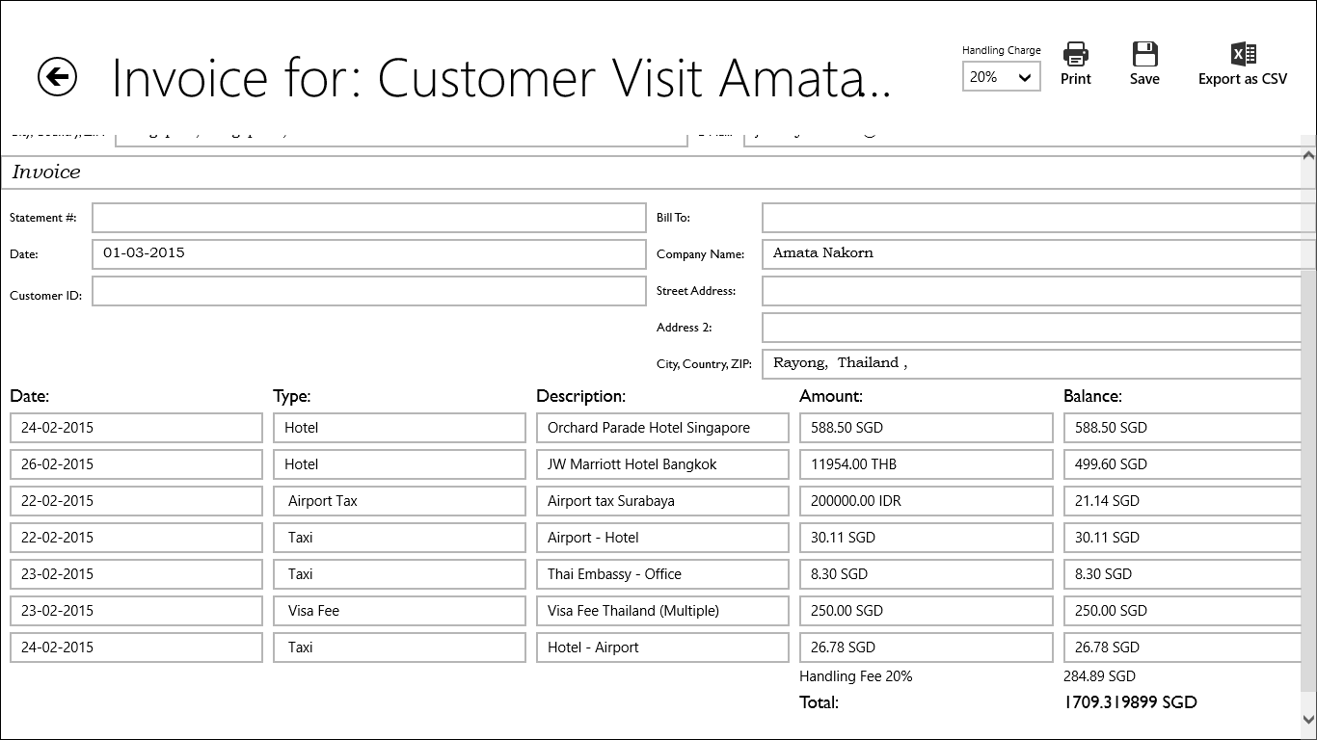
Figure 87: Invoice with Handling Charge

Printing the Invoice
Figure 88: Click the “Print” – Button.
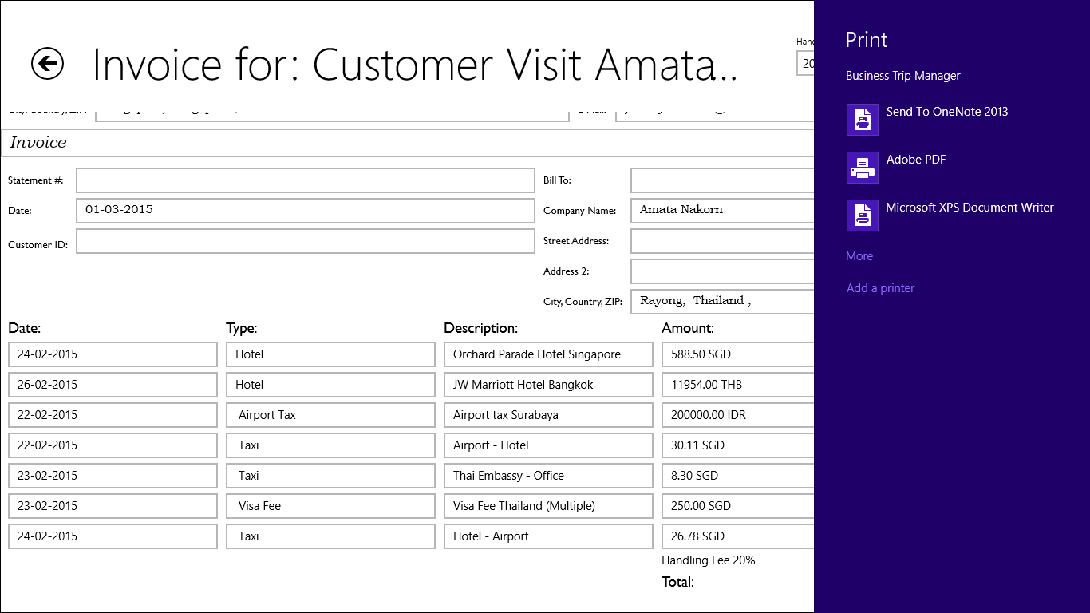
Figure 89: Select the printer you want to use and …
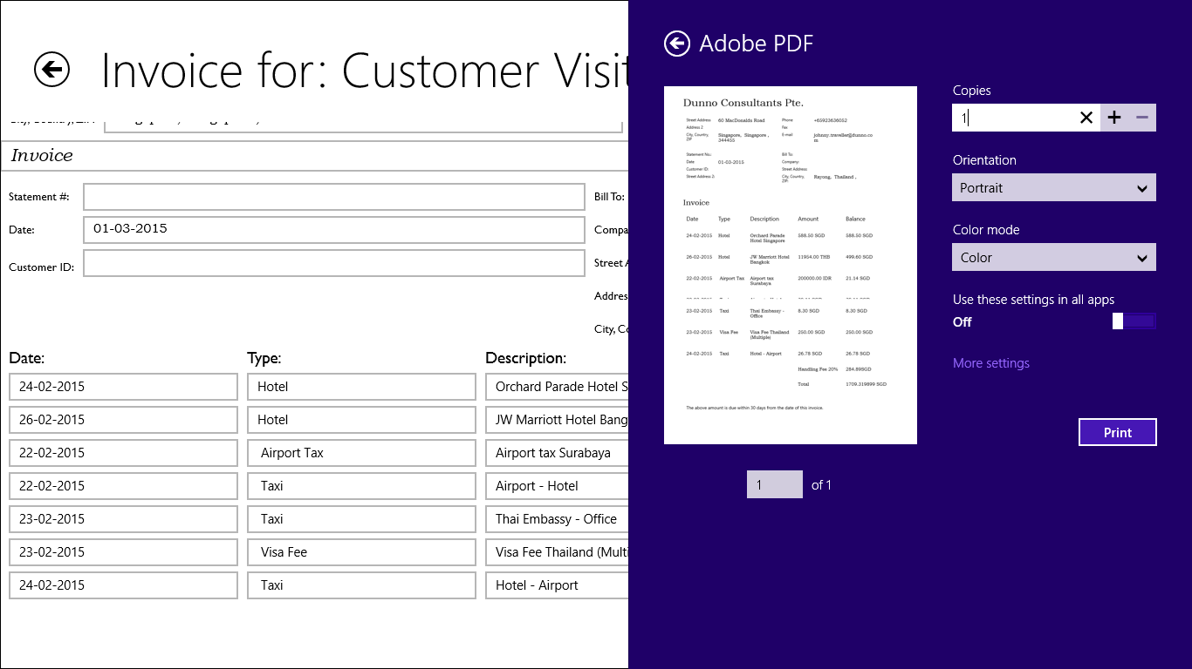
Figure 90: … and make the necessary adjustments. Click the “Print” – Button.
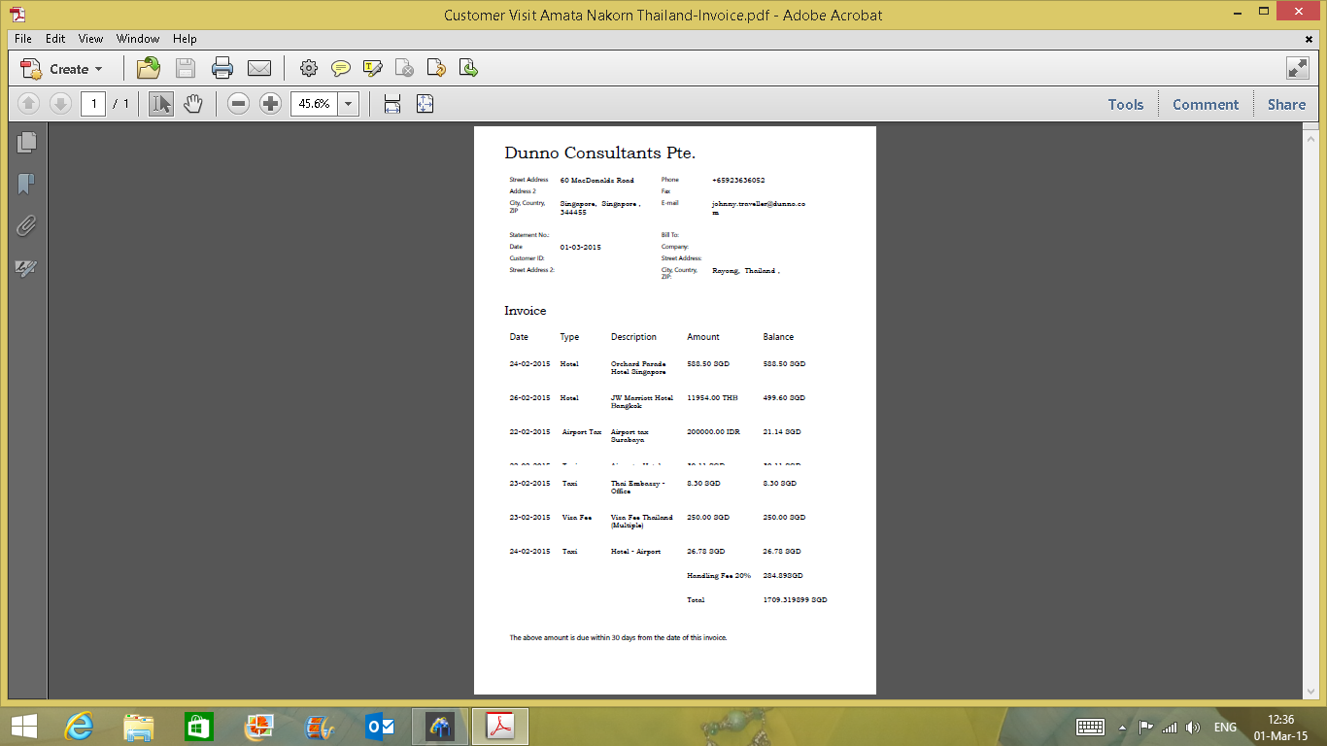
Figure 91: The printed invoice.

Saving the Invoice
Figure 92: Click the “Save” – Button.
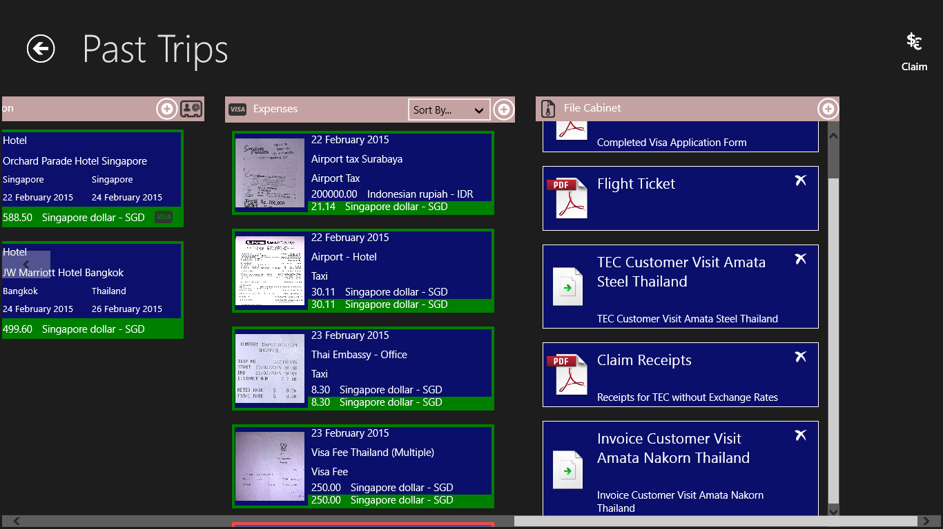
Figure 93: Invoice is saved in the File Cabinet.

8. Create and Print an Expense Claim
Business Trip Manager provides you an easy feature to create and print an expense claim for your trip. You can submit this expense claim together with the supporting document to your manager for reimbursement of your expenses. The expense claim can be also saved in your File Cabinet for easy reference later.
Creating an Expense Claim
Figure 94: Click on the “Claim” – Button in the top right corner.
Figure 95: Select “Create Expense Claim” from the menu.
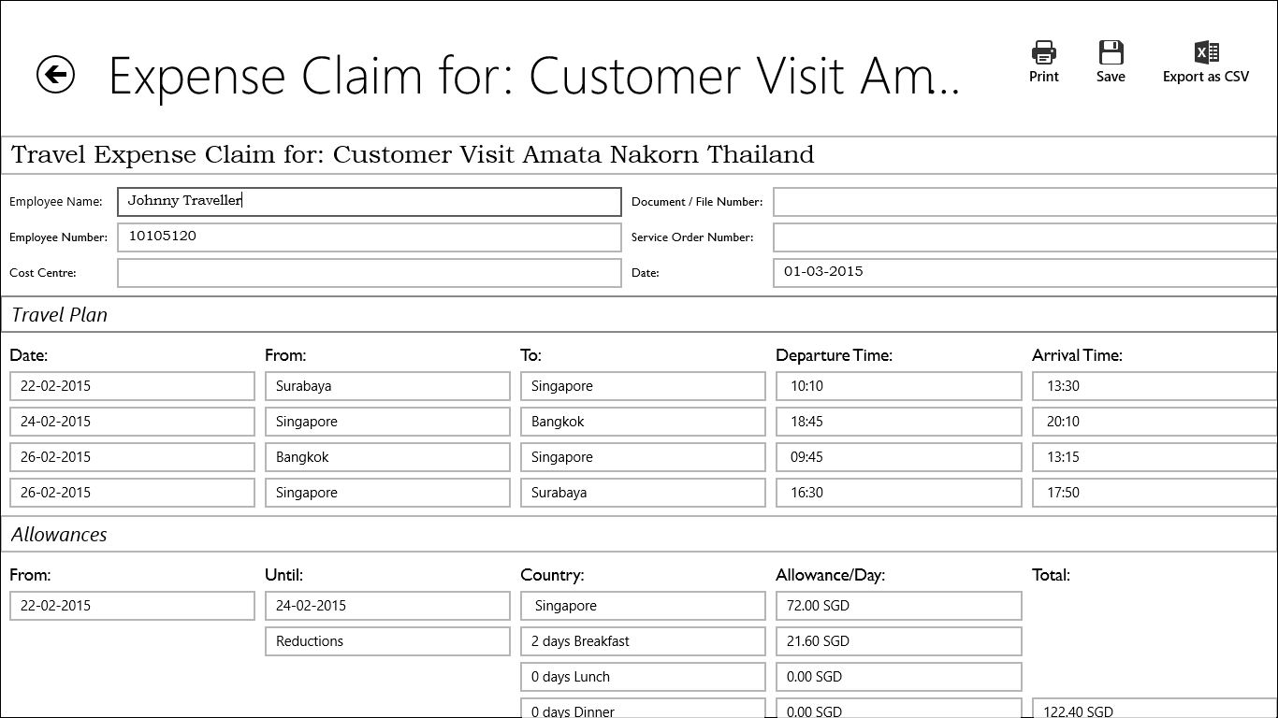
Figure 96: The expense claim will be created. The personal data you have entered in the Business Trip Manager settings will be used. All fields for the personal data, however, are editable.
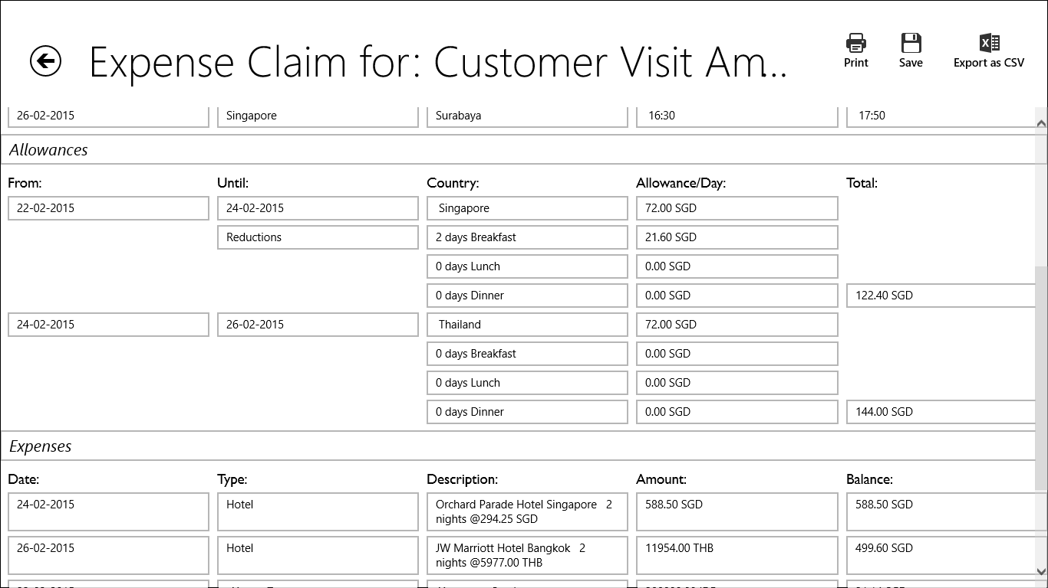
Figure 97: The expense claim reflects the Travel Plan, Allowances and …
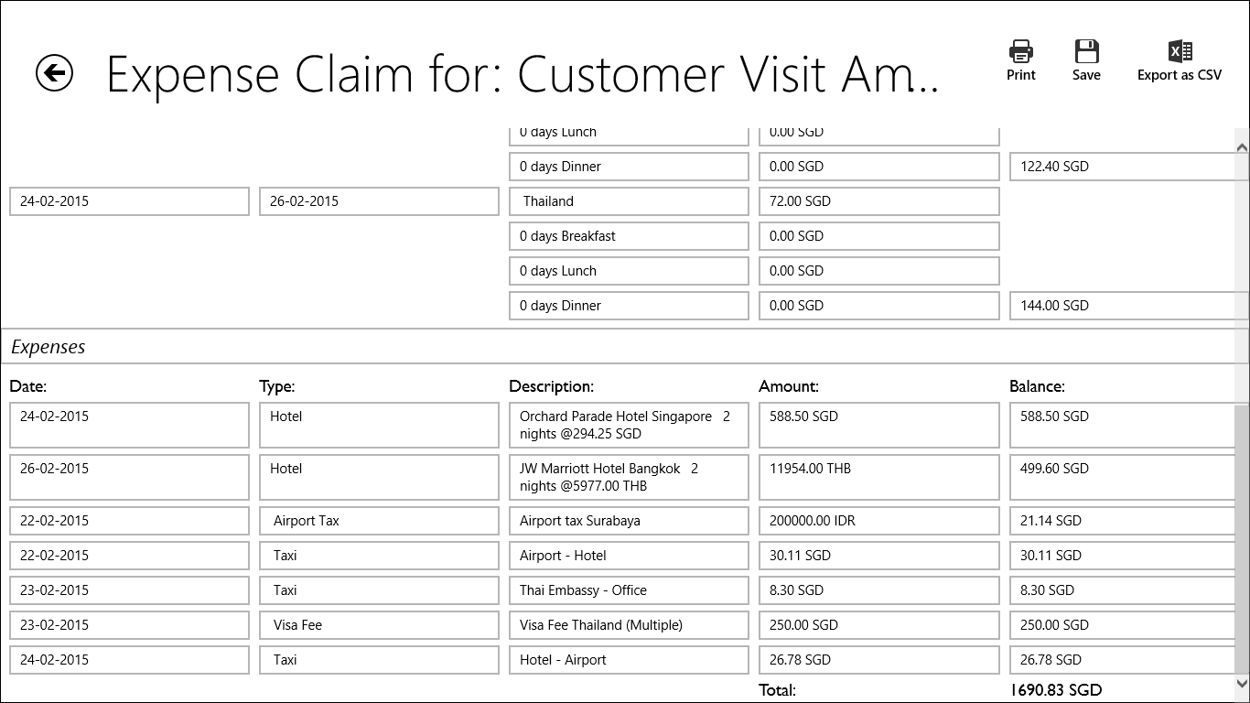
Figure 98: … expenses of the trip marked by you as reimbursable. These fields are not editable. You need to make changes in the corresponding sections of the trip.
☺Hint:
In some cases the daily allowance should not be claimed with the expense claim. If you need to create an expense claim without the daily allowance, you need to uncheck the “Claim Allowances” – Box in the Travel Plan.

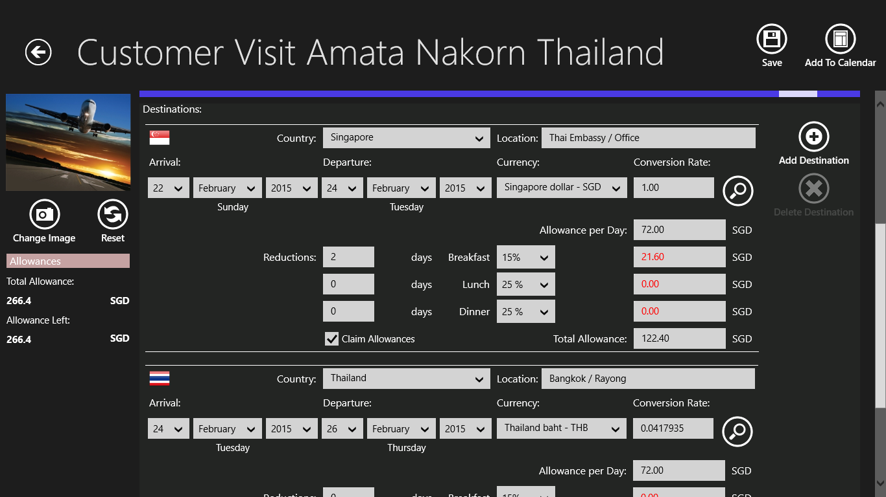

Figure 99: Uncheck the “Claim Allowance” – Box in the Travel Plan to create an expense claim without daily allowances.

Printing the Expense Claim
To print the expense claim, follow the steps as described under “Printing the Invoice”.
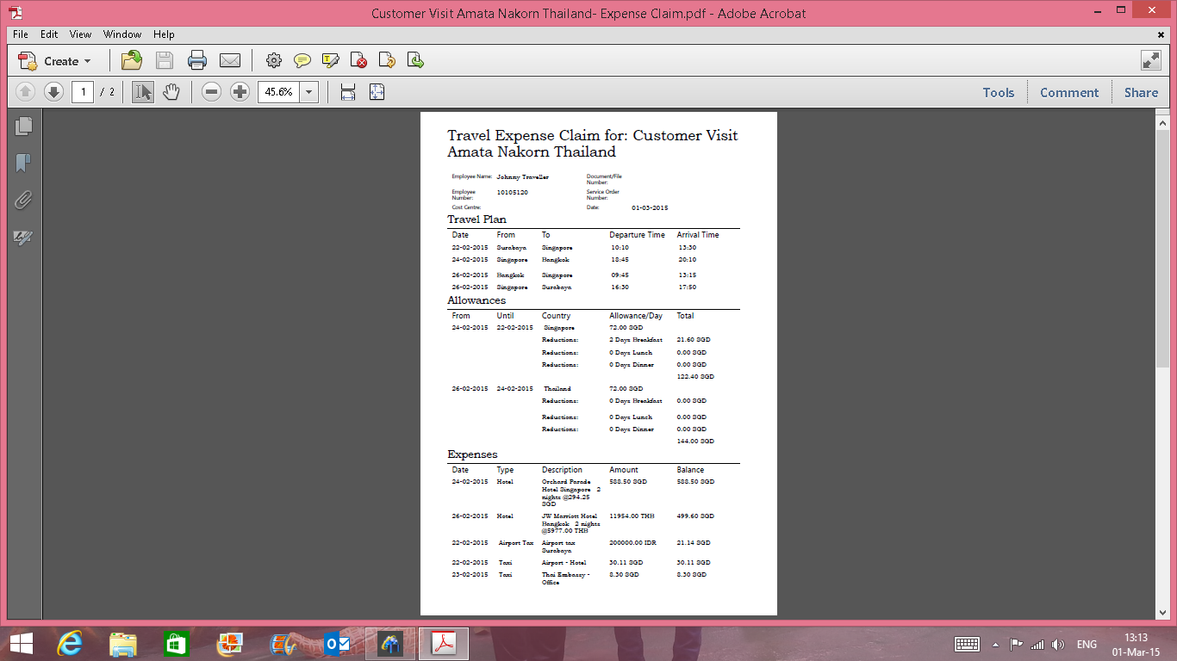
Figure 100: The printed expense claim.
Saving the Expense Claim
Follow the steps as described under “Saving the Invoice” to save the expense claim to the File Cabinet.
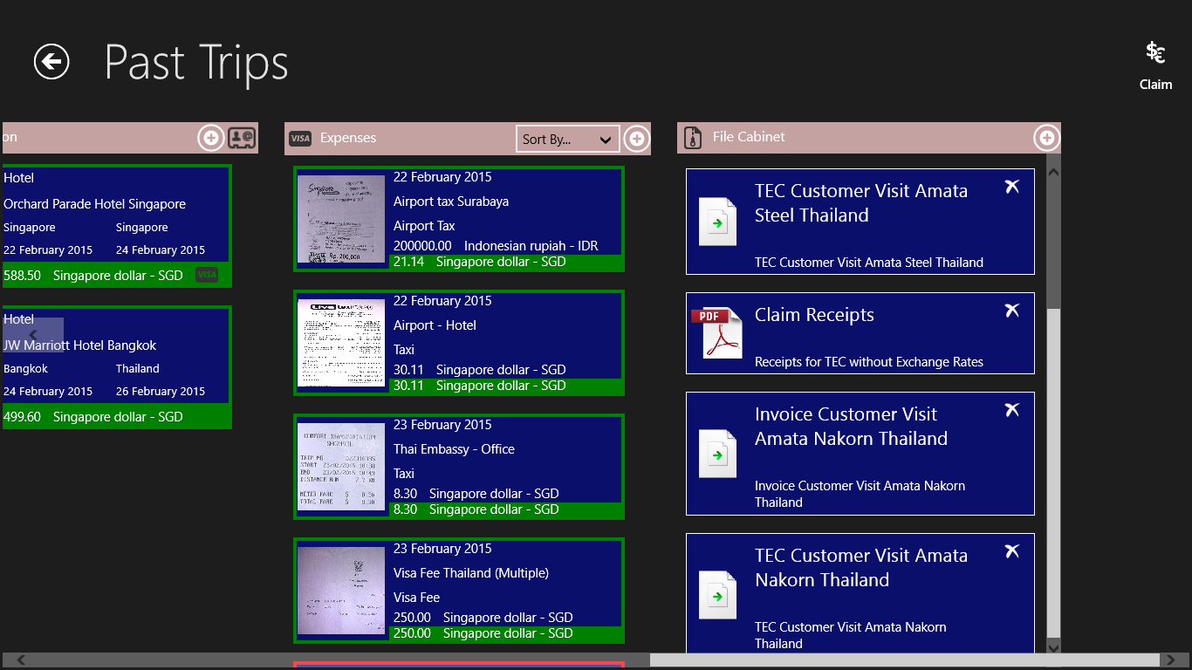
Figure 101: The saved Expense Claim in the File Cabinet.

9. Export Data to Excel as .csv – File
In a number of cases the templates for Invoice and Expense Claim provided by Business Trip Manager cannot be used because they are insufficient or not in the correct format.
For such cases Business Trip Manager provides a feature to export the trip data as .csv (Comma Separated Value) – File. A .csv – file can be opened with a number of applications, i.e. MS Word or MS Excel and further edited. So you can add your own headers and footers, insert Taxes and Service Rates and many more.
Export Data as .csv – file
Create an Invoice or Expense Claim as described in the respective chapters.
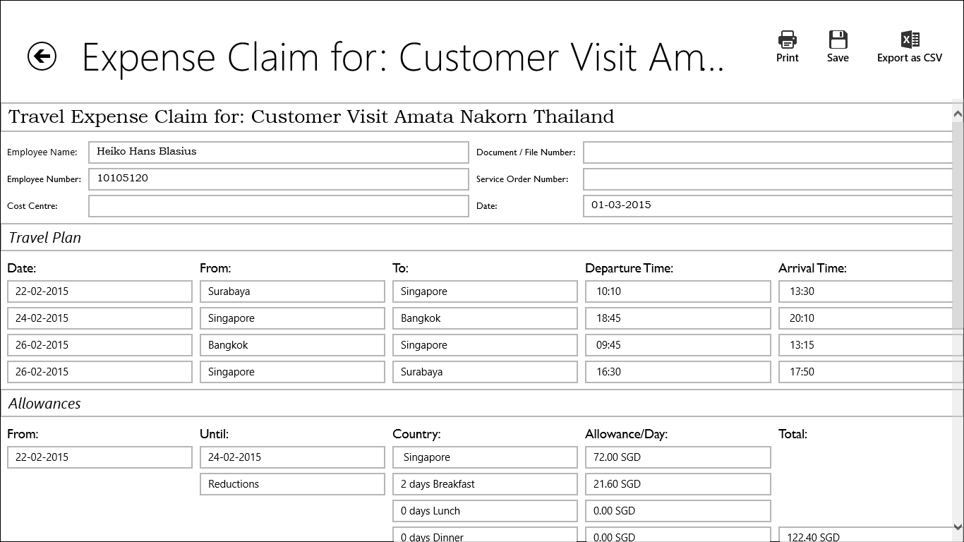
Figure 102: Click the “Export as CSV” – Button.
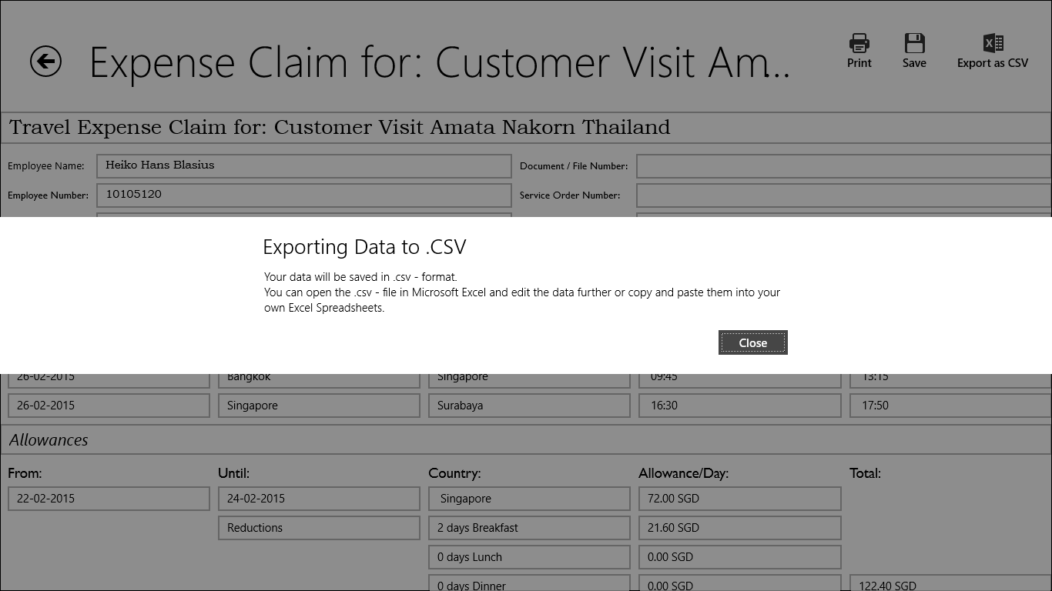
Figure 103: Read and close the Info Dialog.
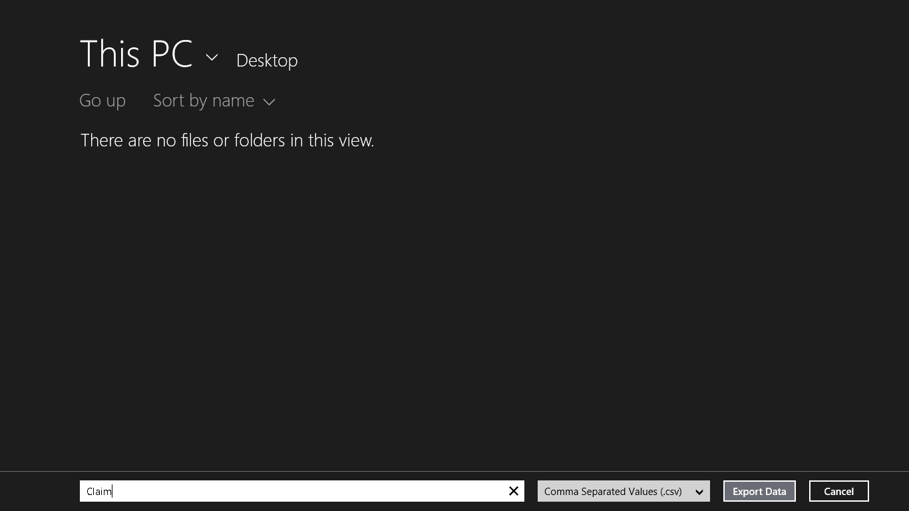
Figure 104: Select where to save the .csv – file.
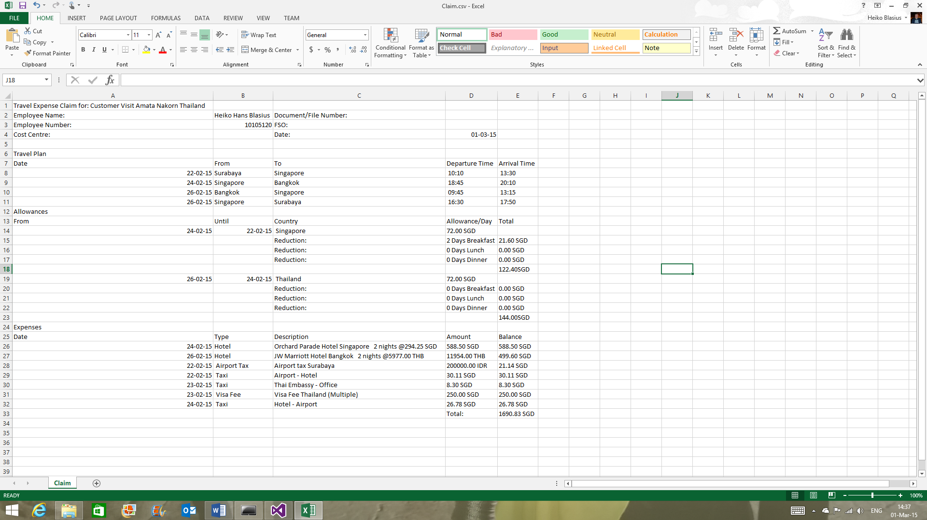
Figure 105: Done! The exported trip data in MS Excel.

10. Duplicate a Trip
Instead of entering all the data for a reoccurring trip again, you can duplicate the trip. Duplicating a trip will create a new trip with all the customer data and travel details from the trip you have chosen to duplicate.
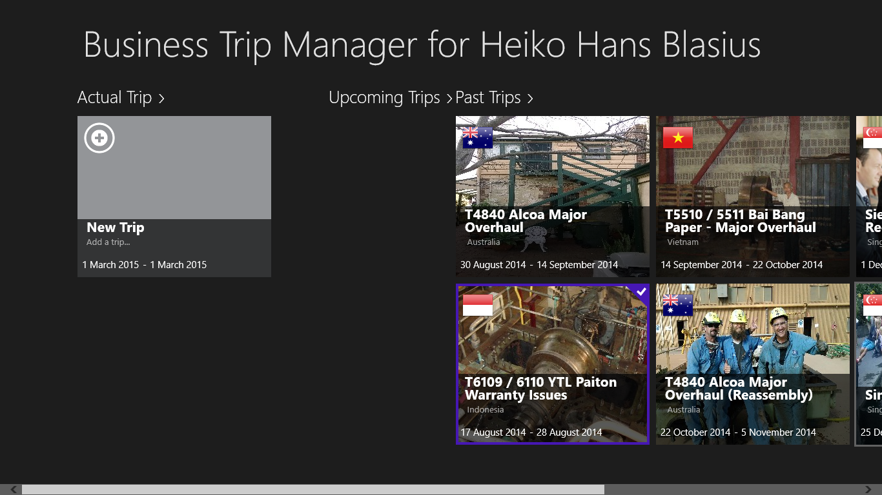

Figure 106: On the start screen, select the trip to duplicate.
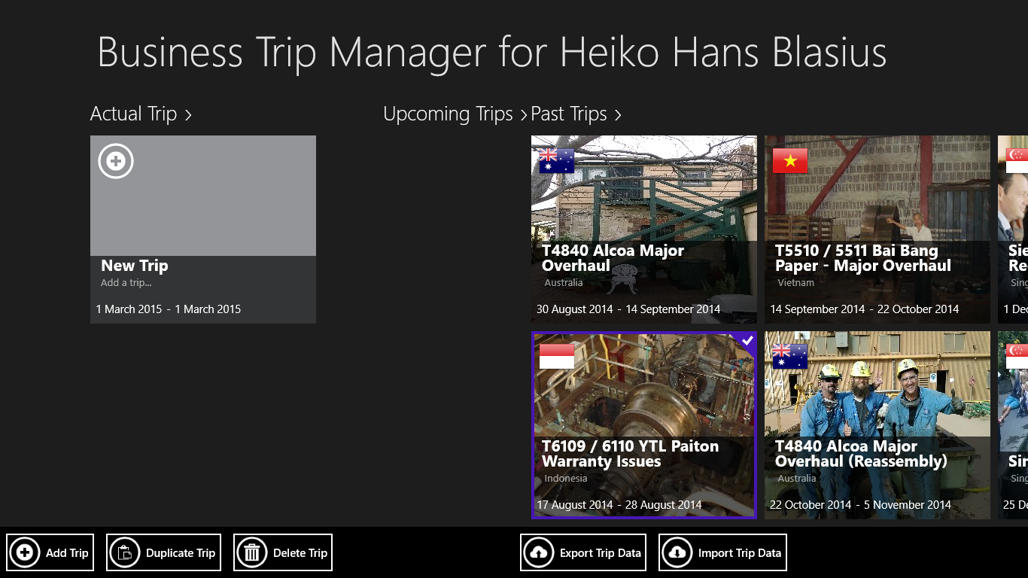
Figure 107: Click the “Duplicate Trip” – Button in the App Menu Bar.
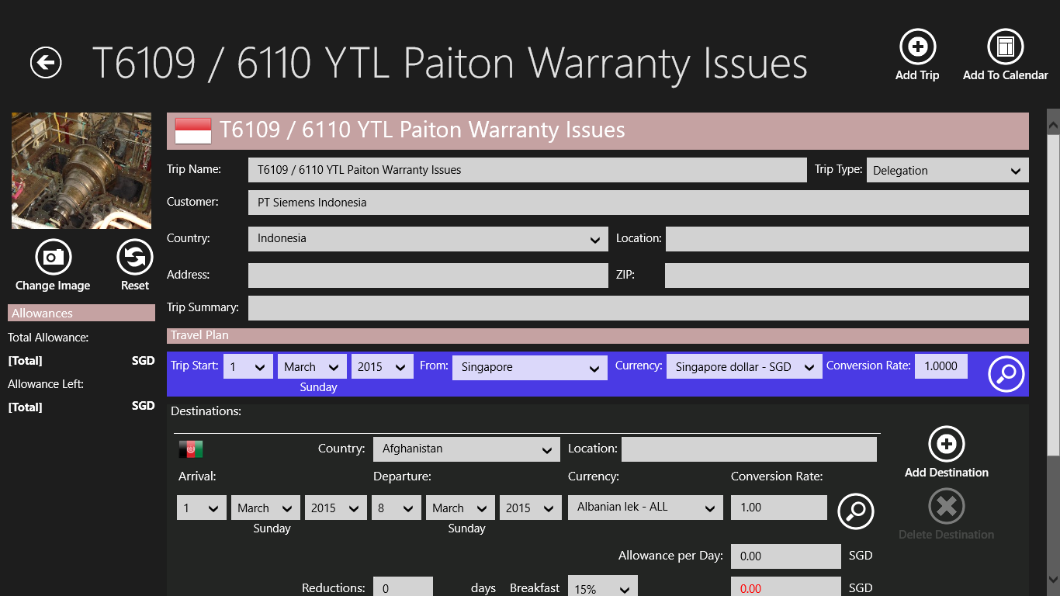
Figure 108: A new trip with the data of the selected trip will be created
11. Backup and Restore your Trip Data
Business Trip Manager provides an easy way to backup and restore your trip data. Just select the Auto – Backup option in the “Options” – Charm. All your trip data will be automatically backed up each time you close the Business Trip Manager App. An algorithm prevents corrupted data from being backed up.
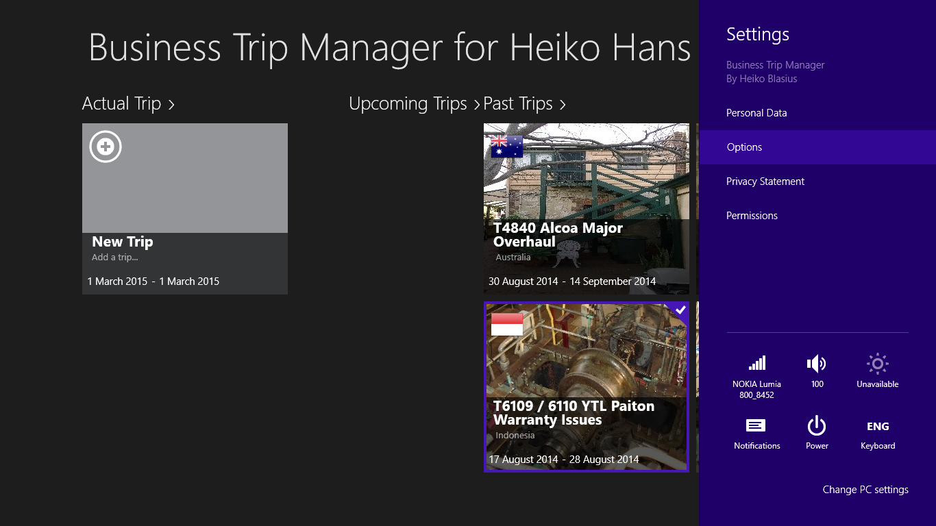
Figure 109: Select “Options” from the Settings – Charm.
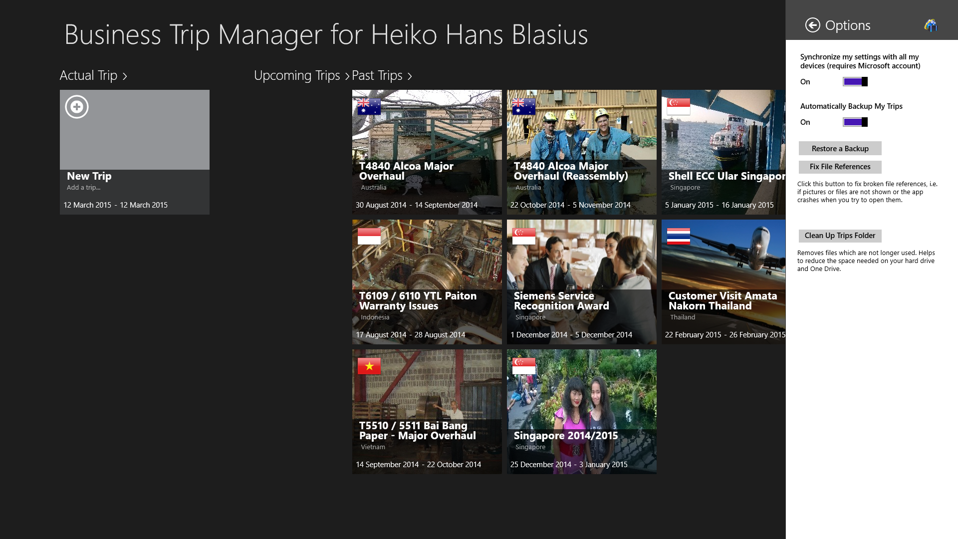
Figure 110: Set “Automatically Backup My Trips” to “On” (By Default it is “On”). The backup will be created automatically when you close the Business Trip Manager App.
In case your trip files have been corrupted or are lost you can easily import the created backup by clicking the “Import a Backup” – Button. Please note that this button is only available if a backup exists.
Note: After importing a backup, you need to close and restart the app.
Figure 111: Import a Backup.

12. Fix File References
In some cases the file references might be lost. This can happen, if you uninstall and reinstall Business Trip Manager and import a backup. It will seem as if all documents for the trip have been lost. No Problem – Business Trip Manager can scan the files and trip data for you and reinstate the references. Everything will be fine again.
Figure 112: Click the “Fix File References” – Button to fix the lost file references. We have observed that it is not required to restart the app afterwards but would still recommend to do so.
13. Clean up your Trip Folder
Even though Business Trip Manager removes all the files which are not needed anymore, it may still happen that files which are no longer used remain on your disk.
Just click the “Clean up Trips Folder” – Button in the Options Charm and Business Trip Manager will remove all unnecessary files and free up disk space.
☺Hint:
In the unlikely case that files are removed which were still in use, do the following:

- Select the Auto Backup Option in the Options Charm.
- Close the app.
- Restart the app and Import the Backup just created
- Close and restart the app.
- The problem should be fixed!

Figure 113: Remove unnecessary files from the trip folder.
14. Import and Export your Trip Data
Importing and exporting of trip data works pretty much the same way as the auto – backup. The only difference is, you can choose what and when to import or export.
You can for example create a backup of your trip data on an external drive. You could also export your trip data to One Drive. The synchronized trip data you can import to Business Trip Manager which you run on another device.
Figure 114: Click the “Export Trip Data” – Button in the App Menu Bar. Choose a folder to export the data to in the following dialog and wait till all data are exported.
Figure 116: To Import a trip, click the “Import Trip Data” – Button in the App Menu Bar. Choose a folder to import the data from in the following.

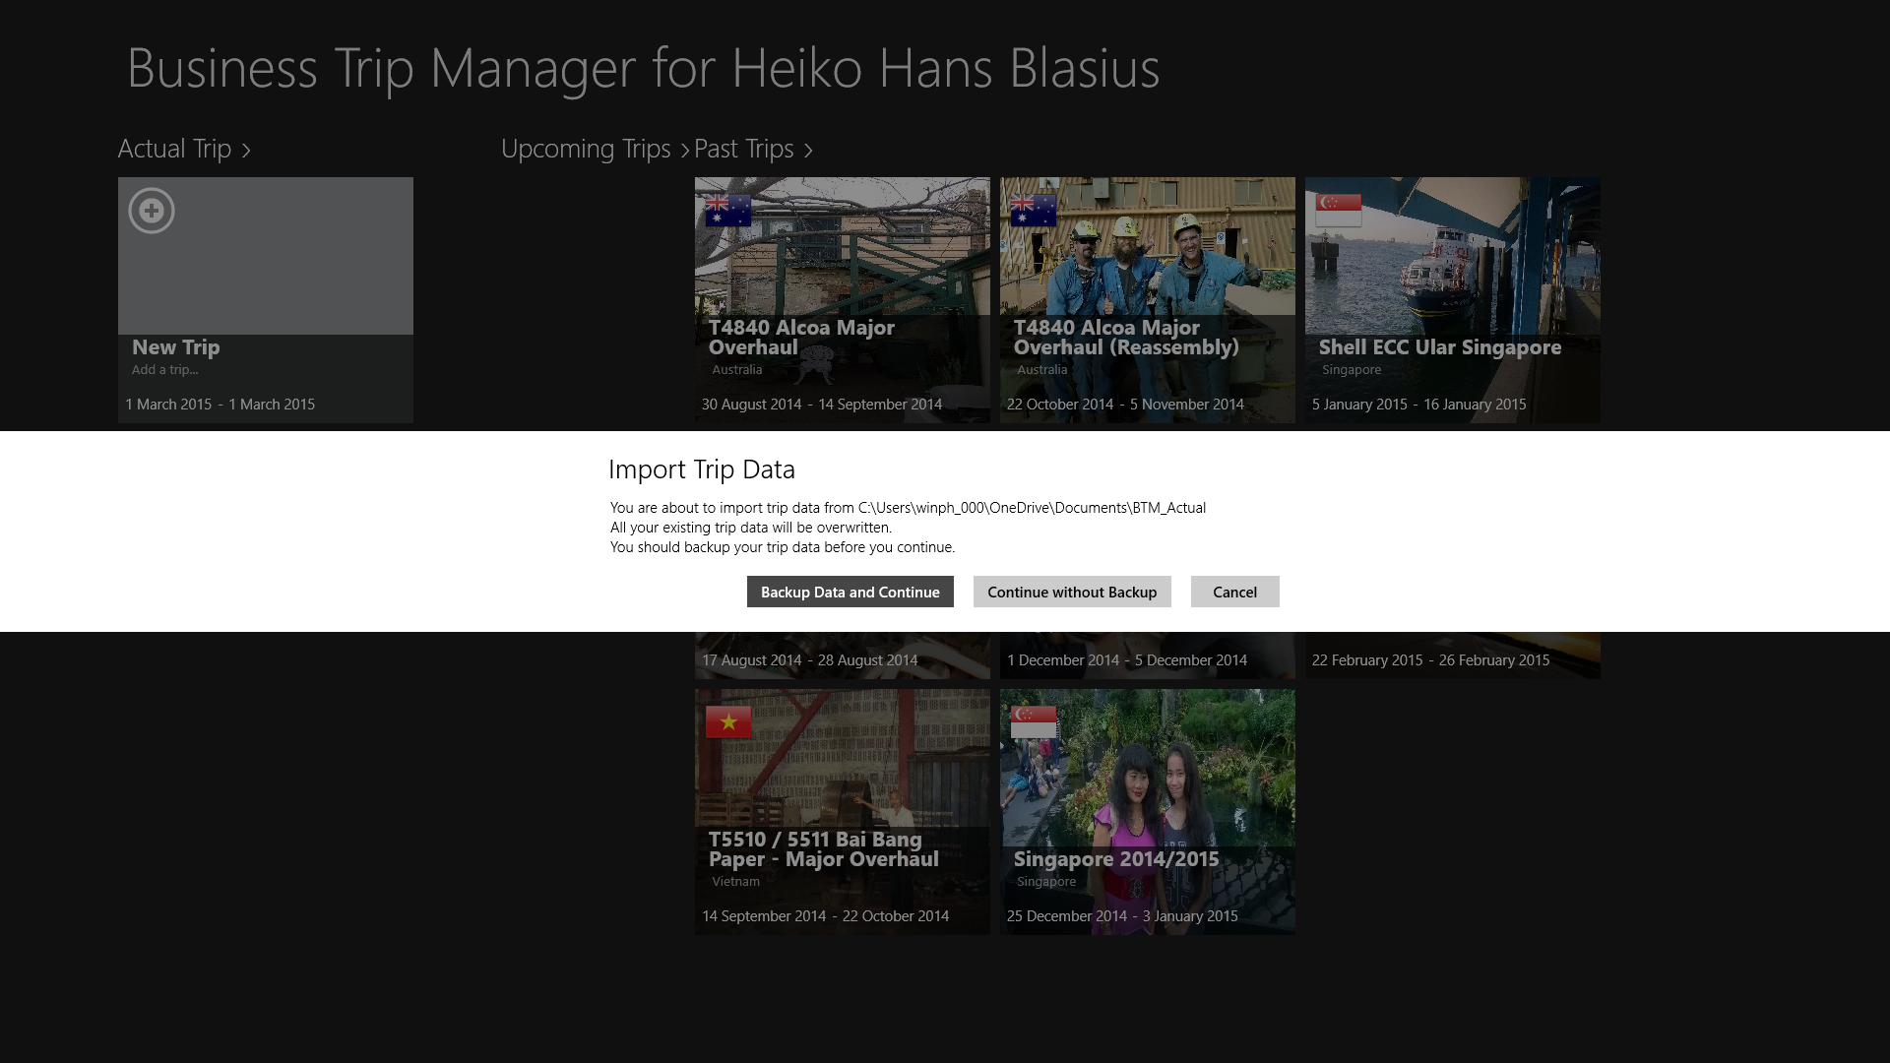
Figure 117: Choose in the following dialog, whether you want to back up your existing trip data before importing the new data. We recommend to back up the trip data first. The backup will be saved in your My Documents folder. Afterwards wait until the trip data are imported. You need to close and restart the app in order to work with the imported data.
☺Hint:
If you have trouble to import data stored on One Drive, make sure the folder with your data on One Drive is made “Available Offline”:
Open the One Drive App on your device, select the folder with your trip data, and then click the “Make Offline” – Button in the App Toolbar. You will have to wait until the files are downloaded to your device.

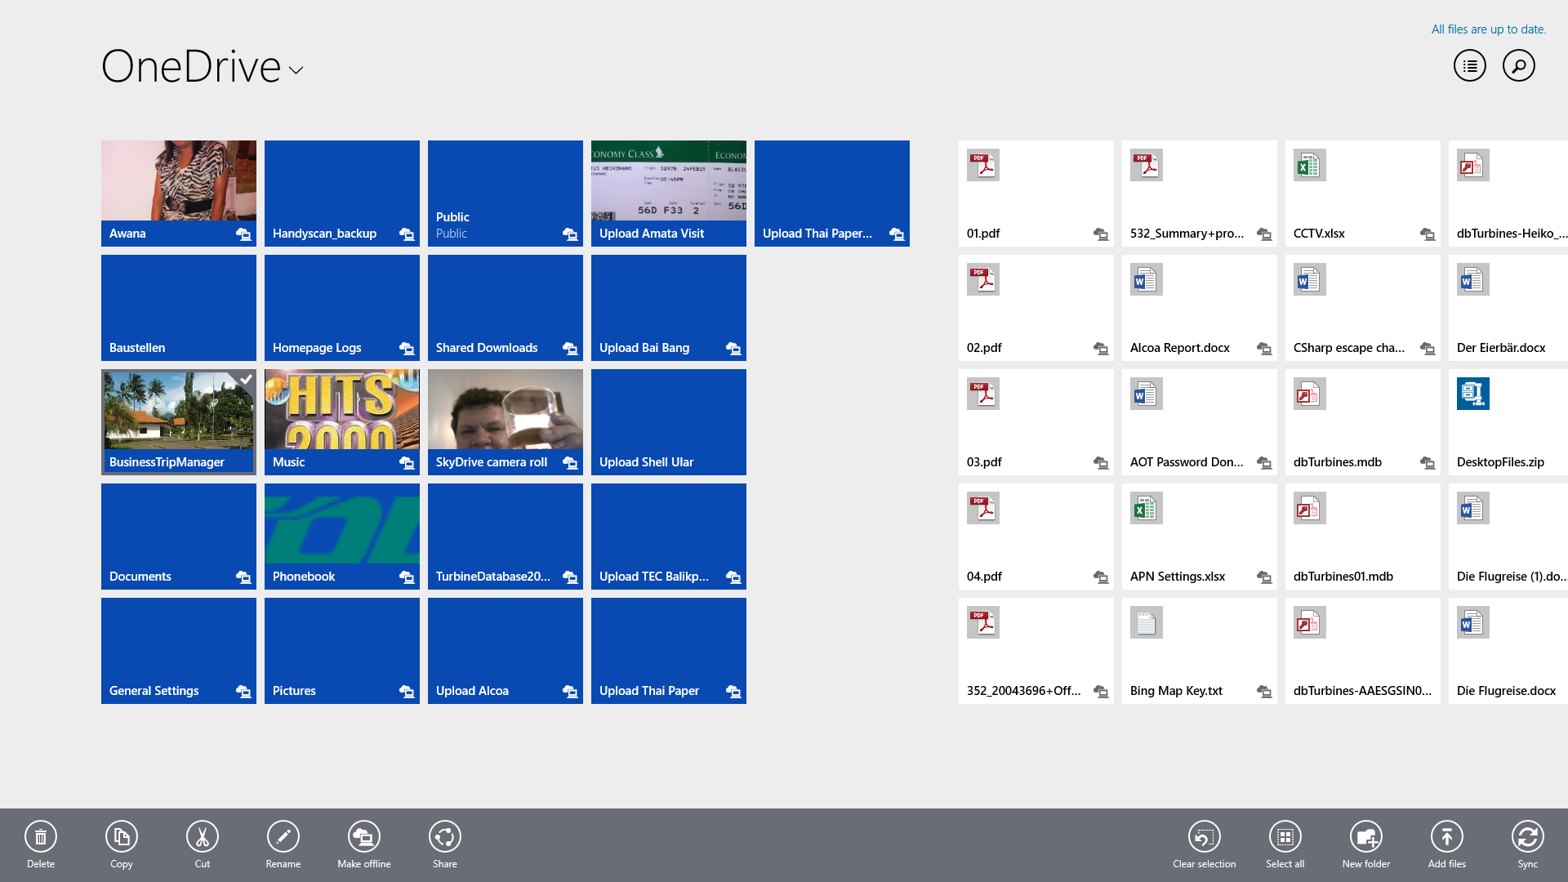

Figure 118: Select the folder with your trip data, and then click the “Make Offline” – Button in the App Toolbar.
If you have Windows 8.1 installed you can do the same from the Windows Explorer:

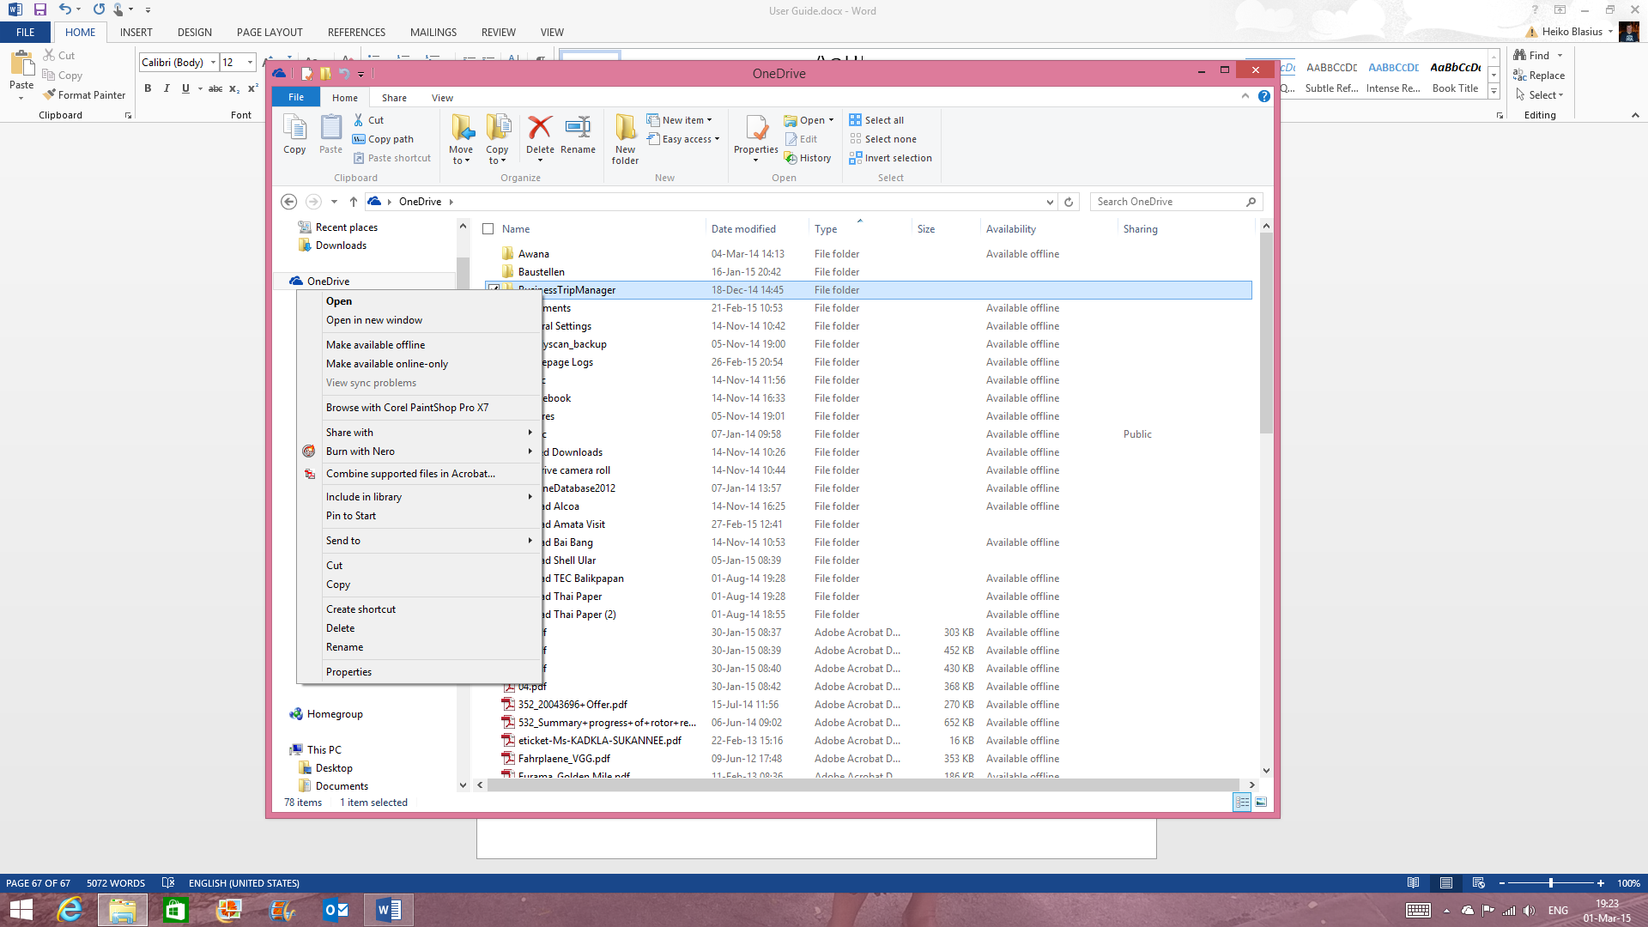
Figure 119: Make the trip data folder “Available Offline” in the Windows Explorer.
15. Good Luck!
Always and everywhere on your Business Trips!
We hope you find our app helpful to effectively and easily plan, organize and manage your business trips.
We hope to hear from you! Every input from our users is welcome to make this app even better. So, if you have any suggestions for us just drop us an e-mail.

If you haven’t gotten Business Trip Manager yet, download it now from the Windows Store!

File Version: 1.00.09
Published: 12/03/2015

